AL MUJTABA EDUCATION TRUST
ANNUAL PROGRESS REPORT FOR YEAR 2025

Executive Summary

In 2025, Al Mujtaba Education Trust (AMET) made meaningful strides in expanding its impact and strengthening its programs aimed at empowering underprivileged communities across Pakistan. Through its scholarship support, the Trust continued to enable deserving students to pursue their education without financial hardship, opening pathways to their brighter future.

Vocational training remained a key pillar of AMET’s work, especially for the girls of Rural Areas. By equipping individuals with practical skills in trades and digital literacy, the Trust contributed to improving livelihoods and fostering economic independence among its beneficiaries.

A major milestone was the start of construction of AMET Education Complex (Ilm o Hunar Institute), at the plot allocated by DHA Rawalpindi. This flagship initiative reflects AMET’s long-term vision to establish a Centre of Knowledge and Skills development.

With strengthened donor engagement and strategic partnerships, AMET expanded its outreach and increased the number of individuals supported during the year - further amplifying its impact.

The year also saw the induction of new Trustees, bringing renewed vision and energy to the organization. This transition is expected to enhance AMET’s ability to scale its Knowledge and Skills development initiatives, expand its footprint in Sindh and Balochistan, and build a strong foundation for long-term sustainability.

This report highlights the Trust’s progress, achievements, and future direction as it continues its mission of transforming lives through education, skills, and opportunity.

. . . . . . . . . . . . . . . . . . . . .

بِسْمِ اللهِ الرَّحْمٰنِ الرَّحِيْمِ

AL MUJTABA EDUCATION TRUST
ANNUAL PROGRESS REPORT – 2025
Preamble
1. The year 2025 represents another significant milestone in the continuing journey of Al Mujtaba Education Trust (AMET). Since its inception in 2016 with an initial award of 96 scholarships—primarily focused on middle and higher secondary education—the Trust has grown substantially. Today, its support extends across a broader academic spectrum, including Technical Education and graduate-level programs. This sustained progress reflects the unwavering commitment of our valued donors and Trustees, under the guidance of our esteemed Founder and former Chairman, Lt Gen Ghulam Muhammad Malik, Retd, who continues to inspire us as Patron.
2. During the year, AMET continued to receive generous support from the business community and corporate partners. Our regular donors also enhanced their annual contributions and Zakat support. As a result, the Trust successfully raised an all-time high of Rs. 204 million in 2025, further strengthening its ability to expand outreach and impact.
3. Focused efforts were undertaken to broaden scholarship coverage across both technical and formal education streams. In particular, the Diploma of Associate Engineering (DAE) scholarship program was expanded to include students from thirteen Institutes of Technology, compared to nine institutions in the previous year. To further strengthen collaboration, AMET signed a Memorandum of Understanding (MoU) with Fauji Fertilizer Company Limited (FFCL), while the MoU with Riphah International University has been renewed.
4. A major development during the year was the commencement of construction of the seven-storey, multi-purpose AMET Ilm-o-Hunar Institute on 13 May 2025. A dedicated fundraising campaign has been launched to support timely completion of the project, targeted for end-2026. A separate account has been opened with Meezan Bank to ensure transparency and efficient management of the project funds.
Scope of the Report
5. This report provides an overview of AMET’s activities and performance during the year, covering following key areas:
a. Scholarship awards and academic performance of beneficiaries.
b. Vocational training programs and outcomes.
c. Governance and Management.
d. Outreach visits and fundraising initiatives.
e. Progress - AMET Education Complex.
g. Photo Gallery - 2025.
Award of Scholarships
6. Overview. The scholarship programs are executed through The Executive Committee, convened regularly throughout the year to review scholarship applications and ensure transparent, merit-based allocation of funds. As a result a total of 1,176 students, including both male and female beneficiaries, received financial support from AMET during 2025. Further details of the scholarship program are outlined below:-
a. General Scholarships. During the year, AMET awarded scholarships to:-
(1) 183 students in Classes 9 and 10.
(2) 221 students in Classes 11 and 12.
b. Higher Education. A total of 95 students were supported in higher education across diverse disciplines, as detailed below:
(1) BS (All Categories) - 82
(2) MBBS - 01
(3) DPT - 03
(4) BSc Metallurgical & Material Engineering - 01
(5) Civil Engineering - 01
(6) Pharm-D (Doctor of Pharmacy) - 03
(7) BDS - 01
(8) BA-LLB - 02
(9) BSc City & Regional Planning - 01
(10) BBA - 01
c. Diploma Programs. Scholarships were awarded to 83 students enrolled in three-year diploma courses across various technical institutes.
d. Certification Courses. AMET sponsored following certification and skill-based courses during 2025:-
(1) Hunar Foundation. 120 students of the following institute were given scholarships through The Hunar Foundation:-
(a) DMS Technical Institute (DMSTI), Karachi - 60 Students
(b) Saeeda Naseem Technical Institute (SNTI) Korangi - 20 Students
(c) Hajiani Ashraf Khatoon Technical Institute (HAKTI) - 20 Students Rasheedabad
(d) Sahib Dad Abdul Mannan Khan Technical - 20 Students
Institute (SDAMKTI Kharian)

(2) NUTECH, Islamabad. 13 students (8 boys, 5 girls) - IT and technical skills.
(3) Govt Degree College, Duki. 9 students (4 boys, 5 girls) - Associate Degree in Science (ADS) programs.
(4) Allied Health Professional Institute Bagh. 1 boy (Dispenser)
(5) Global Institute of Human Development, Mandra. 1 female student (CMW (Community Midwife).
(6) Govt College of Technology, Peshawar. 22 students (20 boys, 2 girls) - Laser cutting and graphic design.
(7) Skills Institute, Sultana Foundation, Islamabad. 4 female students - IT courses.
(8) Govt Graduate College for Women, Shujaabad, Multan. 1 female student - IT course.
(9) Frontier Institute of Medical Sciences (FIMS) Dargai, Malakand. 2 students (1 boy, 1 girl). Dispenser and Lady Health Worker.
(10) Frontier Institute of Modern Sciences, Mansehra. 1 boy, Diploma of Pharmacy (Pharm-B).
(11) Falcon Institute of Medical Sciences, Charsadda. 1 female student - CMW (Community Midwife)
e. Saeeda Naseem & Muhammad Shafi Trusts Scholarships. Under the dedicated funding of the Saeeda Naseem and Muhammad Shafi Trusts:-
(1) 39 female students from rural areas were awarded scholarships for Classes 9 and 10.
(2) Additionally, 410 female students from rural regions of Punjab, KPK and AJ&K received vocational training support, in accordance with donor priorities.
f. Col Sarwar Cheema Scholarships. Under dedicated funding by Adnan Sarwar Cheema, 114 students pursuing Secondary, Higher Secondary, Diploma Courses and Higher Education were awarded these scholarships.
g. Mari Energies (ME) Scholarships. Under dedicated funding by Mari Energies (ME), 146 students pursuing Secondary, Higher Secondary, Diploma Courses and Higher Education benefitted through these scholarships.
h. Fauji Fertilizer Company Ltd (FFC) Scholarships. Under dedicated funding of the Fauji Fertilizer Company Ltd (FFC), 32 students pursuing DAE/ Diploma, ADS, IT, Certification courses and Higher Education benefitted.
i. Muhammad Tariq Dawaiwala Scholarships. Under dedicated funding by Mr. Muhammad Tariq Dawaiwala (Brother Enterprises (Pvt) Ltd), 29 students pursuing Higher Secondary, Diploma Courses, Certification Courses (THF) and Higher Education were awarded these scholarships.
j. SM Farhad Scholarships. Under dedicated funding by Mr. SM Farhad (Din Leather Pvt Ltd), 29 students pursuing Secondary, Higher Secondary, Diploma Courses and Higher Education benefitted.
k. Mrs Shaheen Afzal Scholarships. Under dedicated funding by Mrs Shaheen Afzal, 09 students pursuing Diploma Courses and Higher Education benefitted.
7. Results Achieved. Annual examinations were conducted as per schedule. Overall, AMET-sponsored students demonstrated satisfactory to strong academic performance. A summary is provided below:-

a. General Scholarships Performance
Class | Students | Results
Class | Students | A+ | A | B | C | D | Failed/ Discontinued | Left | Remarks
Secondary (Including Cadet Colleges) | 92 | 22 | 31 | 1 | 1 | 1 | 1 | - | 35*
Intermediate | 150 | 14 | 64 | 13 | - | - | 2 | - | 57*
Higher Education | 93 | 35 | 46 | 5 | 1 | - | - | 4 | 2*
* Results Awaited
b. Technological Skills - The Hunar Foundation (THF). A total of 120 students, including 20 female students, were sponsored for certification courses at Hunar Foundation institutes located in Karachi, Rasheedabad, and Kharian. All qualified.
c. Diploma Programs (DAE) - Performance Summary. A total of 83 students were enrolled across various technical institutes. Performance outcomes are summarized below:-
Institute | Students | Grades Achieved
Institute | Students | A+ | A | B | C | D | Failed | Left | Result Awaited
Askari Institute of Technology (AIT) | 8 | - | 3 | 1 | - | - | 3@ | 1*
Faizul Islam Institute of Technology (FIT) | 9 | 1 | 6 | - | - | - | 1@ |  | 1
Prince Salman Institute of Technology (PSIT) | 9 | - | 3 | - | - | - | 4@ | 1* | 1
Kahuta Institute of Technology (KIT) | 8 | 2 | 4 | - | - | - | 2@
Govt College of Technology, Peshawar | 16 | 1 | 5 | 2 | 1 | - | 3@ |  | 4
Govt Polytechnic Institute, Sardar Garhi, Psc | 12 | - | 3 | 5 | 1 | - | 1@ |  | 2
Govt College of Technology, Kohat | 10 | - | 3 | 1 | - | - | 4@ | 1* | 1
Allied Health Trg Institute Bagh | 4 | - | 2 | - | 1 | - | 1@
GCT Rawalakot | 2 | - | - | - | - | - | - |  | 2
Khurshid Memorial Institute of Health Services Talagang | 1 | - | - | - | - | - | - |  | 1
NUTECH | 2 | - | - | - | - | - | - |  | 2
CTTI | 1 | - | - | - | - | - | - |  | 1
HHIRS | 1 | - | - | - | - | - | - |  | 1
Total | 83 | 4 | 29 | 9 | 3 | - | 19@ | 3* | 16
@Scholarships have been stopped.
* left the institute.

8. Graduation Programs Results. As of 31 December 2025, a total of 121 AMET-supported higher education students successfully completed their degrees and stepped into professional fields, contributing to their families and society.
9. Some High Achievers of Different Scholarship Programs.
a. Samra Akmal (CNIC No: 82302-6094972-2)
Samra Akmal is pursuing a BS in Medical Imaging Technology at Riphah International University, Islamabad (7th semester). She has demonstrated strong academic performance, achieving a semester GPA of 3.77 and maintaining a cumulative GPA of 3.05. Despite facing significant personal challenges—including the loss of her mother and her father’s ongoing dialysis treatment - Samra has continued her education with resilience while managing family responsibilities as the eldest sibling. Support from Al-Mujtaba Education Trust has enabled her to continue her studies without financial interruption, strengthening her motivation and confidence. Her journey reflects determination and the positive impact of sustained educational support.
b. Abdul Majid (CNIC No: 14202-9008994-9)
Abdul Majid, from Dhamial, Rawalpindi, completed his FSc in 2021 with an outstanding score of 1071/1100 (97%). He is currently a 3rd-year MBBS student at Shaikh Khalifa Bin Zayed Al Nahyan Medical College, Lahore. He has consistently demonstrated academic excellence, discipline, and a clear commitment to his professional goals. Abdul Majid aspires to become a competent and compassionate doctor, dedicated to serving underprivileged communities. His achievements reflect both merit and purpose, aligning closely with AMET’s mission of supporting deserving students in higher education.
c. Ayesha Sardar (CNIC No: 13503-7584102-2)
Ayesha Sardar, from Baffa Khurd, has been supported by AMET since Grade 9. She successfully completed her BS in Medical Laboratory Technology from Riphah International University with an outstanding CGPA of 3.83. Coming from a modest background and being an orphan, her educational journey was made possible through AMET’s support, including tuition and hostel expenses. Her academic excellence and dedication highlight the transformative impact of sustained support. Ayesha’s success serves as an inspiration for other students to overcome challenges and achieve their potential.
d. Sajid Khan (CNIC No: 13201-5103137-7)
Sajid Khan is currently pursuing a BS in Civil Engineering (6th semester) at UET Peshawar. Coming from a financially constrained background and without parental support, his journey has been particularly challenging. A scholarship from AMET since Class 9 enabled him to continue his education and later secure admission to UET on open merit. Continued financial support allowed him to focus fully on his studies. He currently holds an outstanding CGPA of 3.98 and is the second position holder in his batch, reflecting exceptional dedication and perseverance.
e. Sehrish Rauf (CNIC No: 38405-5422238-4)
Sehrish Rauf, an AMET alumna, faced financial hardship after her father’s demise in 2015. With continuous support from the Trust, she completed her BS Zoology from the University of Sargodha with a CGPA of 3.71 (Silver Medal). She further excelled by completing her M-Phil in Zoology with a CGPA of 3.98 (Gold Medal). AMET’s long-term support played a key role in her academic success. Currently preparing for CSS and competitive examinations, she aspires to contribute to society and support future students.
f. Asjad Ishfaq (CNIC No: 37203-8169887-5)
Asjad Ishfaq has been an AMET scholarship recipient since 2016. With the Trust’s support, he completed his FSc with an A+ grade and graduated in Environmental Engineering from UET Taxila. He is currently working as Compliance & Sustainability Executive at Samad Apparel, Lahore, focusing on regulatory and environmental initiatives.He aims to progress into a managerial role and pursue a Master’s degree in Environmental Engineering, reflecting his commitment to professional growth.

g. Muhammad Haseeb Ahmad (CNIC No: 38404-6146143-7)
Muhammad Haseeb Ahmad received AMET support during his matriculation and intermediate education, enabling him to continue his studies with confidence. He has completed a degree in Robotics Engineering from Edith Cowan University, Australia, and is currently working as a Neurotech Engineer. His work involves developing advanced technologies to assist in brain tumor surgery. He credits AMET’s support as instrumental in his success and encourages other students to use education as a means to contribute positively to society.
Vocational Training
10. General. AMET has seven Vocational Centres (VCs) located at Sillanwali (Sargodha), Chawali (Chakwal), Rera (Bagh-AJK), Baffa (Mansehra), Mandra (Rawalpindi), Jewra (Kahuta) and Khabeki (Khushab). At these VCs Two courses, each of 6 months, were conducted in which 410 female/ male students belonging to rural areas were imparted vocational training in Basic Computer Course, Dress Making, Embroidery, Character Building and Amoor-e-Khanadari.

11. VC Courses (Students Trained)

Ser | Name of VC | Courses
Ser | Name of VC | Dress Making Courses |  |  | Computer Courses
Ser | Name of VC | Course-1  Jan - Jun 2025 | Course-2  Jul - Dec 2025 | No of Students Trained | Course-1  Jan - Jun 2025 | Course-2  Jul - Dec 2025 | No of Students Trained
a | VC Sillanwali | 20 | 20 | 40 | 19 | 20 | 39
b | VC Chawali | 13 | 16 | 29 | 15 | 19 | 34
c | VC Bucha | 16 | 18 | 34 | 0 | 0 | 0
d | VC Rera | 18 | 23 | 41 | 0 | 21 | 21
e | Baffa | 21 | 25 | 46 | 0 | 0 | 0
f | VC Jewra | 30 | 35 | 65 | 0 | 12 | 12
g | VC Khabeki | 22 | 27 | 49 | - | - | -
Total |  | 140 | 164 | 304 | 34 | 72 | 106

All students qualified and were awarded certificates.

12. VCs Results
Serial | Course Title | Students Trained | Grades Obtained
 |  |  | A+ | A | B | C | D | Absent/ Failed | Left
a | Computer Courses | 89* | 8 | 19 | 12 | 14 | 4 | 2 | -
b | Dress Making Courses | 321@ | 36 | 59 | 34 | 50 | 28 | 13 | -
Total |  | 410 | 44 | 78 | 46 | 64 | 32 | 15
* Result of 30 students awaited
@ Result of 101 students awaited

13. Certificate Awarding Ceremonies by VCs. These were held twice a year at each VC, in which qualifying students were awarded certificates of Dress Making and IT. Top performer were recognized through cash awards. Some photographs are incl in Photo Gallery.
Governance and Management
14. Board of Trustees (BOT) Meetings
a. BOT Meeting - 22 April 2025
(1) The Board approved the minutes of the December 2024 meeting and reviewed the Annual Report 2024, acknowledging key achievements already shared with major donors.
(2) The Scholarship Program 2025 was presented with a projected outlay of Rs. 78 million, covering higher education, technical education, and vocational training. In addition, a Technical Scholarship Plan for 262 students, with a budget of Rs. 37.6 million, was approved to promote market-relevant and employable skills.
(3) The Board reviewed institutional development initiatives and directed improvements in outreach tools, including enhancement of the Trust’s website and brochure. Progress on the Education Complex and Vocational Centres was reviewed, and the Board expressed satisfaction while emphasizing continued focus on fundraising, program expansion, and timely project execution.
b. BOT Meeting - 23 September 2025
(1) To strengthen governance and technical capacity, three new trustees were inducted, whereas Brig Tariq Saeed, Retd was de-inducted on his request. The new Trustees are:--
(a) Brig Dr. Rukhsana Khizer, Retd
(b) Brig Dr. Samia Irum, Retd
(c) Brig Dr. Hafiz Habib Ullah Shah, Retd
(2) A comprehensive financial review reflected a strong and stable position, with substantial accumulated funds, controlled expenditure, and adequate allocations for scholarships. The 2024 audit report presented was considered clean, with no adverse observations.
(3) The Board assessed the Trust as financially sound and growth-oriented, with a continued focus on transparency, financial discipline, and expansion of educational outreach. Board was satisfied with the Education Complex progress and appreciated the significant donations inflows for the project.
c. BOT Meeting - 16 December 2025
(1) Col Asad Haidri (Retd) was inducted as Trustee, enhancing governance capacity and future leadership potential.
(2) Review of scholarship programs of 2025 indicated enhanced support to 1,176 students against the planned target of 993, with scholarships amounting to approximately Rs. 89.6 million across Matric, Intermediate, Higher Education, DAE, and vocational training streams. Vocational Centres trained 410 students during the year.
(3) The Board approved an expanded Technical Scholarship Plan for 2026, targeting 30-40% growth across key educational segments.
(4) A structured Fundraising Plan for 2026 was finalized, covering major cities including Rawalpindi, Lahore, Karachi, Faisalabad, Sialkot, Sukkur, and Peshawar, with trustees assigned responsibilities for engaging high-value donors.
(5) Operational improvements were emphasized by the Board particularly in enhancing teaching quality at Vocational Centres expanding scholarship programs to remote rural areas of Sindh & Balochistan, strengthening institutional capacity, and ensuring timely execution of all initiatives.
15. Executive Committee Meetings. These were held on regular basis under the Chairmanship of the CEO, to award scholarships to the deserving underprivileged youth across Pakistan. Eight such meetings were held in 2025. Summary of proceedings at Annex A.
16. Financial Management / Audit.
a. Financial Overview During the year 2025, the Trust continued its commitment to support education and skill development programs and maintained a stable financial position with total available funds amounting to 204.2 million. A major portion of the funds was utilized for scholarships and educational support programs to benefit deserving students across various academic and vocational fields. The Trust also incurred operational and administrative expenses necessary for organizational activities. After meeting all expenses, the Trust have a closing balance of 76.99 million for future educational and welfare activities.
b. Audit Financial 2025. Amir Alam Khan & Co have been engaged for financial audit for the Trust since its inception. The auditors have completed the audit for 2025. The audited financial statement is at Annex B.

17. Tax Exemption Certificate by FBR. AMET has been regularly obtaining Tax exemption certificates u/s 2(36) from the FBR. The current certificate, valid from Jan to Dec 2026, is at Annex C.
18. Certification by Pakistan Center for Philanthropy (PCP). Subject certification is done after every three years. The present certificate, at Annex D, is valid till end 2026. The renewal process has been initiated.

19. Memorandums of Understanding (MoUs)
a. MoU signed with Fauji Fertilizer Company (FFC), Rawalpindi.
b. MoU with Riphah International University has been renewed.
Outreach Visits and Fundraisers
20. Lahore - Sialkot Fundraisers / Donations During First Half 2025
a. AMET annual fundraiser in Lahore was held on 24 Feb at DHA J Club. Over 200 friends of AMET participated. The event proceeded with AMET presentation and concluded with dinner sponsored by DHA Lahore through kind courtesy of Comd 4 Corps.
b. Fundraiser in Sialkot was held on 25 Feb at Services Officers Mess. Despite already planned events in the city, reasonable members of business community and military friends attended.
c. Rs. 119 million was raised through above fund fundraisers and other donations received from across Pakistan during the first half 2025.
21. Foundation Laying - AMET Education Complex in DHA Rwp. The Patron, Lt Gen Ghulam Muhammad Malik, Retd, performed the foundation laying of the complex in a simple ceremony on 13 May 2025. The briefing followed by Tea was attended by large no of AMET Friends. The work on the Project, however, commenced in Aug, after Monsoon season was over.
22. Karachi Visit / Fundraiser. An AMET delegation comprising Patron, Chairman, Brig Wasim, Maj Sohail and Dr Shazia visited Karachi to mobilize funds for AMET Education Complex and engage major donors. Despite schedule adjustments the visit achieved strong outcomes through effective engagements with leading businessmen, bankers, regulators, and institutions. DHA Karachi and HQ 5 Corps provided full logistical support, including hosting arrangements for the Fund Raising Dinner on 12 July 2025. Key Outcomes include:-
(1) Major Financial Gain: Donation by Mr. Tariq Rafi enhanced from PKR 15M to PKR 25M.
(2) Expanded Donor Outreach: Engagements with corporate, banking, and philanthropic leaders (MCB Investment, Al Baraka Bank, Meezan Investments, etc.), with follow-ups planned.
(3) Digital Fundraising Initiated: Registration with Jazz Cash underway to enable online donations.
(4) Institutional Linkages Strengthened: Productive interactions with Sindh Rangers, NAB, Ombudsman, Rescue 1122, and visits to Hunar Foundation, AKUH, and Habib University.
(5) Rs 83 Million were raised through Karachi fundraiser and other donations received from across Pakistan during the second half 2025.
23. Visits to AMET Office. Summary at Annex E.
Education Complex
24. In 2024 AMET was allotted a 1.87 kanal plot in DHA Phase 1, Rawalpindi, to build a purpose - built Education Complex. In mid-2025, we initiated the construction of this Ilm-o-Hunar Institute with an estimated cost of Rs. 300 million. Rs 173.1 million were raised through the fundraising functions /donations during 2025. In Sha Allah, the project is likely to be completed by end 2026.

25. The seven-story complex will serve as a hub for education, skill development and community uplift, through equipping under - privileged youth with the skills needed to survive and succeed in today’s challenging environment, where job market is constantly shrinking due to rapid population increase and volatile economy. The institute will house following:-
- Paramedics Training Centre.
- Mining Skills Hub.
- IT/Digital Skills Training.
- Selective foreign language learning for exportable skilled manpower .
- Govt Schools Teachers Training.
- Islamic Library and Prayer Hall.
- AMET Offices

Photo Gallery - 2025
26. Vocational Training Centers - Annex F.
27. Fund Raising Functions (FRF) - Annex G.
28. AMET Education Complex Foundation Laying - Annex H.

29. MoU Signing with FFC (Sona Welfar Foundation). Annex J.
Conclusion
30. The year 2025 was marked by significant achievements. A total of 1,176 students were supported through scholarships, increasing the cumulative number of beneficiaries since 2016 to 6,271. Annual targets were fully achieved, owing to the continued generosity of donors. With sustained support, AMET aims to further expand its outreach - particularly in Sindh and Balochistan - while advancing the development of a model Ilm-o-Hunar Institute. May Allah SWT continue to guide and bless us with success in our endeavors to break the poverty- illiteracy linkage, for a better and prosperous future of Pakistan’s underprivileged youth.

_________June 2026  Rawalpindi  Distribution: Annex K | Chairman  Al Mujtaba Education Trust  (Lt Gen Muhammad Sabir, Retd)

Annex-A
SUMMARY OF EXECUTIVE COMMITTEE MEETINGS - 2025
ECM 1/25 - 11 Mar 2025
Category | Considered | Approved | Pending
Higher Education | 73 | 27 | 46

ECM 2/25 - 29 May 2025
Category | Considered | Approved | Pending
Cadet Colleges | 2 | 2 | 0
9th & 10th Class | 120 | 120 | 0
11th & 12th Class | 14 | 9 | 5
Technical Skills | 4 | 4 | 0

ECM 3/25 - 24 July 2025. No scholarships cases considered. Only management issues discussed.
ECM 4/25 - 28 Aug 2025
Category | Considered | Approved | Pending
9th & 10th Class | 20 | 20 | 0
11th & 12th Class | 114 | 113 | 1

ECM 5/25 - 07 Oct 2025
Category | Considered | Approved | Pending
9th & 10th Class | 34 | 20 | 14
11th & 12th Class | 95 | 56 | 39
Certification Course | 120 | 120 | 0

ECM 6/25 - 21 Oct 2025
Category | Considered | Approved | Pending
9th & 10th Class | 3 | 2 | 1
11th & 12th Class | 7 | 5 | 2
Higher Education | 146 | 45 | 101

ECM 7/25 - 28 Oct 2025
Category | Considered | Approved | Pending
9th & 10th Class | 15 | 15 | 0
11th & 12th Class | 36 | 33 | 3
Higher Education | 134 | 23 | 111
Certification Course | 22 | 22 | 0

ECM 8/25 - 11 Nov 2025
Category | Considered | Approved | Pending
9th & 10th Class | 4 | 4 | 0
11th & 12th Class | 8 | 8 | 0
Diploma Courses | 121 | 92 | 29
Certification Course | 29 | 29 | 0

SUMMARY OF SCHOLARSHIPS WITH EXPENDITURE - 2025

Class | Vacancies Allotted | Vacancies Availed | Amount of Scholarship
9th & 10th Class | 140 | 176 | Rs. 10,729,400
11th & 12th Class | 180 | 214 | Rs. 20,132,800
Higher Education | 42 | 109 | Rs. 33,860,000
DAE | 70 | 92 | Rs. 9,860,000
Cert Courses (THF) | 120 | 120 | Rs. 3,600,000
Cert Courses (others) | 20 | 24 | Rs. 414,000
IT (Adv+Basic)/ CC | 20 | 18 | Rs. 1,177,500
Total | 592 | 753 | Rs. 79,773,700

Annex B
AUDITED FINANCAL STATEMENT - 2025
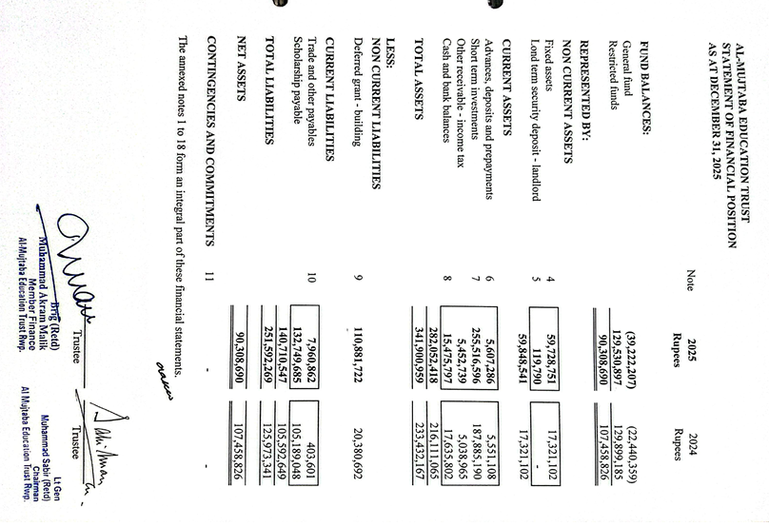

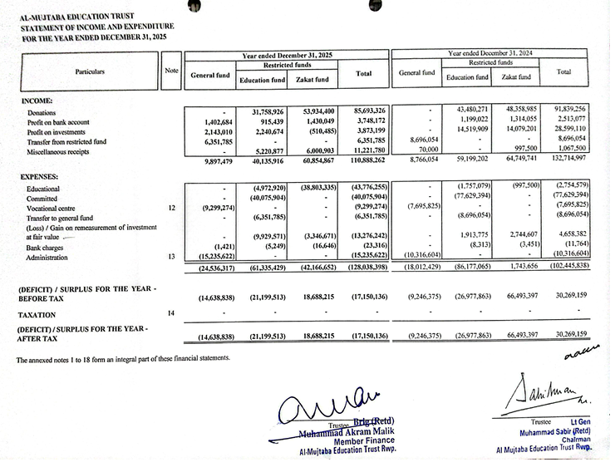
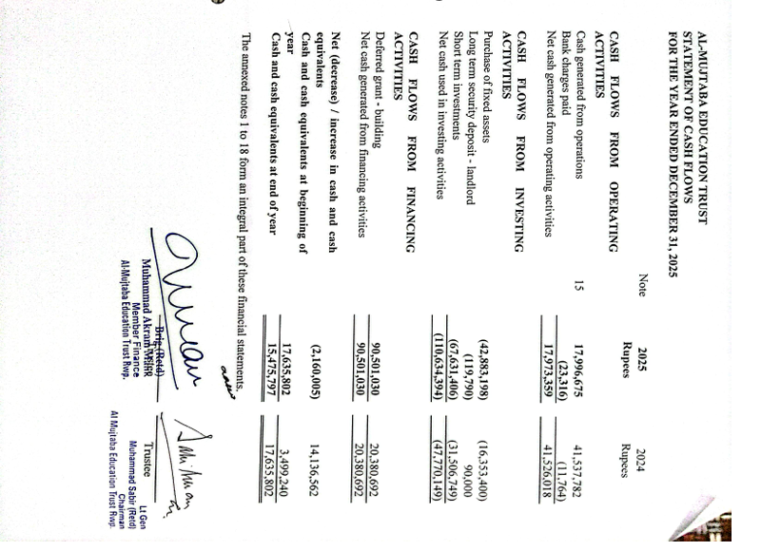
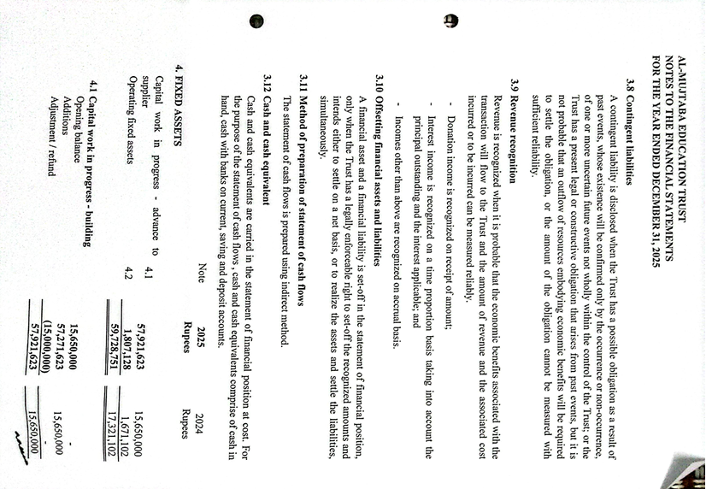
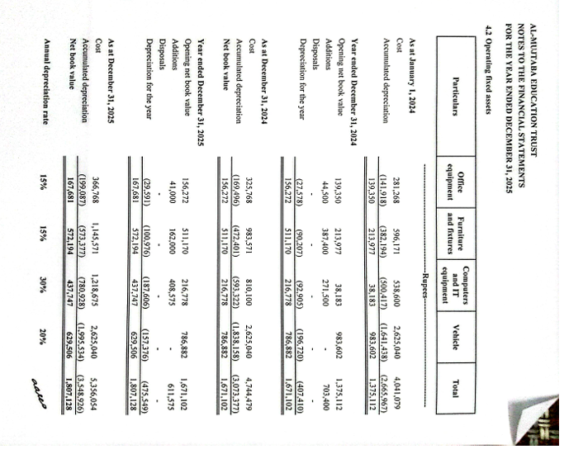
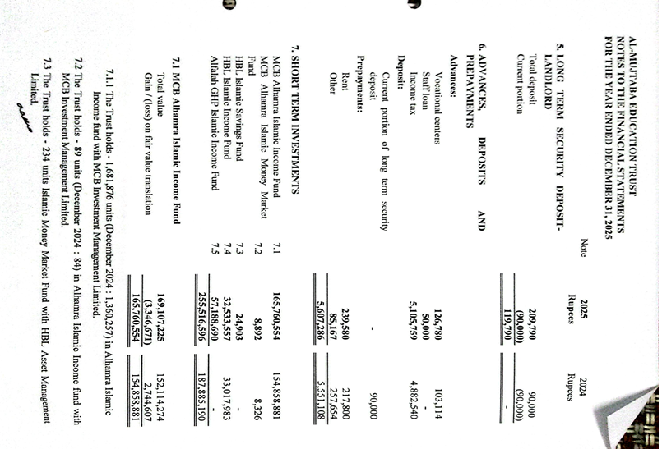
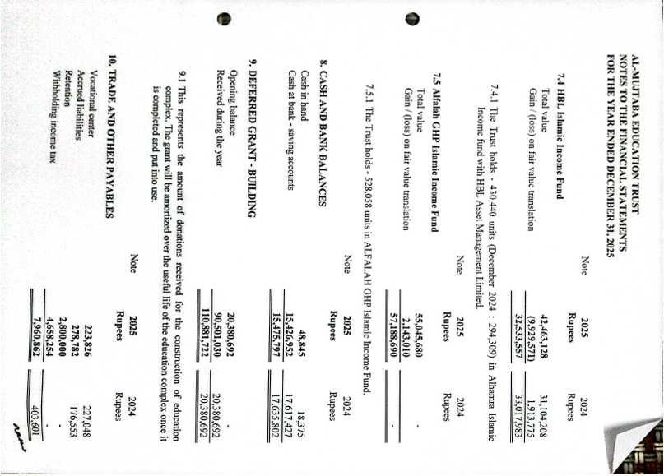
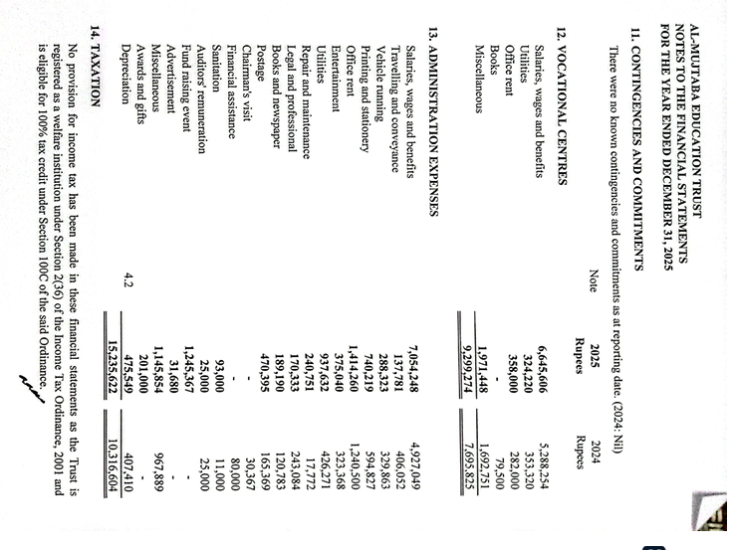
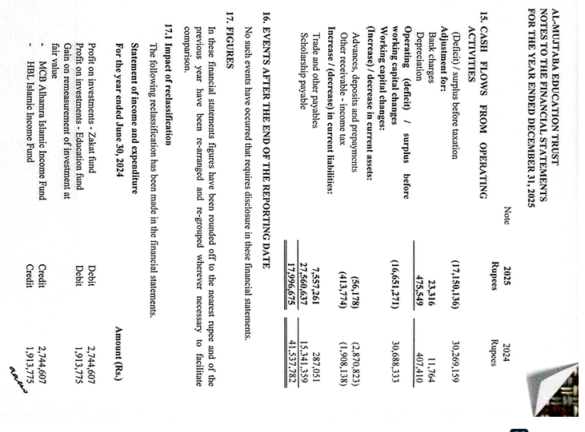
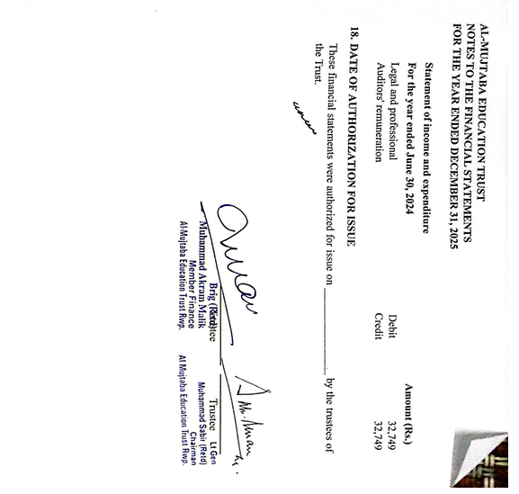

Annex C
TAX EXEMPTION CERTIFICATE
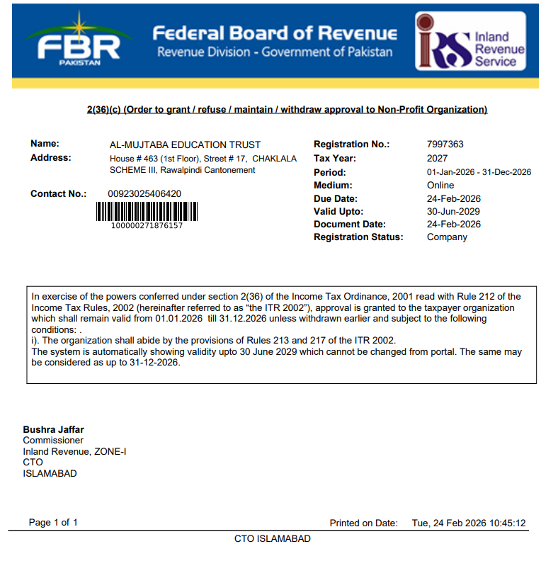
Annex D
PCP CERTIFICATE

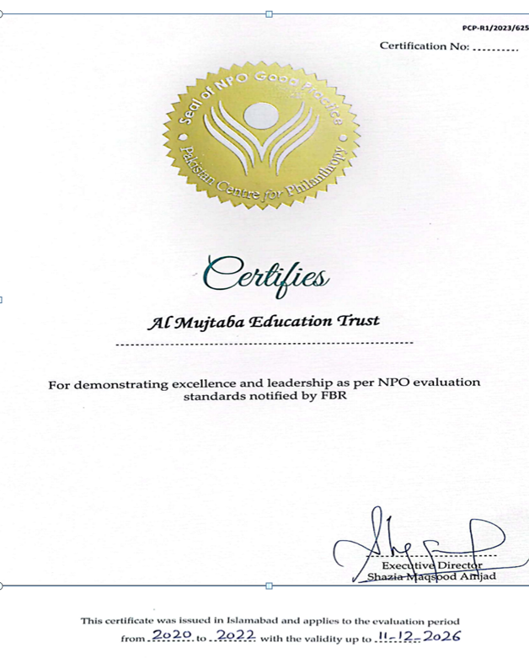

Annex E

MAJOR EVENTS/VISITS - 2025
Serial Date Event
1. 4 Feb 2025 - Lecture to AMET members on “Prevention of Heart Diseases” by Dr Farzana Hashmi.
2. 24 Feb - Fund Raising Dinner at Lahore.
3. 25 Feb - Fund Raising Dinner at Sialkot.
4. 4 Mar - Visit to Trust by Mr Adnan Sarwar Cheema.
5. 6 Mar - Visit to Trust by Mr. Mushtaq Aanwar Ch and a briefing to him about Education Complex.
6. 11 Mar - Executive Committee Meeting - 1/25.
7. 19 Mar - Visit to Trst by Mr Tariq Rafi.
8. 17 Apr - Visit to Trust by Mr. Umar S/O Ishaq Saqi.
9. 17 Apr - Visit to Trust by Mr.Tariq Dawaiwala.
10. 22 Apr - Board of Trustees Meeting - 1/25.
11. 25 Apr - Visit of a delegation led by Mr. Qaisar Shaikh, Federal Minister, along-with following:-
  - Senator, Lt Gen Abdul Qayyum, Retd.
b. Sardar Waheed Samroo, MNA.
c. Raja Najabat Hussain, UK.
d. Mr. Shahzada Hayat, UK.
e. Ch. Liaqat Ali, ex Mayor Wathaston.
f. Ch. Shaukat Ali, British Muslims Friends of Labour
g. Malik Muhammad Habib Khan, Retd IG Police/ Former Caretaker Interior Minister.
h. Syed Shan Hussain, Property Investor.
i. Ch Amjad.
12. 29 Apr - MOU signing with FFC (Sona Welfare Foundation).
13. 13 May - Foundation Laying Ceremony of AMET Education Complex at DHA, Rawallpindi.
14. 29 May - Executive Committee Meeting - 2/25.
15. 27 Jun - Visit by QMG to AMET and a briefing about Education Complex.
16. 9 Jul - Visit by Senator Azam Swati.
17. 12 Jul - Fund Raising Dinner at Karachi.
18. 24 Jul - Executive Committee Meeting - 3/25.
19. 20 Aug - Certificate Awarding Ceremony - VC Rera (Bagh).
20 22 Aug - Certificate Awarding Ceremony - VC Chawali (Chakwal).
21. 23 Aug - Certificate Awarding Ceremony - VC Sillanwali (Sargodha).
22. 26 Aug - Certificate Awarding Ceremony - VC Baffa (Mansehra)
23. 28 Aug - Certificate Awarding Ceremony - VC Mandra (Rawalpindi)
24. 28 Aug - Executive Committee Meeting - 4/25.
25. 28 Aug - Commencement of work at AMET Educational Complex.
26. 30 Aug - Certificate Award Ceremony - VC Khabeki (Khushab).
27. 09 Sep - Certificate Award Ceremony - VC Jewra (Kahuta).
28. 23 Sep - Board of Trustees Meeting - 2/25.
29. 23 Sep - Following new Trustees were inducted in BOT 2/25:-
a. Brig Dr. Rukhsana Khizer, Retd.
b. Brig Dr. Samia Irum, Retd.
c. Brig Dr. Hafiz Habib Ullah Shah, Retd.
30. 30 Sep - Call on President Centaurus Gp by Patron, Chairman & Member Special Proj.
31. 7 Oct - Executive Committee Meeting - 5/25.
32. 14 Oct - Col Ahsin Jahangir, Retd, joined as Trustee.
33. 21 Oct - Executive Committee Meeting - 6/25.
34. 28 Oct - Executive Committee Meeting - 7/25.
35. 11 Nov - Executive Committee Meeting - 8/25.
36. 02 Dec - Visit of Brig Javed Baig and Col Riffat for AMET Office Rent Agreement.
37. 09 Dec - Visit of Nawab Sarfraz Sial, Col Asad Hadri, Col Malik Mehmood Ur Rasheed.
38. 16 Dec - Col Asad Haidri, Retd, joined as Trustee.
39. 16 Dec - Board of Trustees Meeting - 3/25.
40. 31 Dec - Certificate Award Ceremony, 2nd half 2025 - VC Sillanwali (Sargodha).

Annex F
AMET VOCATIONAL CENTERS
(Certificate Awarding Ceremonies 2025)
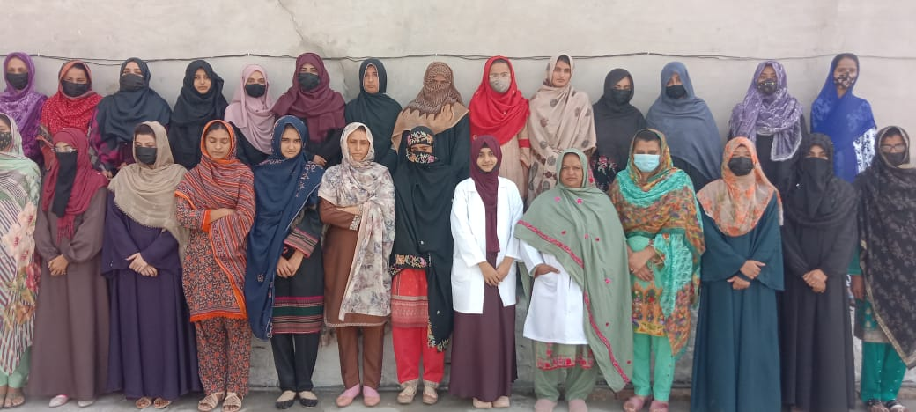
Vocational Centre Sillanwali (Sargodha) - 23 Aug 2025
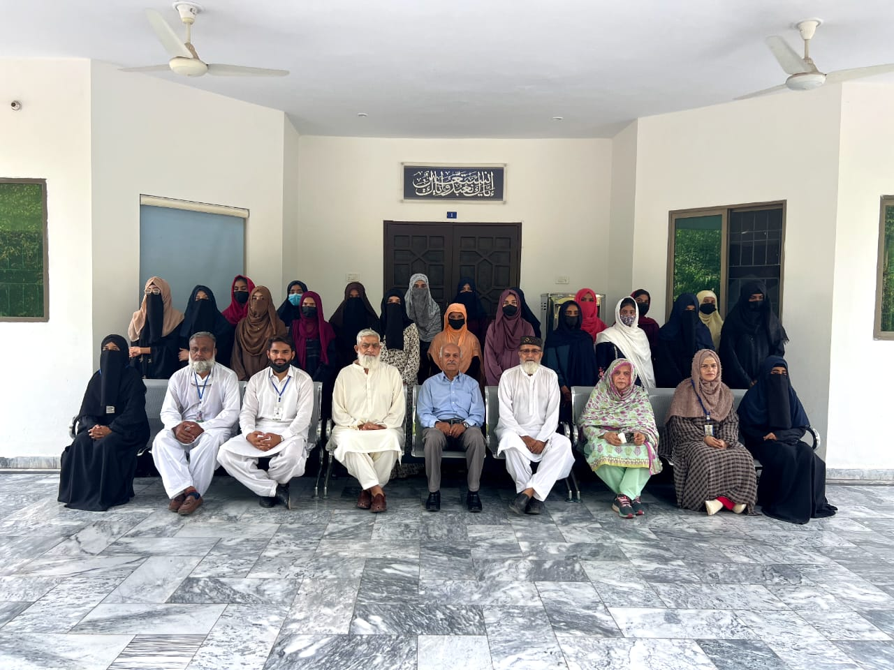
23 Aug 2025

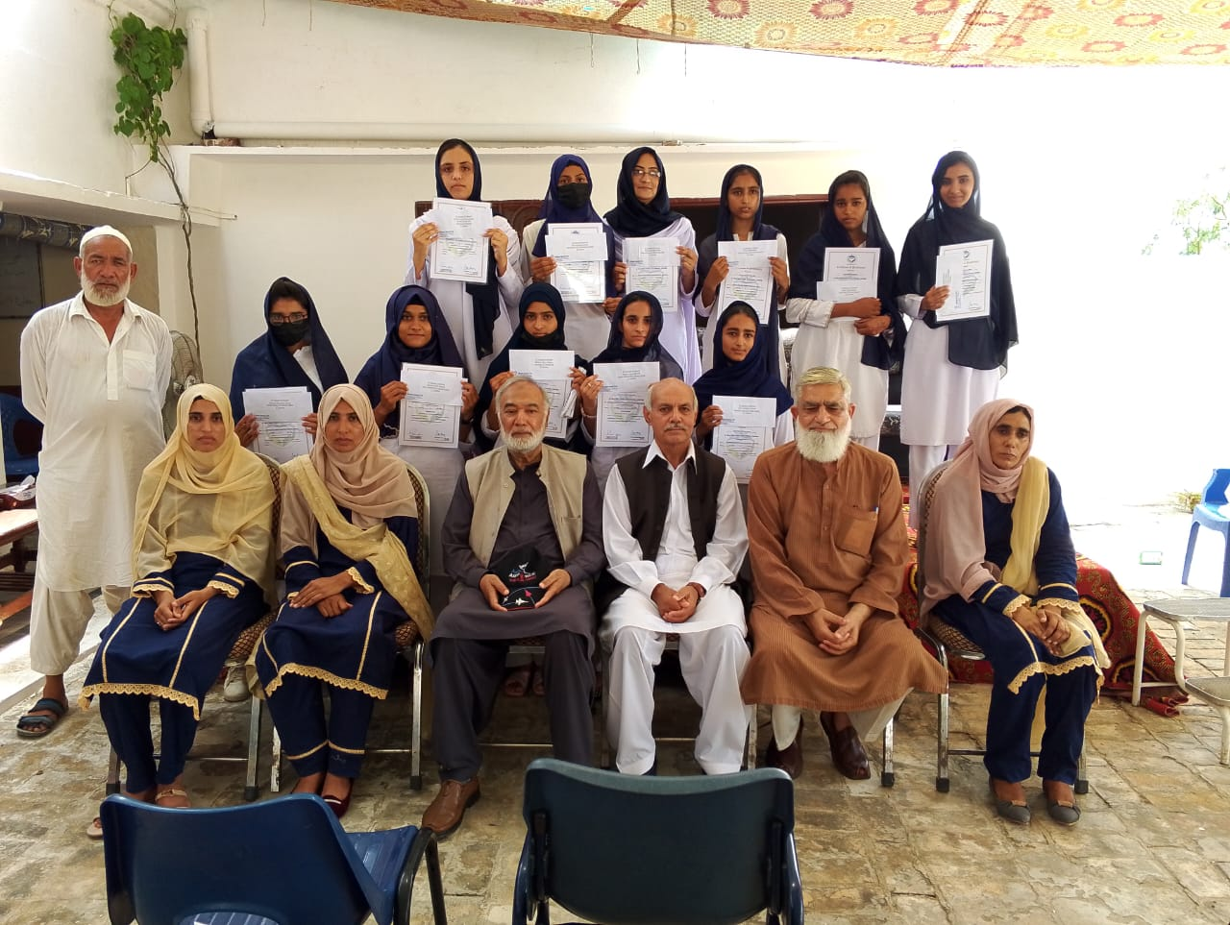
Vocational Centre Chawali (Chakwal) - 22 Aug 2025
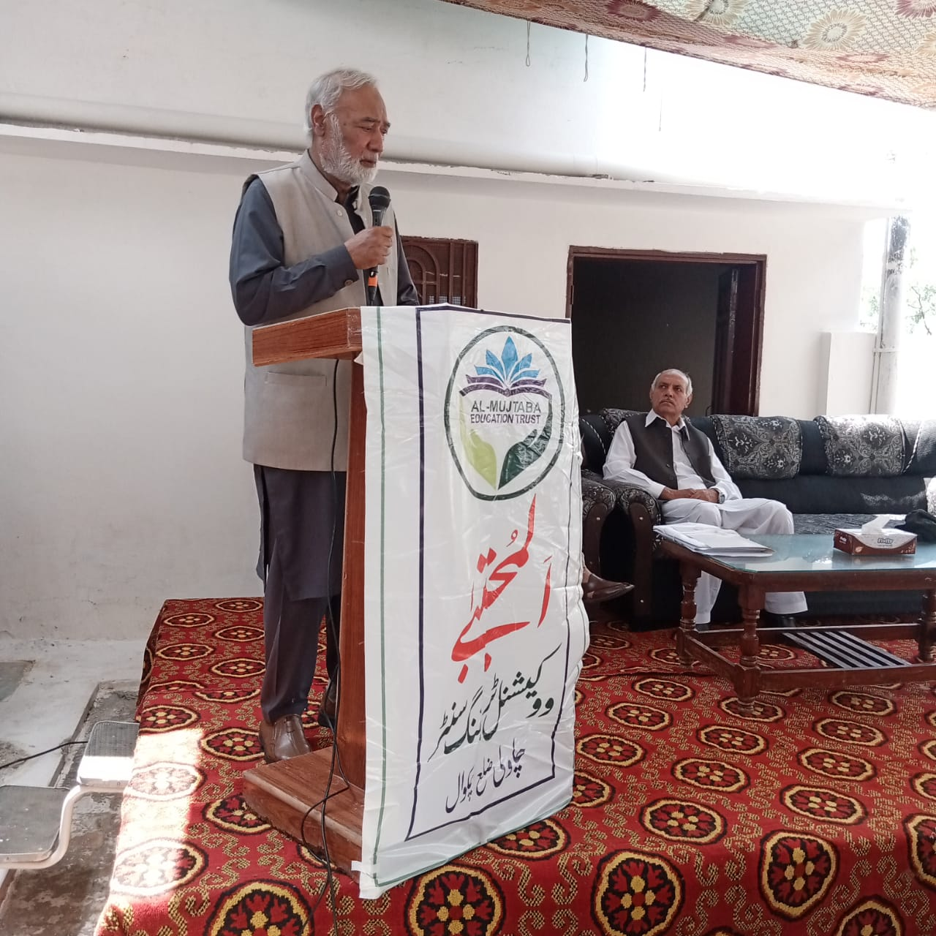
22 Aug 2025
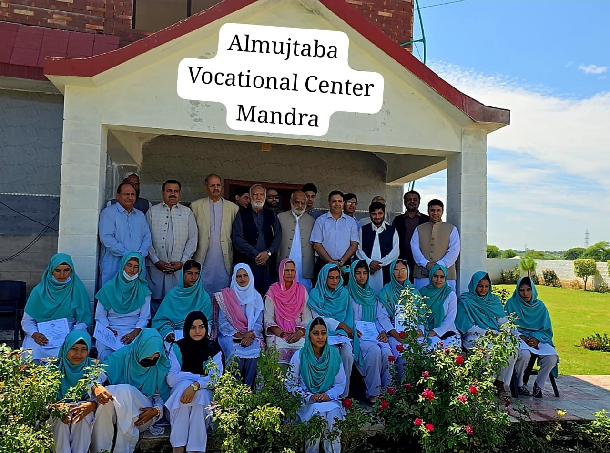
Vocational Centre Mandra (Rawalpindi - 28 Aug 2025
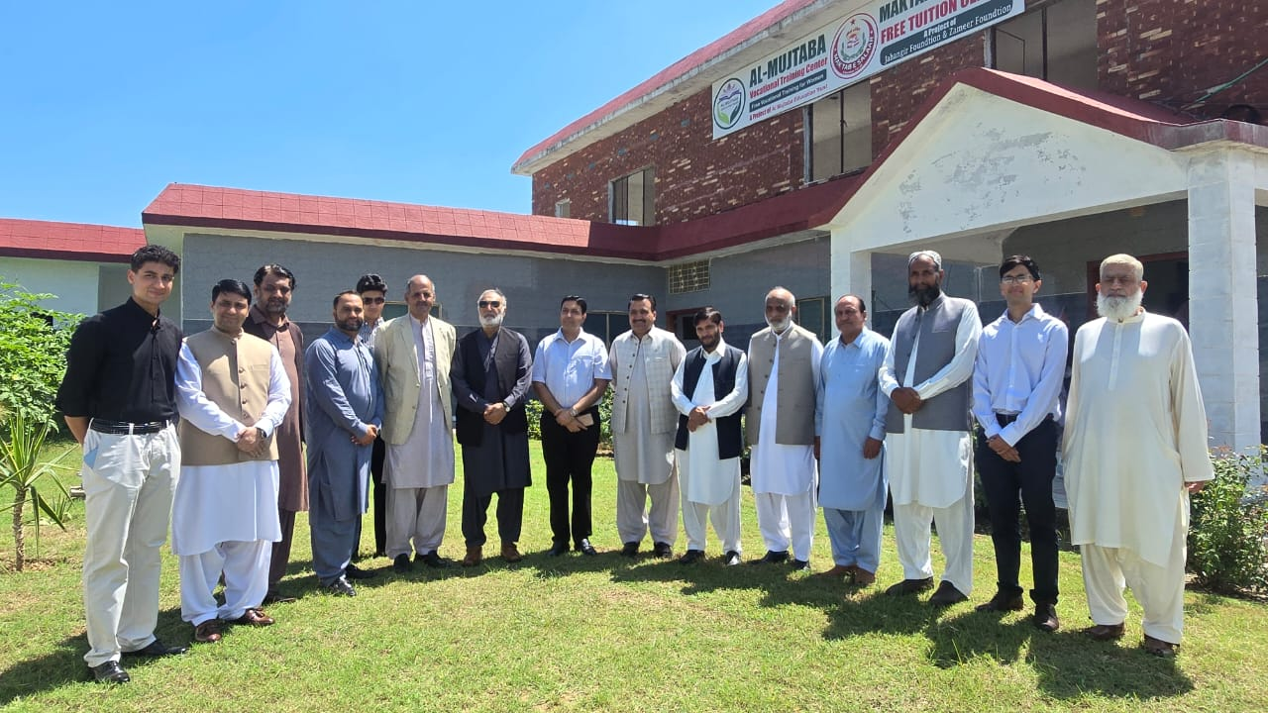
28 Aug 2025

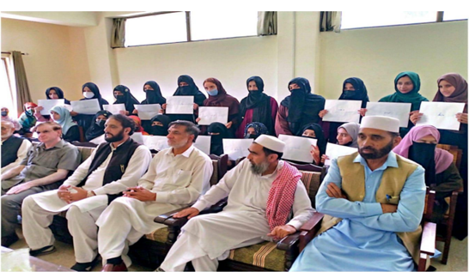
Vocational Centre Rera (Bagh) - 20 Aug 2025
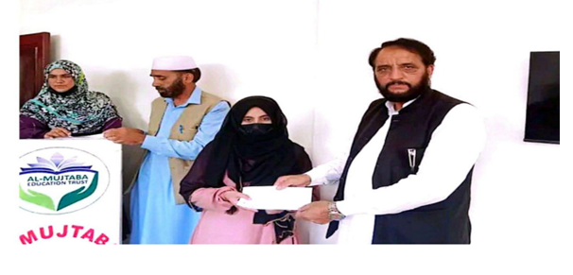
20 Aug 2025

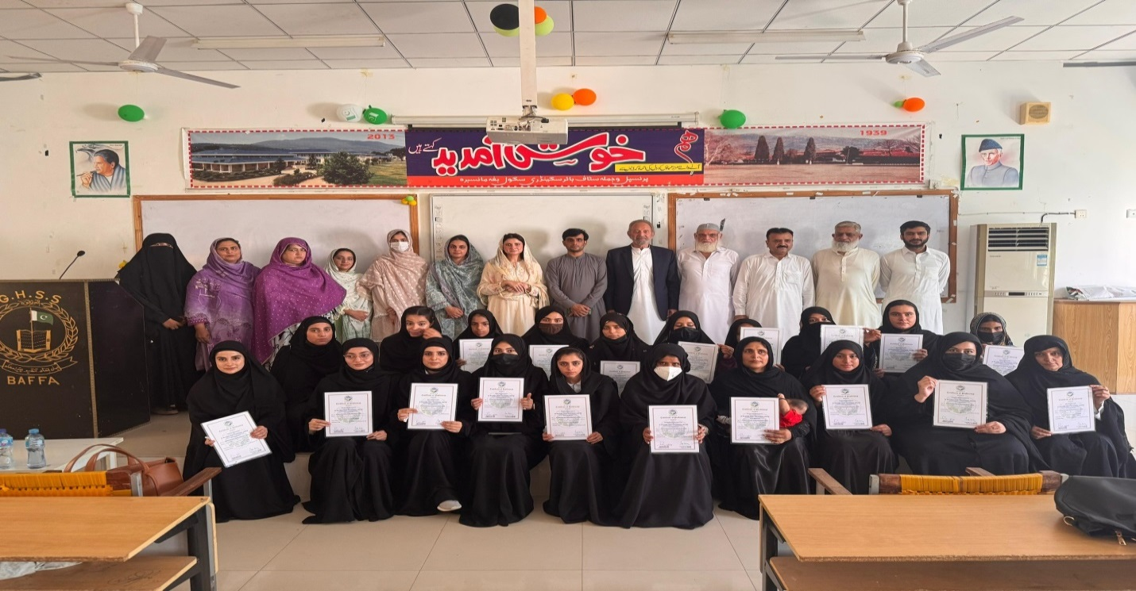
Vocational Centre Baffa (Mansehra) - 26 Aug 2025

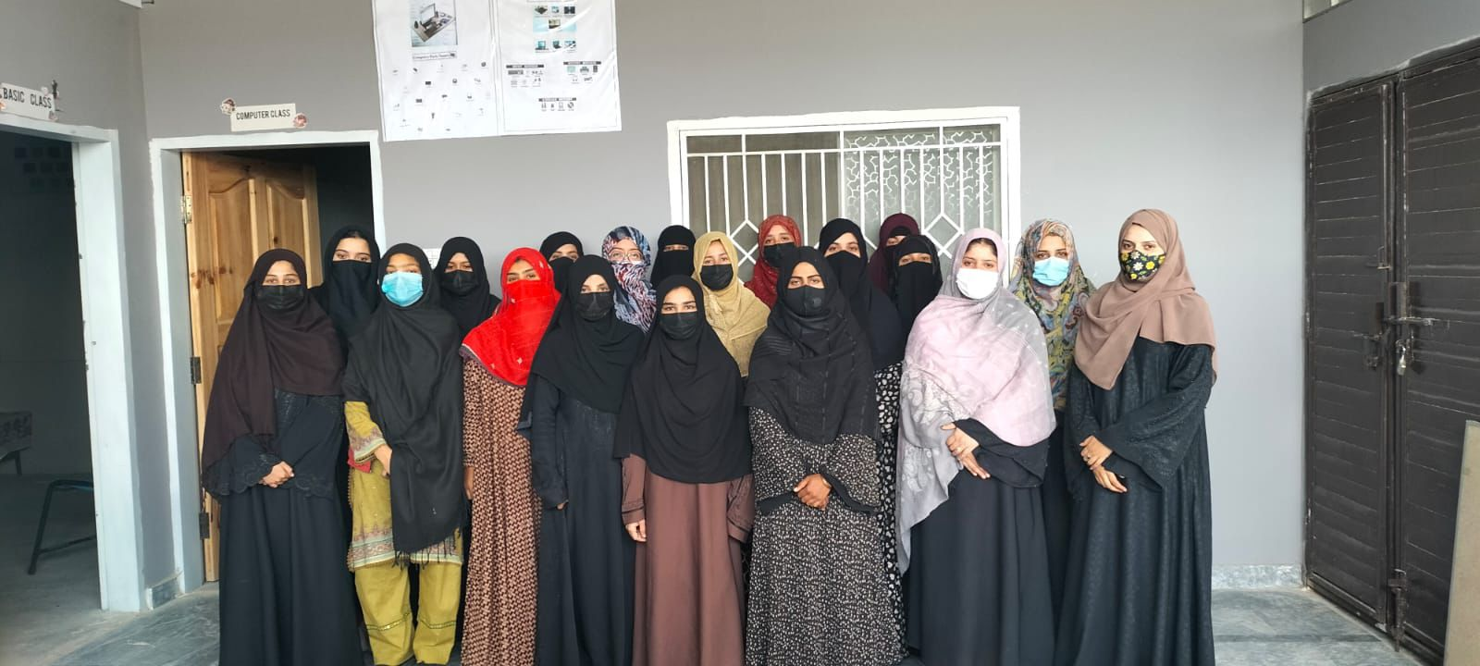
26 Aug 2025

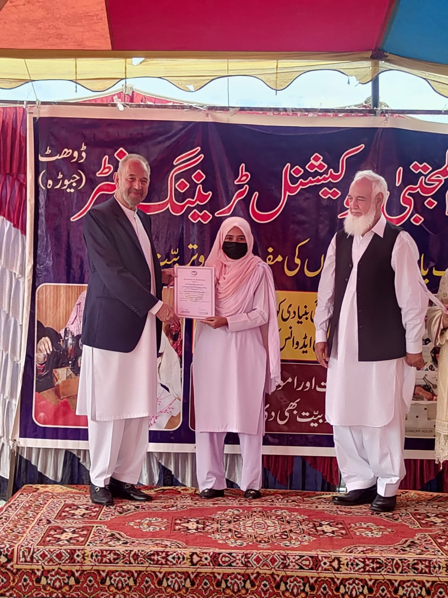
Vocational Centre Jewra (Kahuta) - 9 Sep 2025
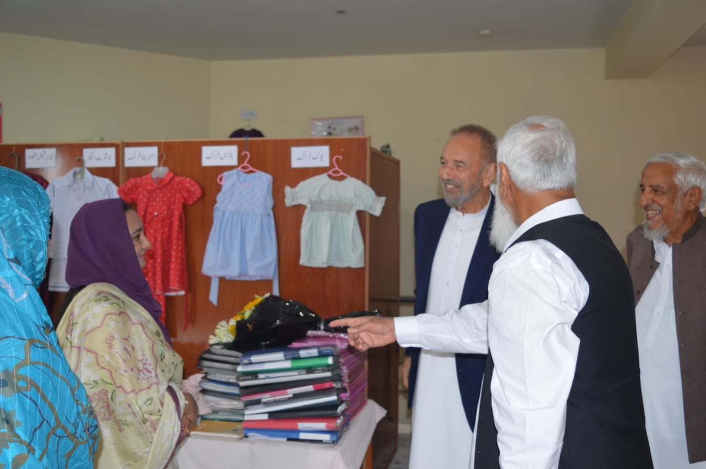
9 Sep 2025
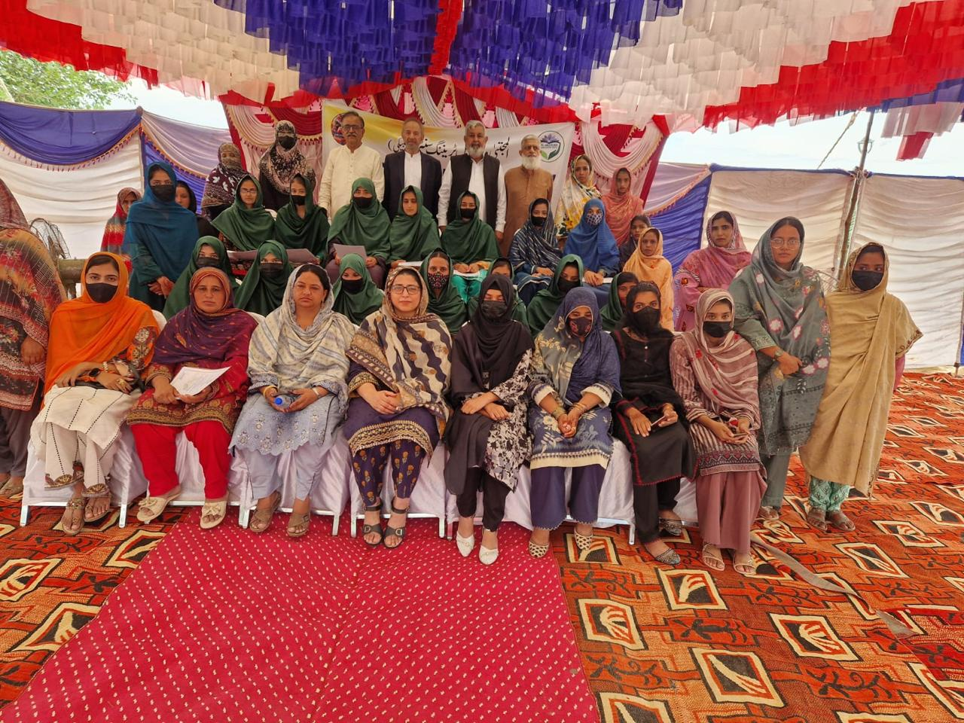
Vocational Centre Khabeki (Khushab) - 30 Aug 2025
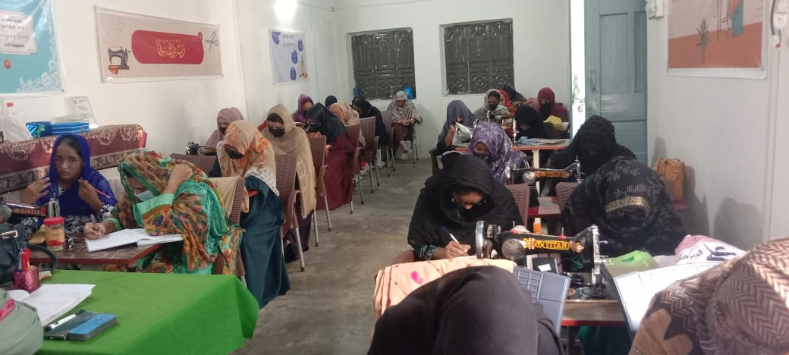
30 Aug 2025

Annex G
FUND RAISING FUNCTIONS
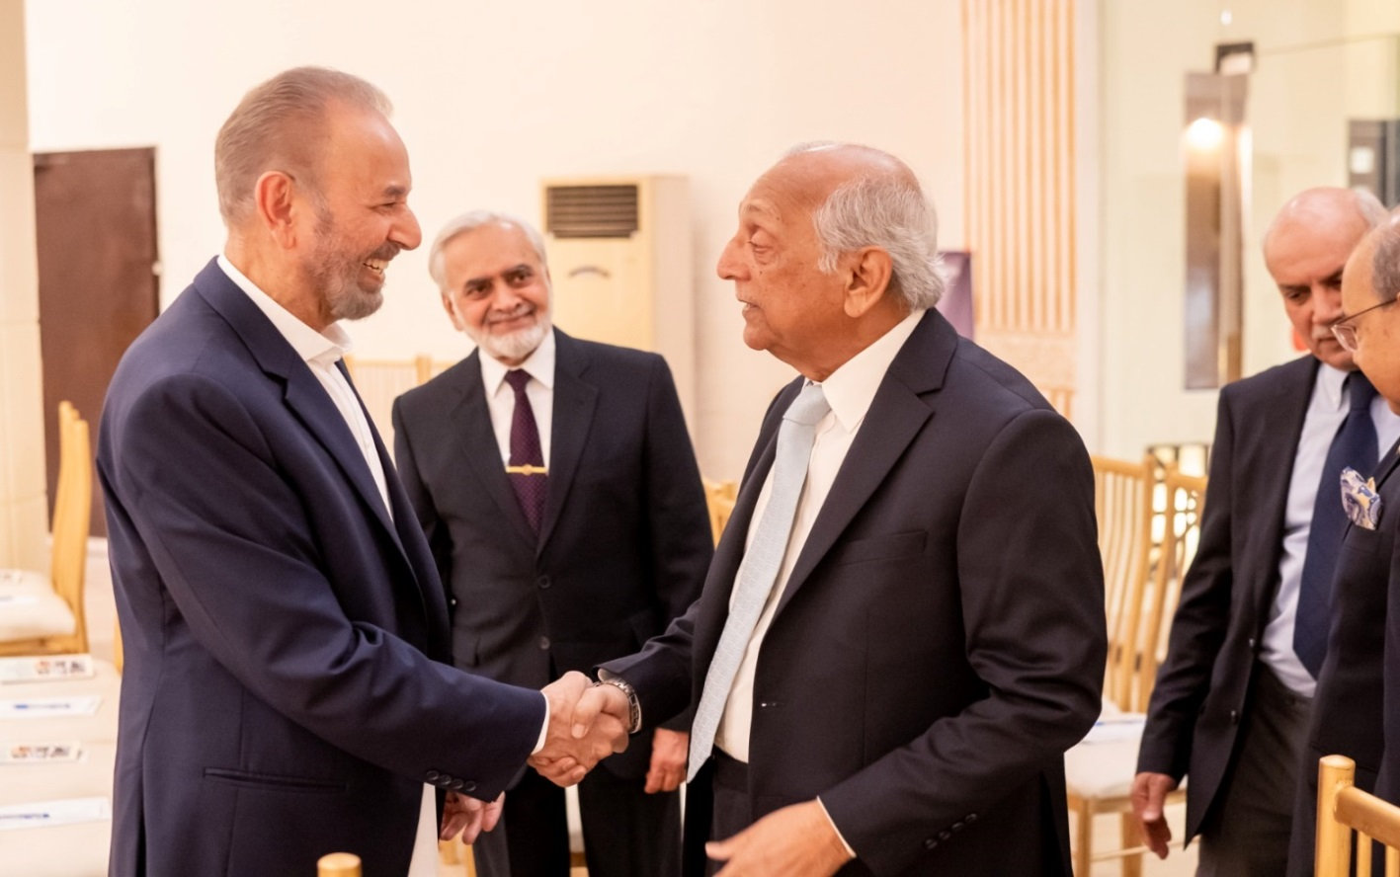
FRF Lahore - 24 Feb 2025
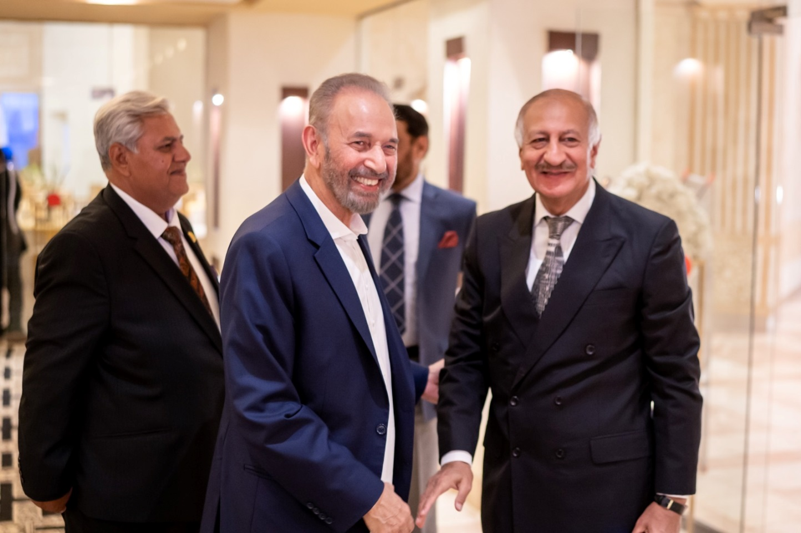
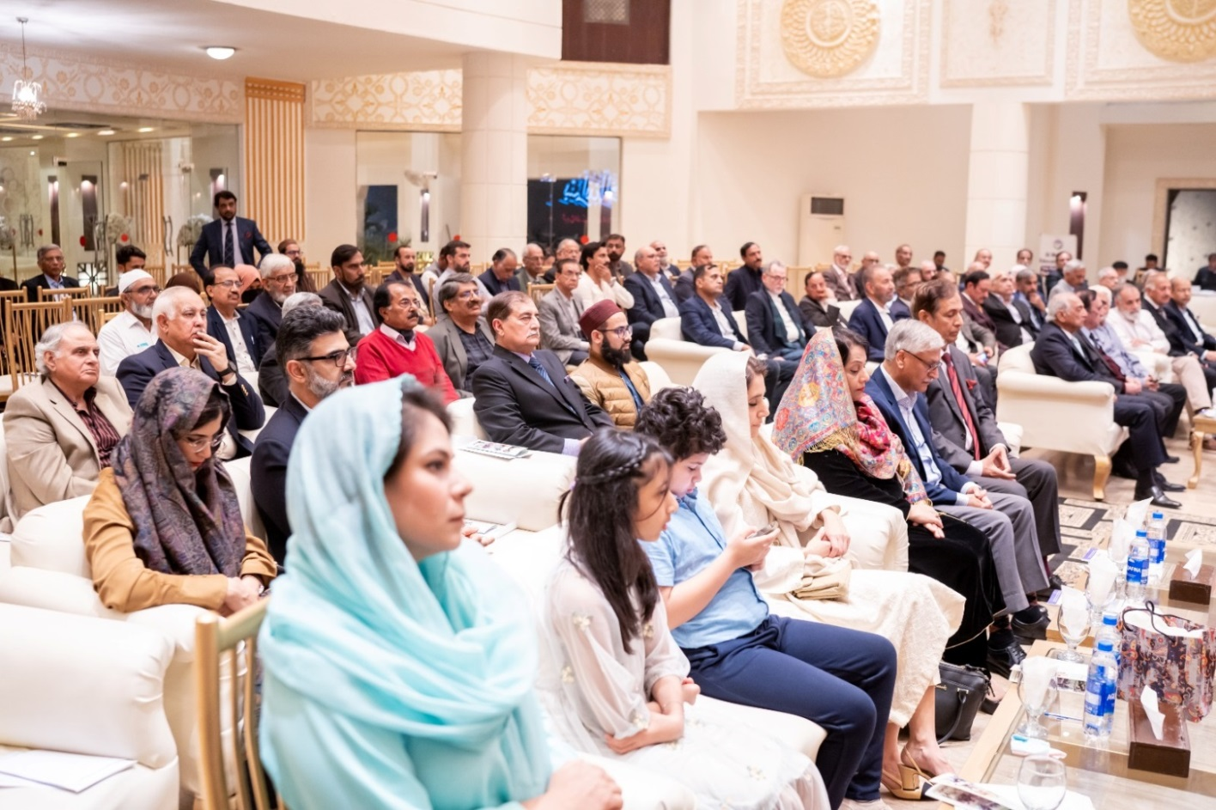
FRF Lahore - 24 Feb 2025

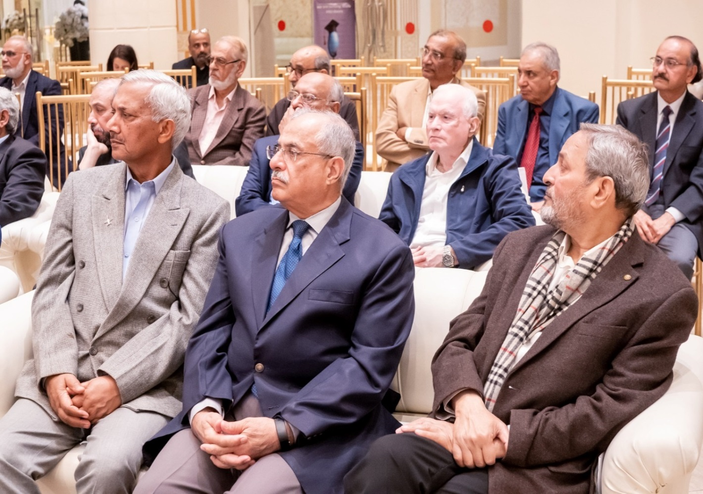

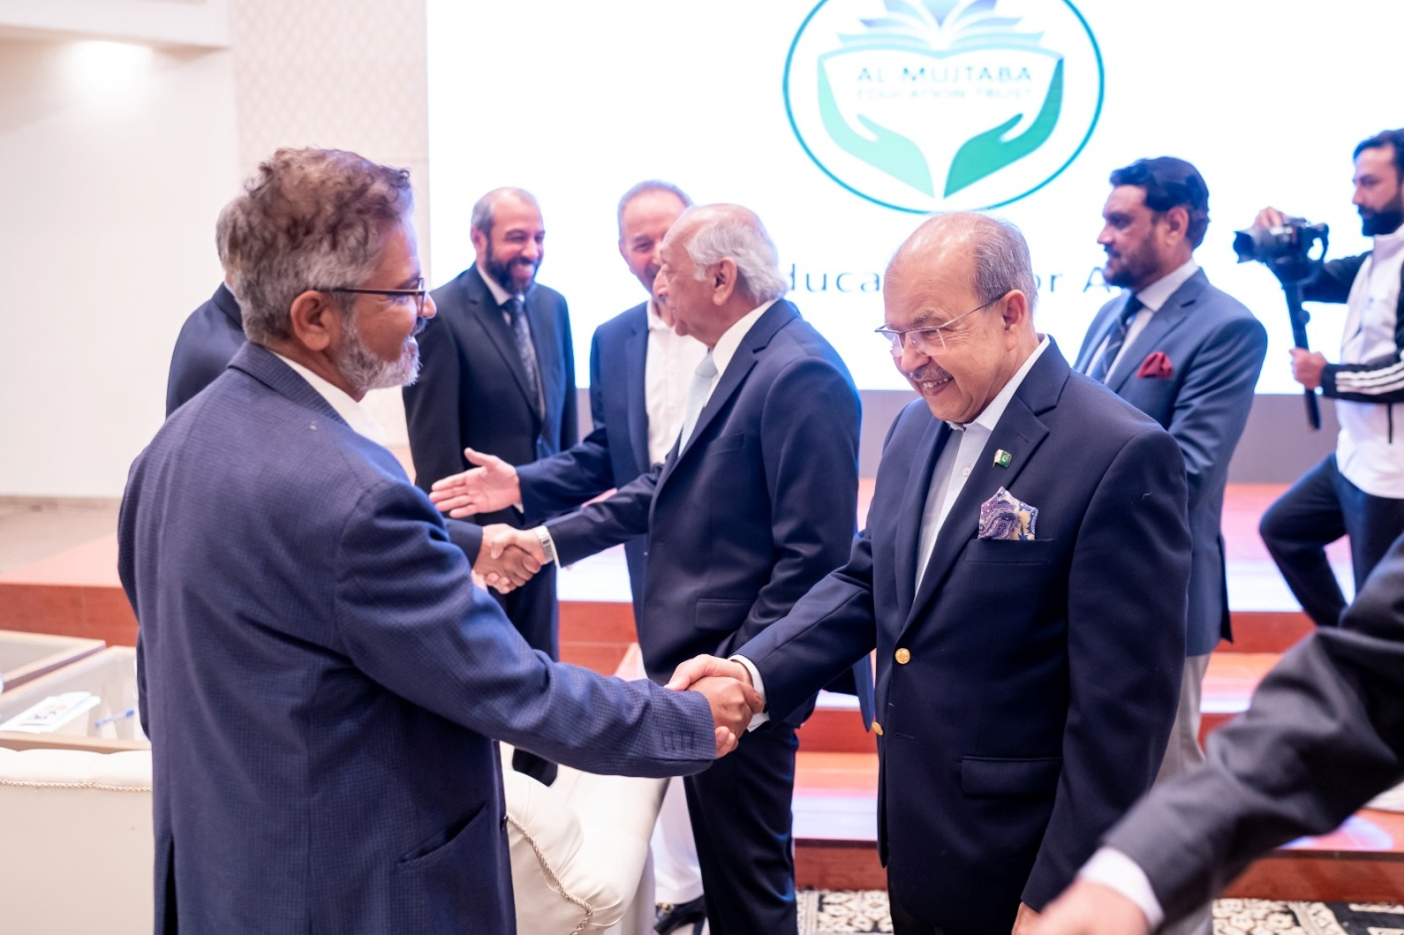
FRF Lahore - 24 Feb 2025
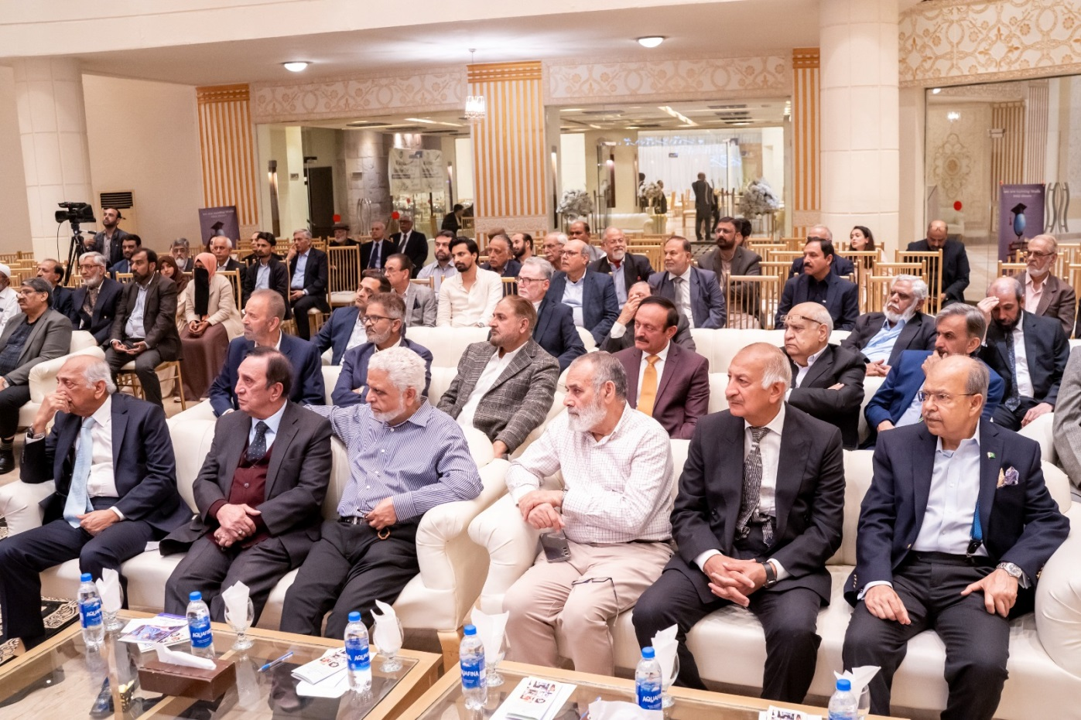

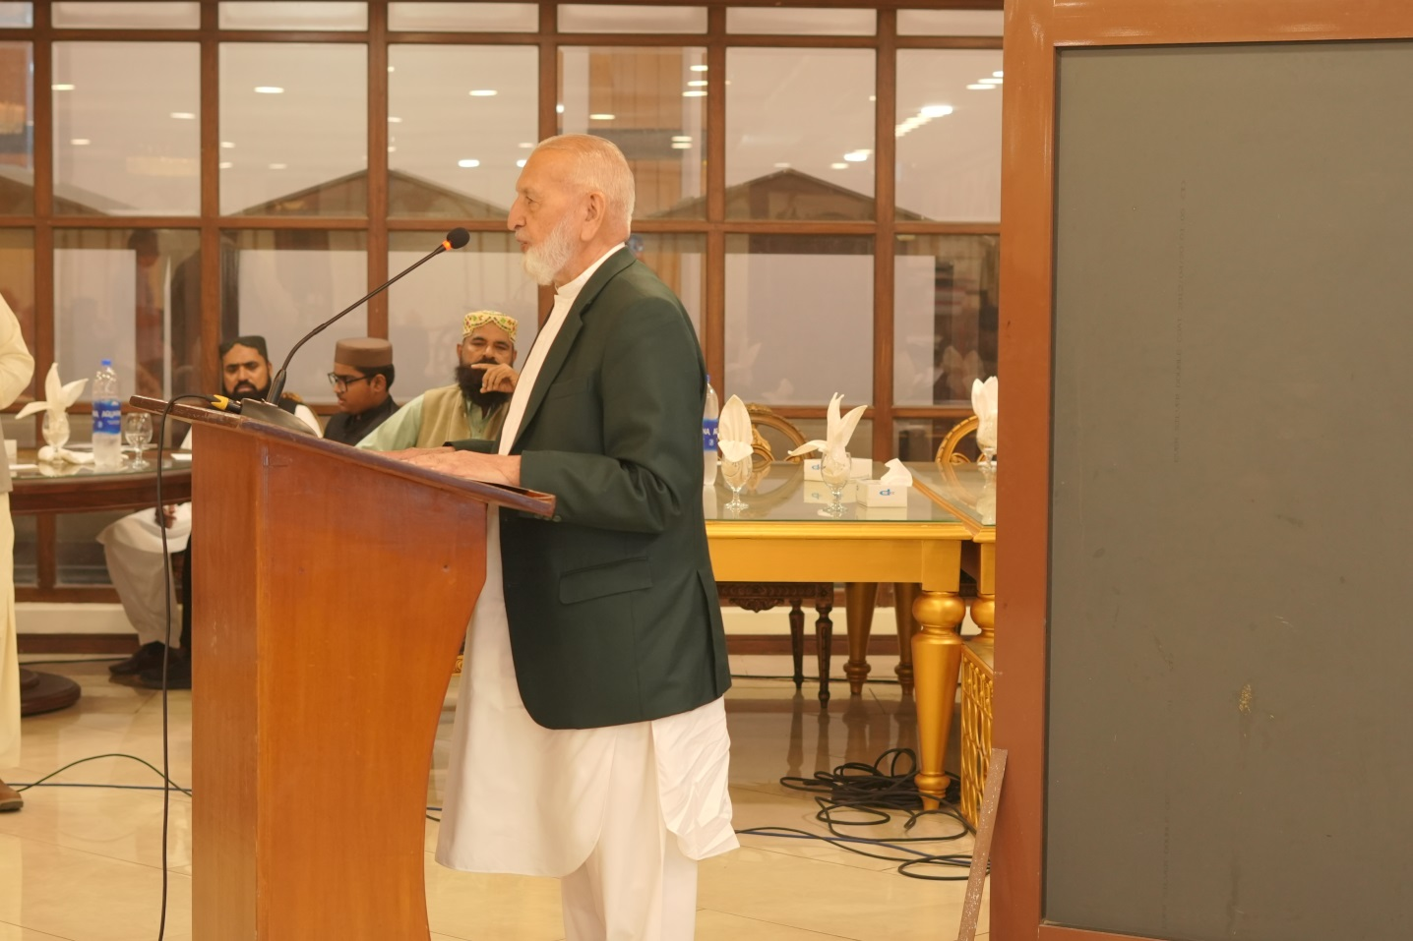
FRF Karachi - 12 Jul 2025
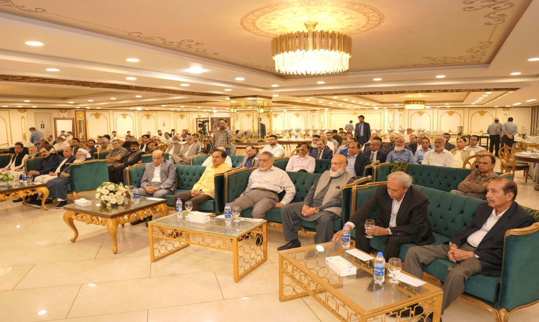
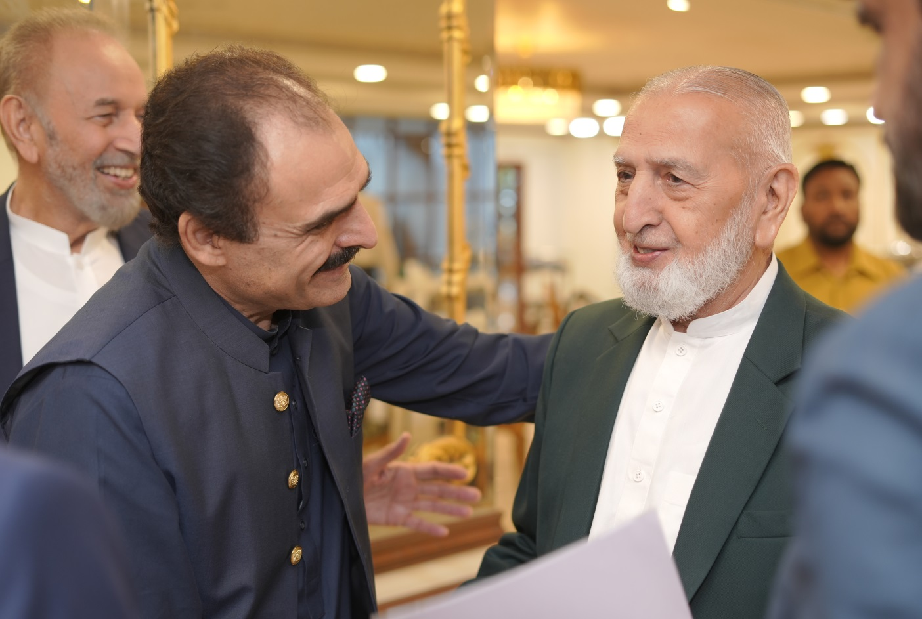
FRF Karachi - 12 Jul 2025
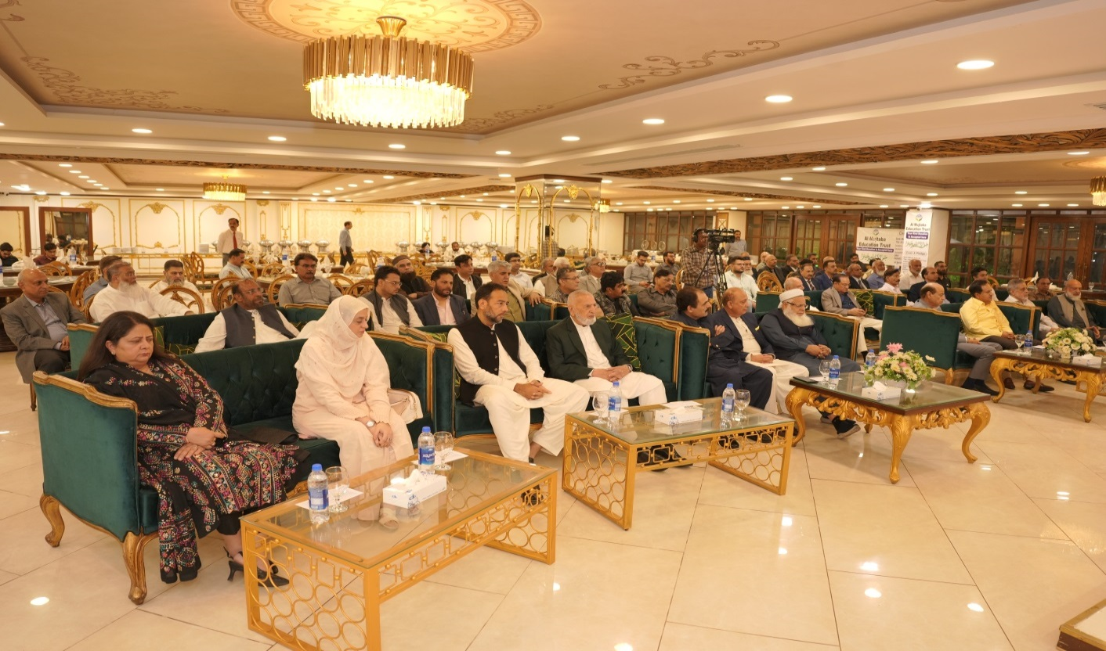

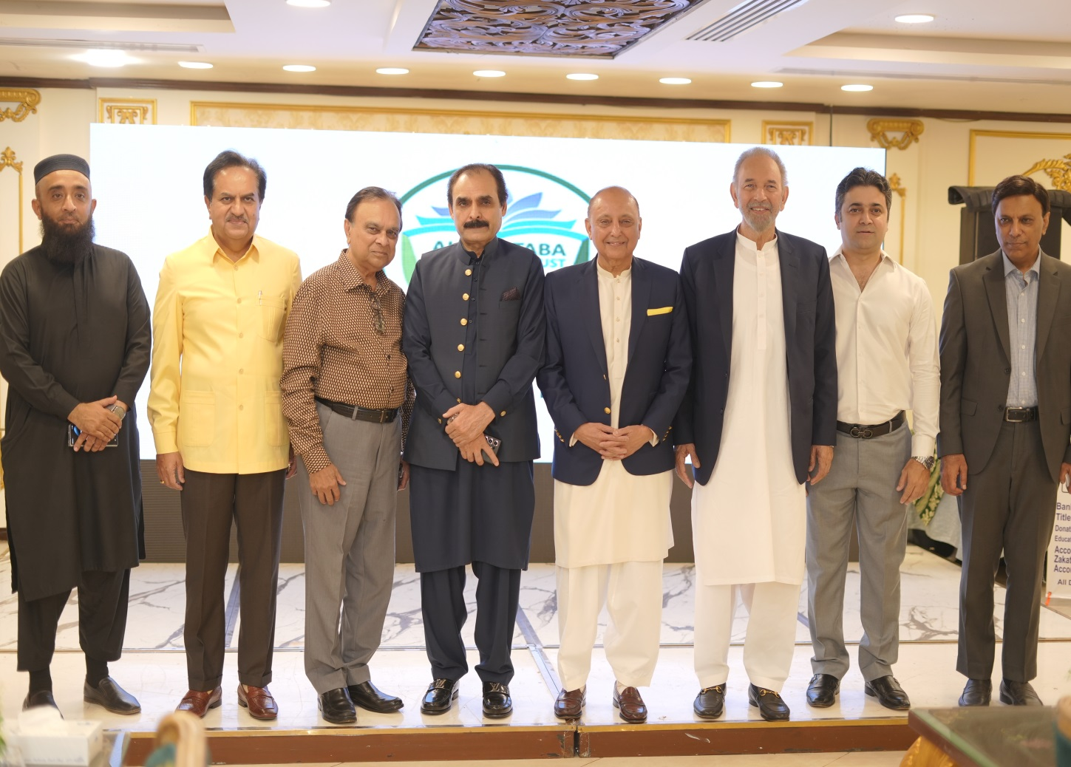
FRF Karachi - 12 Jul 2025
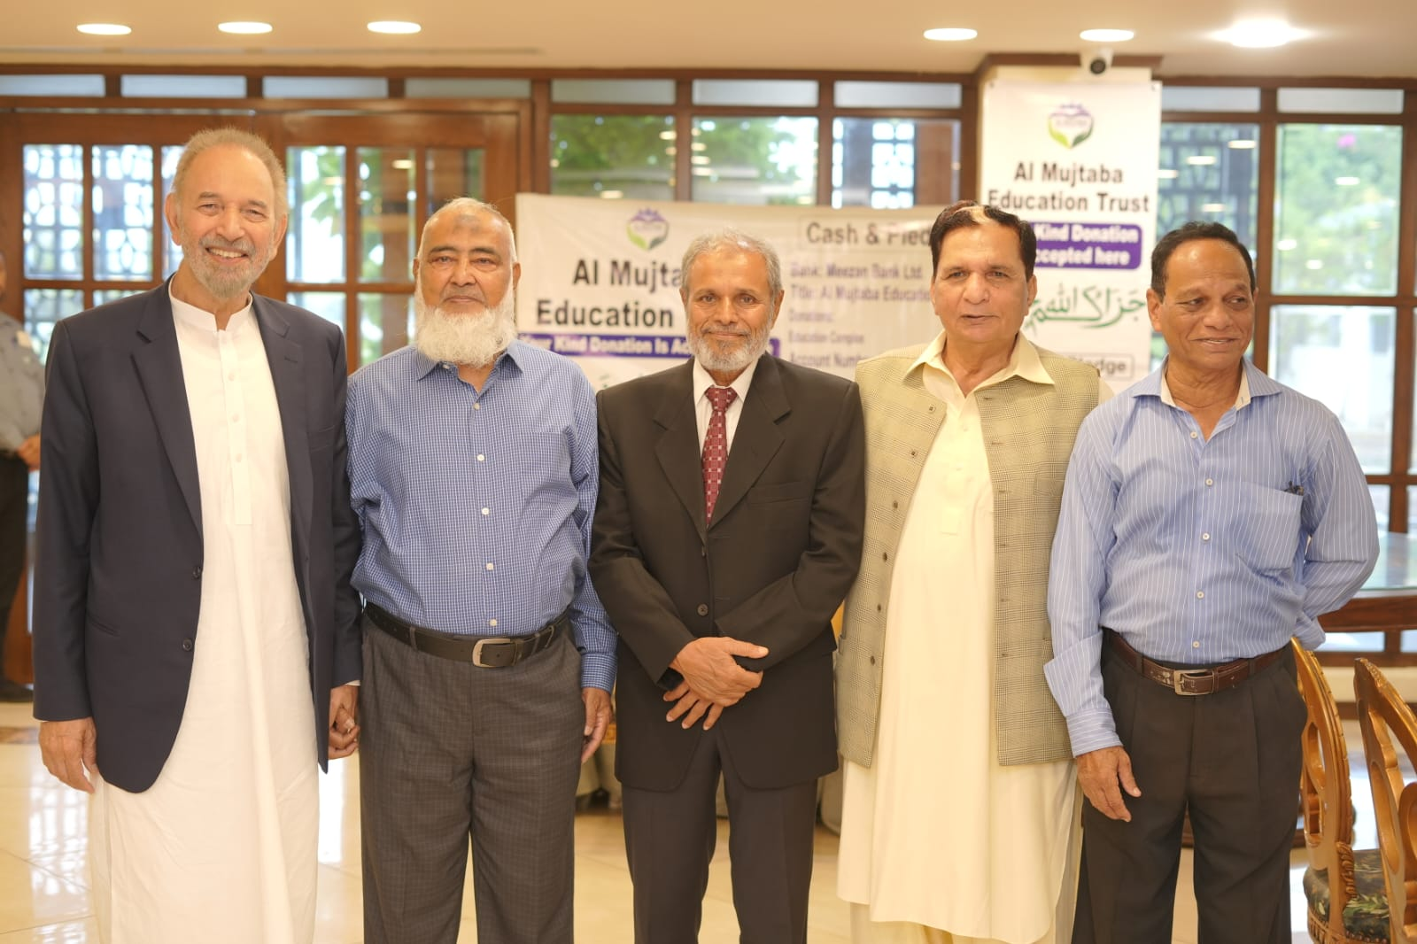

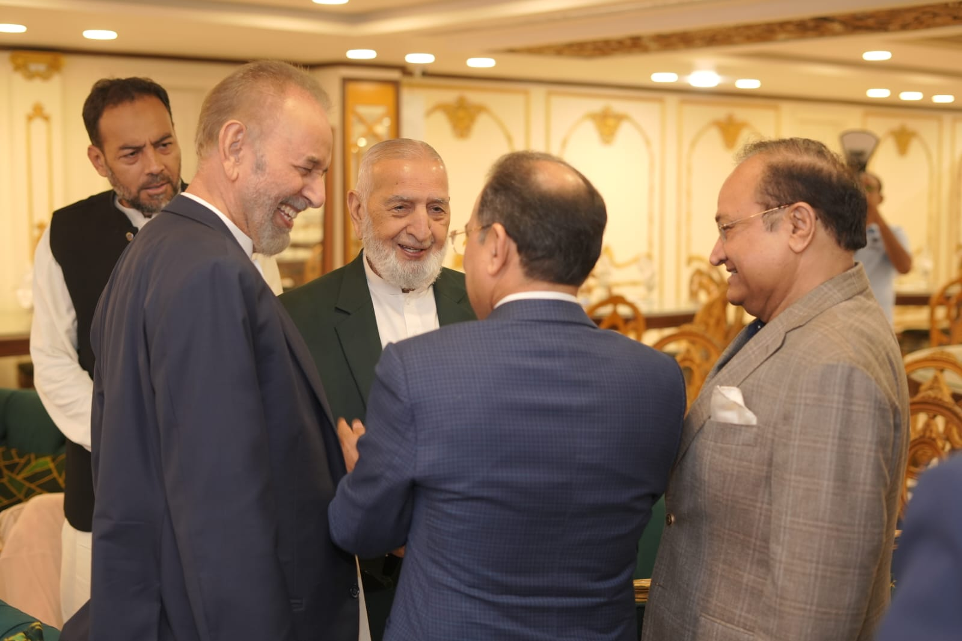
FRF Karachi - 12 Jul 2025
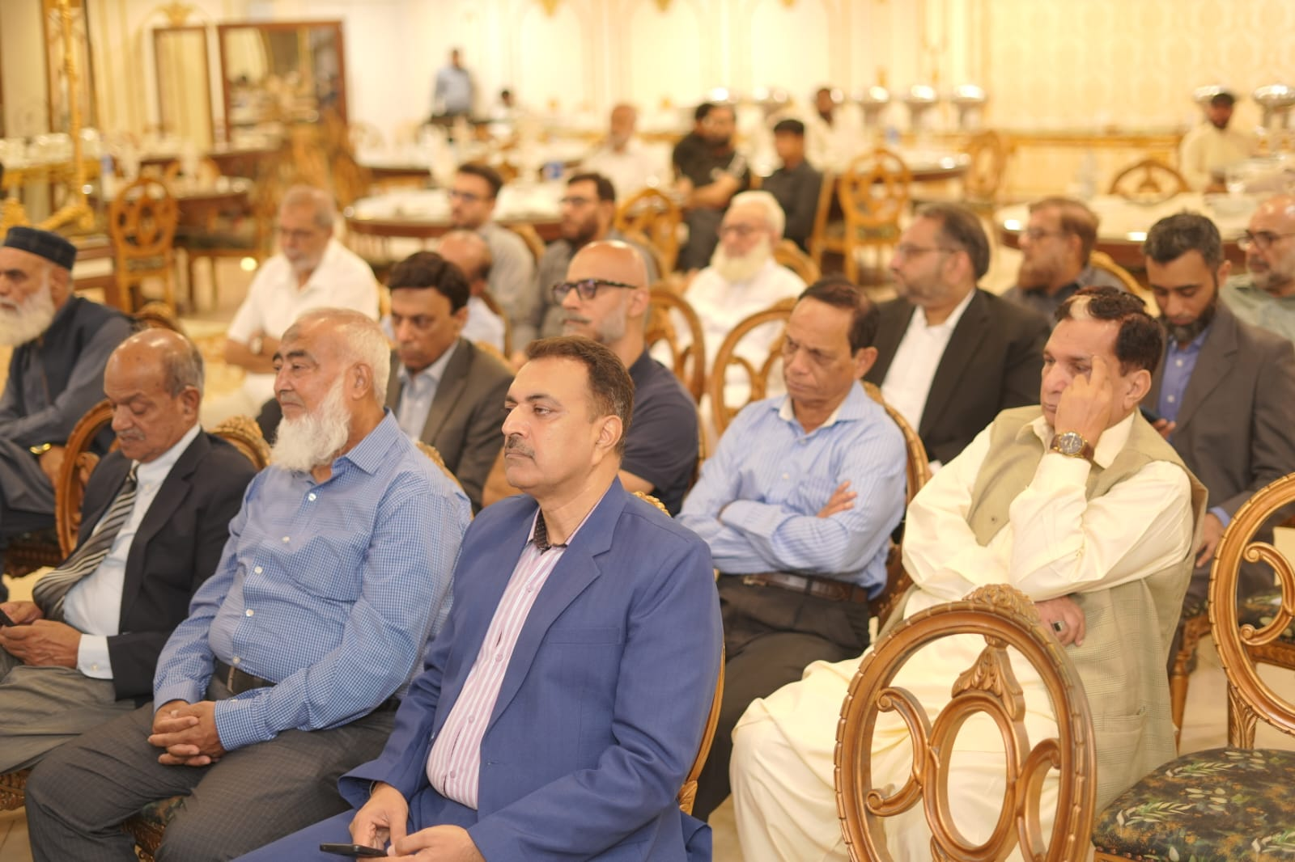
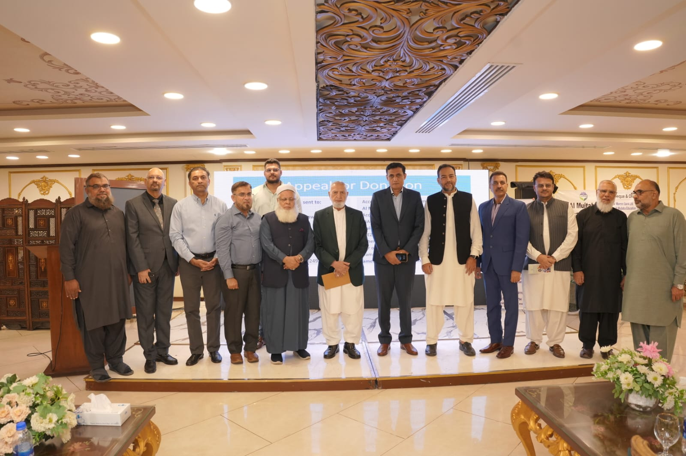
FRF Karachi - 12 Jul 2025
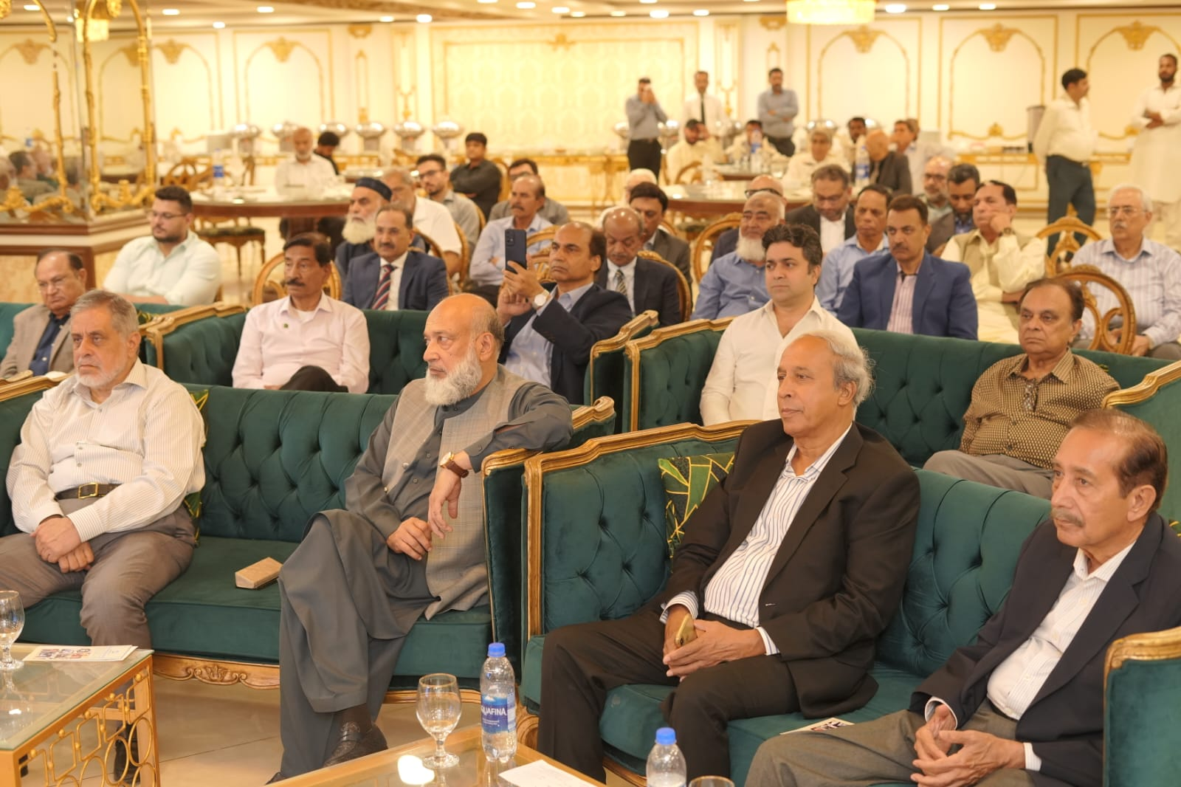

Annex H
AMET EDUCATION COMPLEX (EC)
(Foundation Laying Ceremony (13 May 2025)
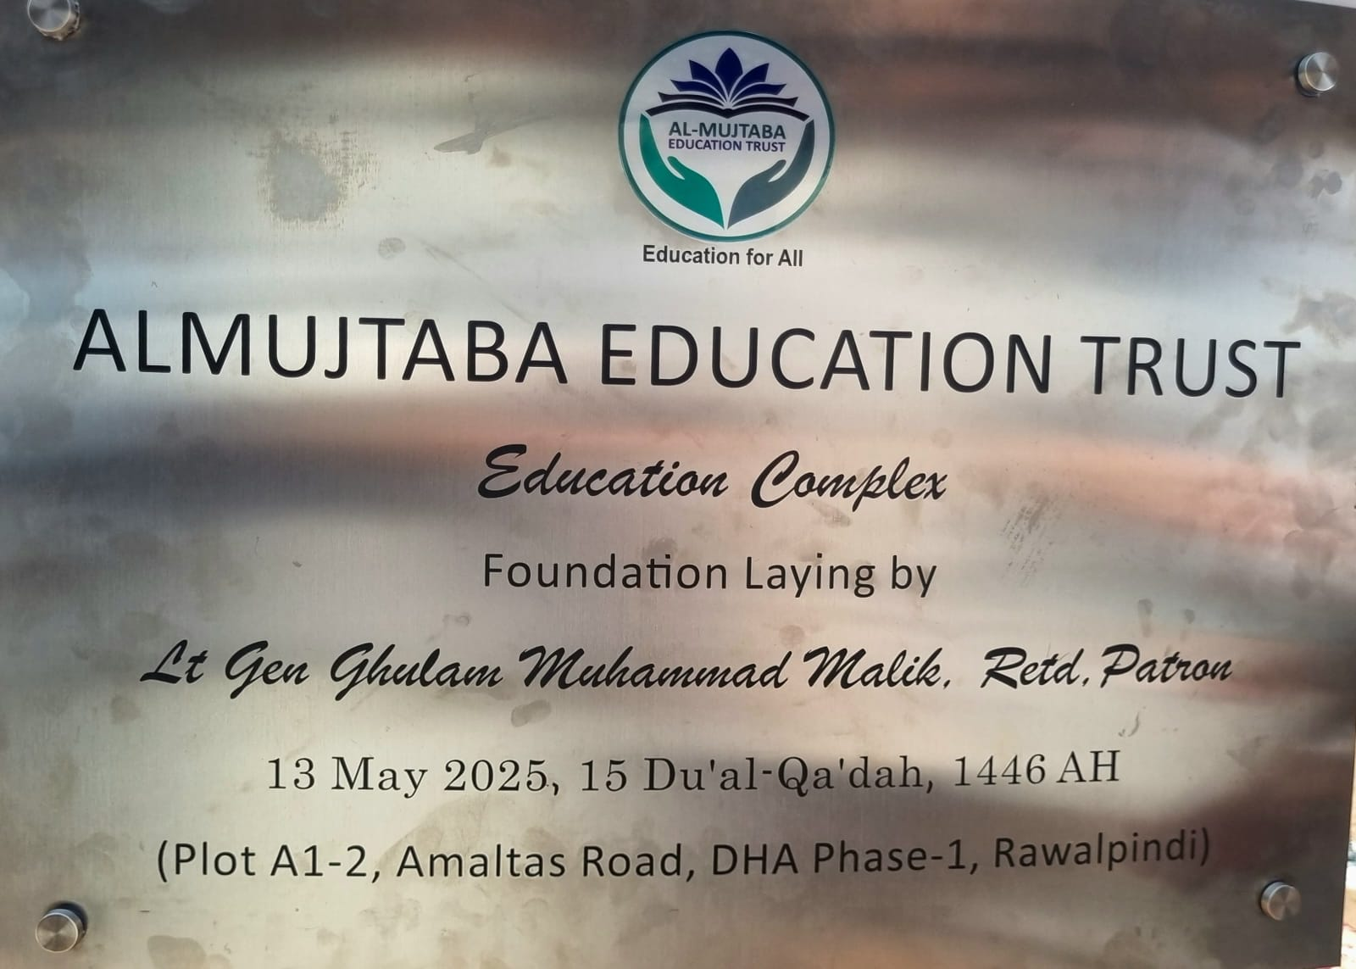

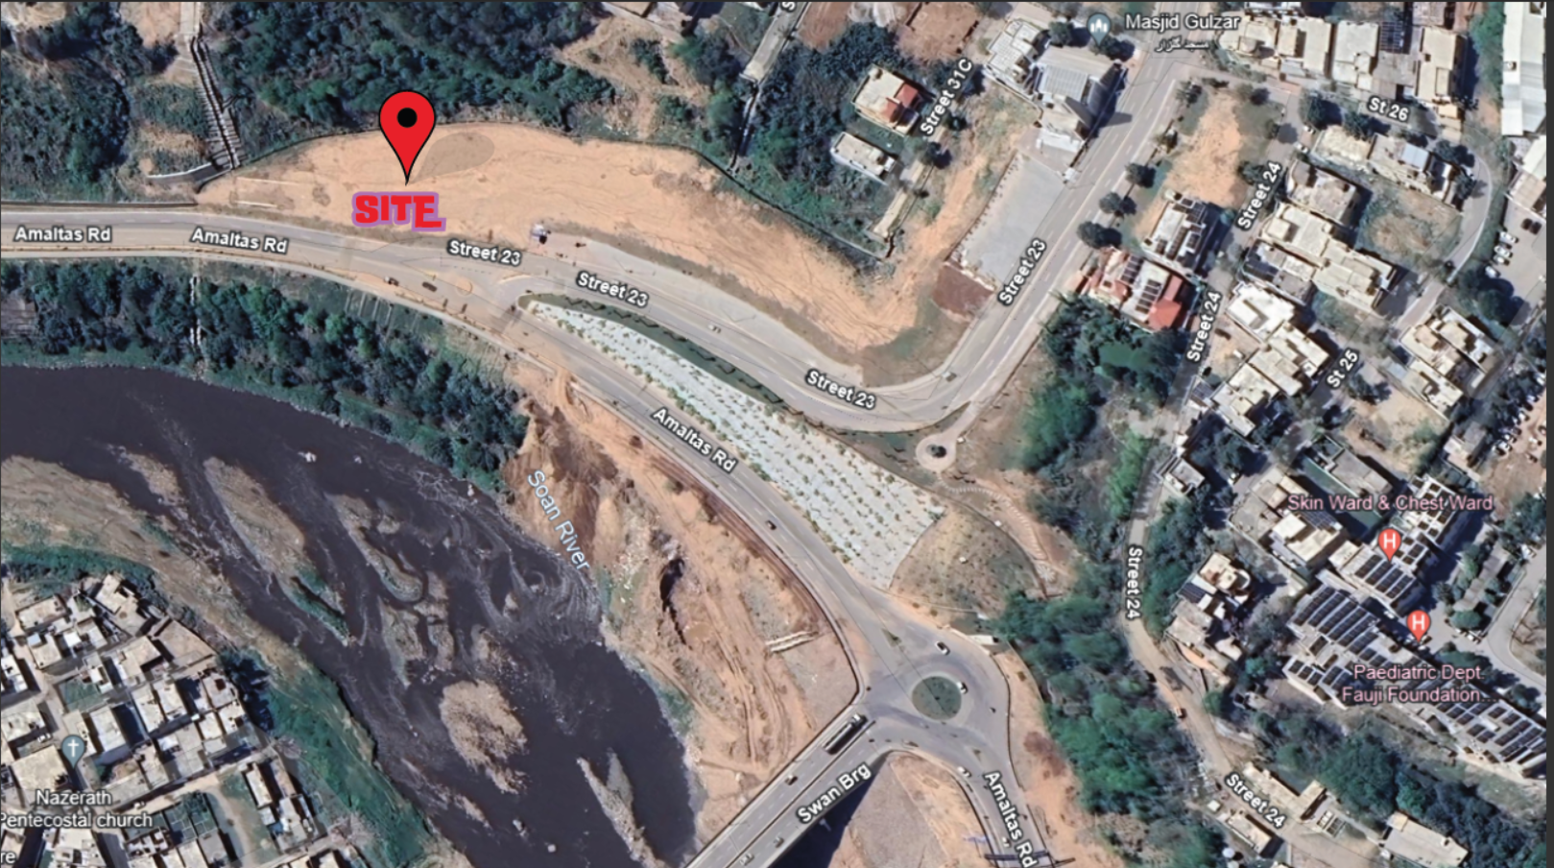

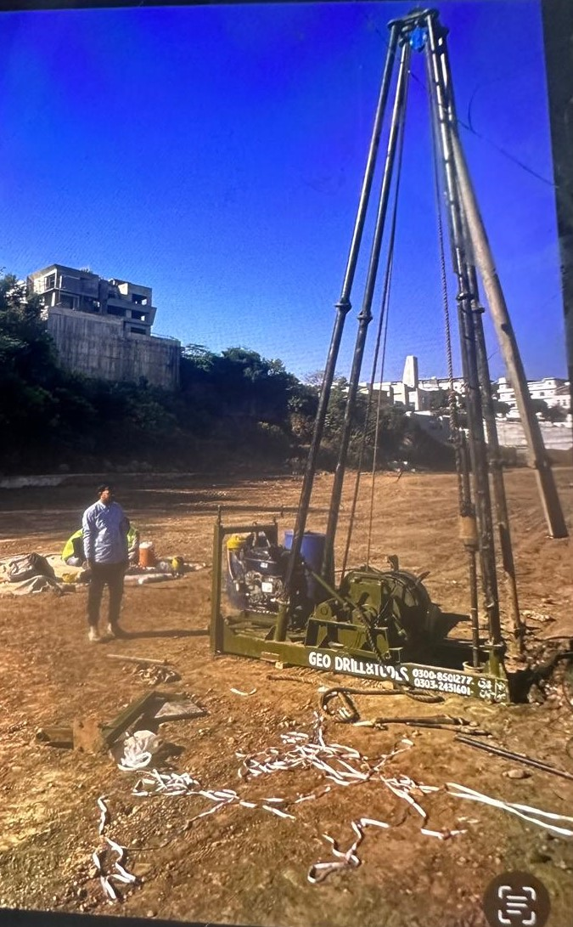

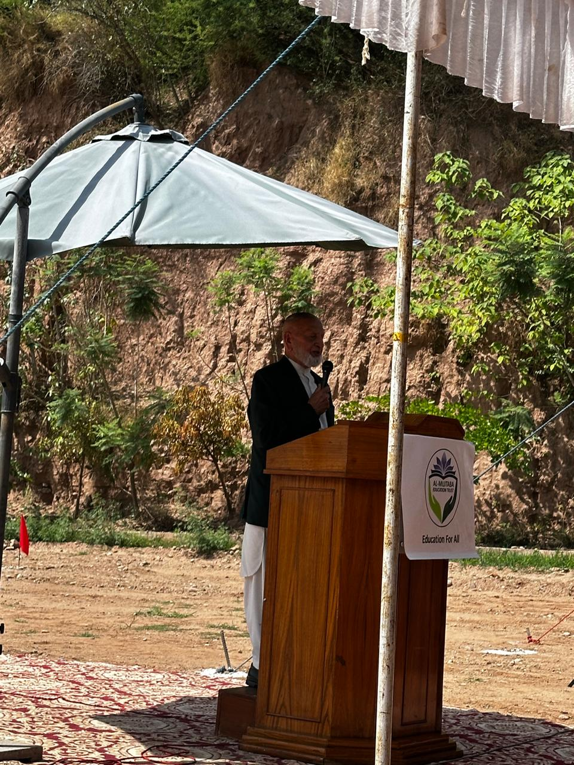

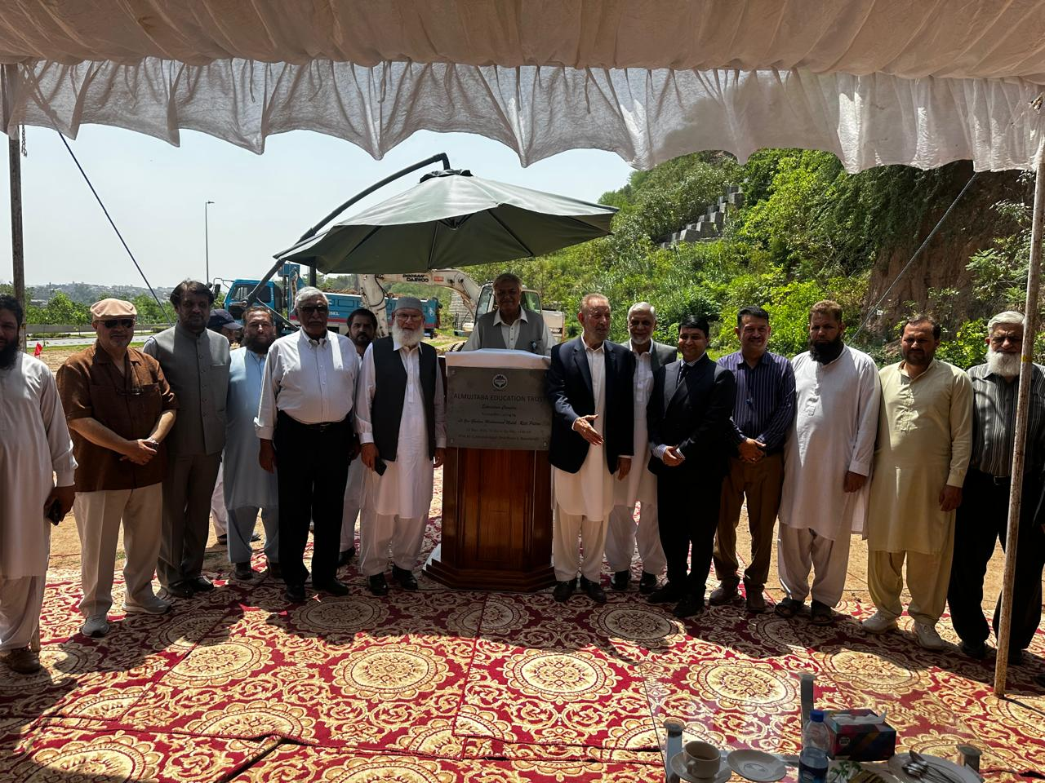

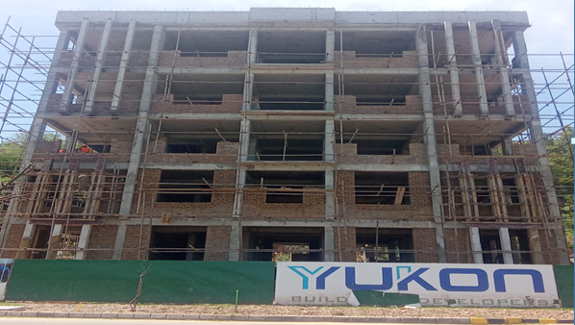
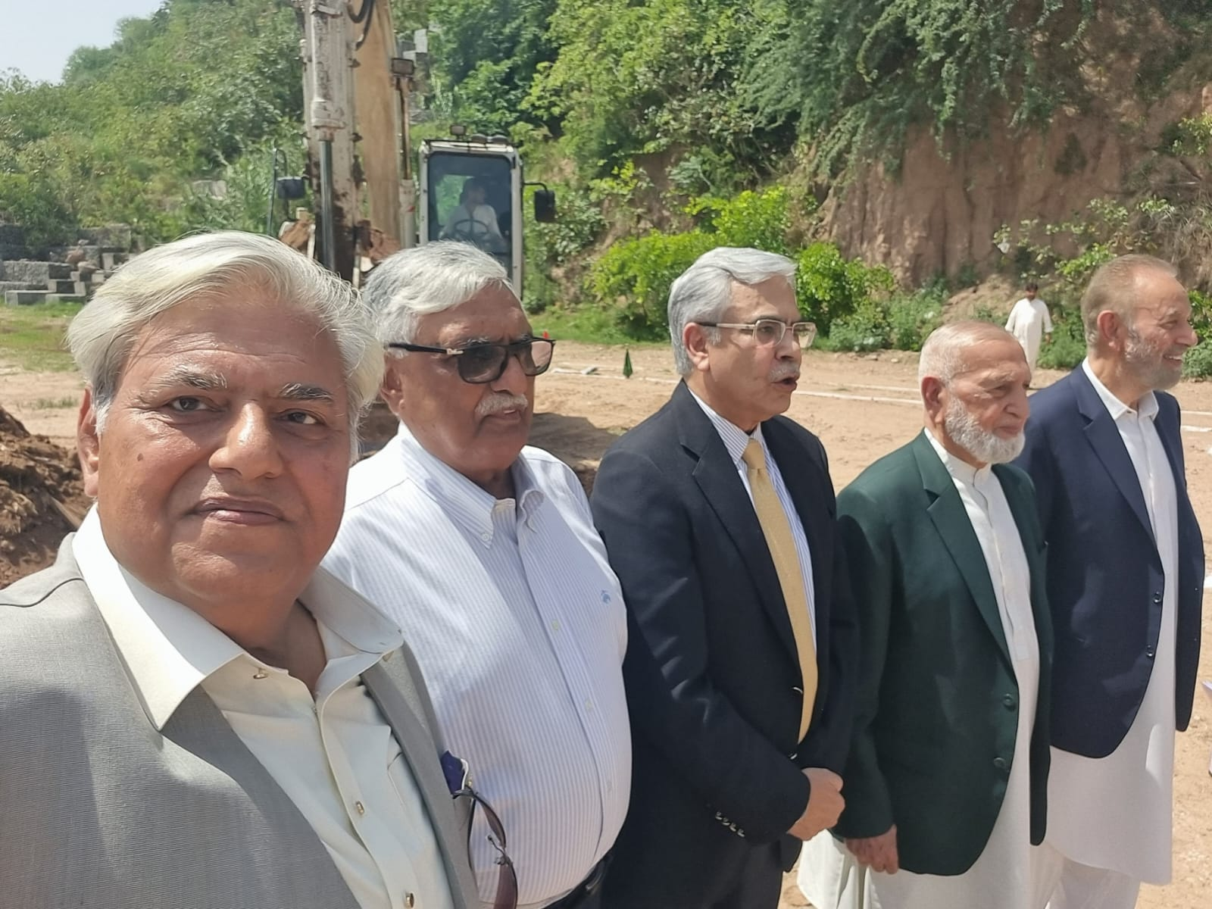
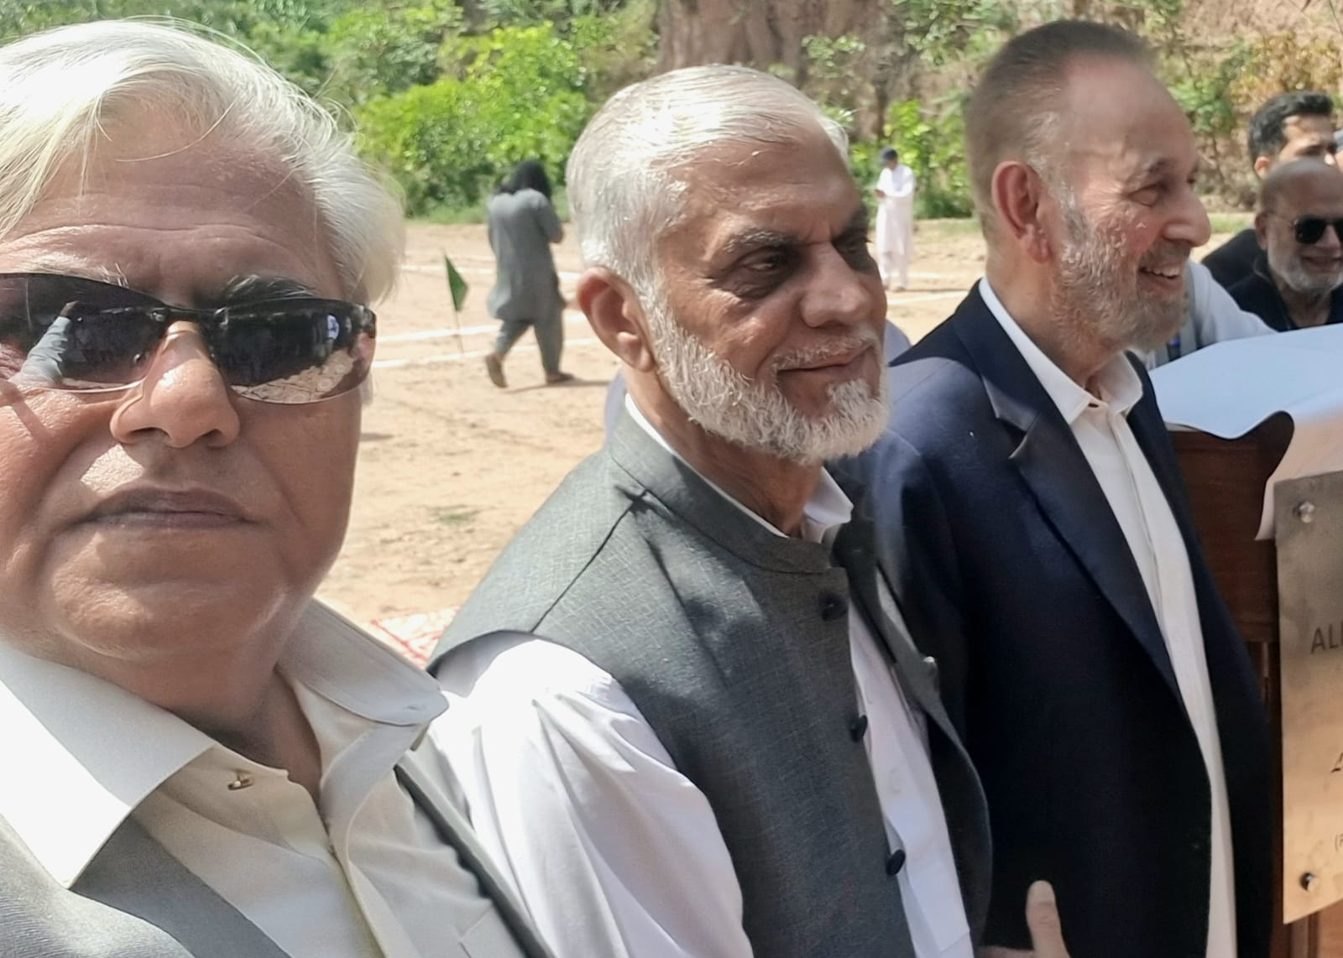
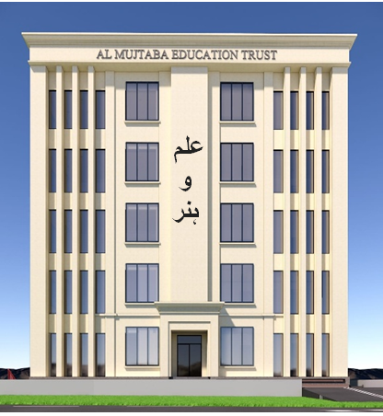

Annex J

MOU WITH FFC (SONA WELFARE FOUNDATION)
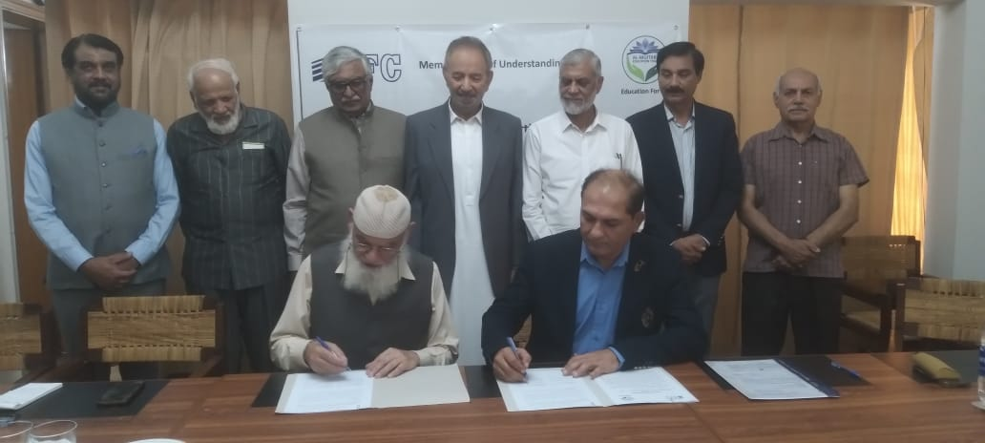
Signing of MOU with Sona Welfare Foundation (SWF)

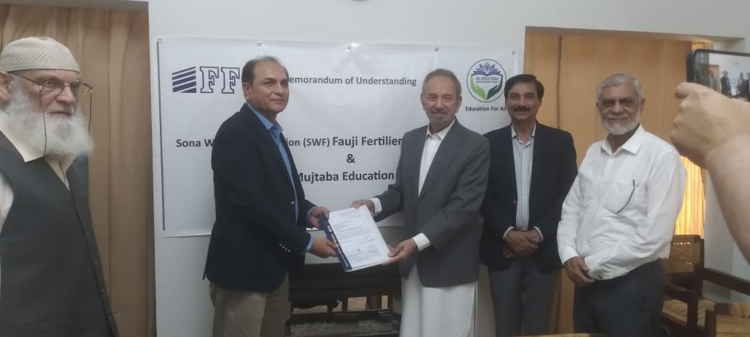
Annex K
DIST LIST ANNUAL PROGRESS REPORT - 2025

Serial | Name and Address
Corporate Sector Donors
1. | Mr. Faheem Haider  Managing Director /Chief Executive  Mari Enegries Ltd  21 Mauve Area ,3rd Road  G 10/4  Islamabad  Mob: 0306-0854770
2. | Mr. Jahangir Piracha  Managing Director/ Chief Executive Officer  FFC/Sona welfare Foundation  Sona Tower 156-The Mall,  Rawalpindi Cantt  Tel: 051-8452105
3. | Mr. Qamar Haris Manzoor Managing Director /Chief Executive  Fauji Cement Company Limited Fauji Tower, 68 Tipu Road Chaklala Cantt Rawalpindi Cantt  Tel: 051-9280081-8
4. | Mr. Yasir Shafi  Managing Trustee  Muhammad Shafi and Saeeda Naseem Trusts  Shafi House, 35-A/3, Lalazar  Opposite Beach Luxury Hotel  Karachi 740000  Mob: 0300-8243308
5. | Lt Gen Muhammad Hassan Khattak  QMG GHQ  Rawalpindi Cantt  Tel: 051-9274431
6. | Maj. Gen. Muhammad Shamraiz  DG Rangers Sindh  Headquarters Pakistan Rangers (Sindh)  Muslim Jinnah Courts Building  Dr. Ziauddin Ahmed Road  Karachi-74000  Mob: 0332-5470146
7. | Professor Dr. Anis Ahmad  Vice Chancellor  Riphah International University Gulberg Green  Expressway Islamabad  Tel: 051-5912890
8. | Mr. Shahab Rizvi  Chairman,  Pakistan Petroleum Limited  4th Floor, PIDC House  Dr. Ziauddin Ahmed Road  Karachi  Mob: 0301-8251518
9. | Mr. Badiuddin Akbar  Chief Executive Officer  Central Depositary Company  House, 99-B, Block B, S.M.C.H.S  Main Shahrah-e-Faisal  Karachi-74400
10. | Dr Syed Amir Ali  President / Chief Executive  Meezan Bank Limited  2nd Floor, Meezan House, C-25,  Estate Avenue, Site  Karachi  Mob: 0308-2990552
11. | Mr. Fawad Ateeq Barray  Chairman,  Haseen Habib Foundation  65-C, Street 7, Main Jami Commercial  DHA Phase VII  Karachi  Mob: 0300-8262747
12. | Mr. Rizwan Atta  President / Chief Executive  Bank Islami Pakistan Ltd  11th Floor, Executive Tower One  Dolmen City, Marine Drive, Block 4, Clifton  Karachi  Mob: 0333-3451644
13. | Maj Gen Abdul Sami  DG FWO  509 Kashmir Road  RA Bazar  Rawalpindi Cantt  Tel: 051-9271308
14. | Mr. Mahmud Trunkwala  Chairman  World Group  Head Office, 43-D, Off Shahrah-e-Faisal  PECHS, Block 6  Karachi  Tel: 021-34526594  Tel: 021-34549968
Individual Donors
15. | Gen Qamar Javed Bajwa, Retd  House 16 A, Golf Road Rawalpindi Cantt  Telephone # 051-9274793  Mob: 0325-5323690
16. | Mr Gul Asghar Khan Baghoor  Room 202, 2nd Floor,Block D  Pakistan Secretariat,  Islamabad  Mob: 0300-9800289
17. | Mr. Adnan Sarwar Cheema  House 24, Margalla Road  Sector F/7-3  Islamabad  Mob: 0300-8558221
18. | Mr Mushtaq Anwar Ch  House 10, Lane 5, Sector E,  DHA Phase 2  Islamabad
19. | Mr. Muhammad Tariq Rafi  Chairman, Siddiqsons Group  27th Floor, Ocean Tower  G-3, Block-9, KDA Scheme No. 5  Main Clifton Road  Karachi  Mob: 0300-8220190
20. | Mr. Altaf Ghaunchi  C/O Chairman, Siddiqsons Group  27th Floor, Ocean Tower  G-3, Block-9, KDA Scheme No. 5  Main Clifton Road  Karachi
21. | Mr. Sabir Hameed  House 83, Block W,  DHA Phase 3  Lahore
22. | Mr. S.M. Farhad  Din Leather (Pvt.) Ltd., Din House  35-A/1, Lalazar Area  Opposite Beach Luxury Hotel  Karachi  Telephone # 021-5610009  Tel: 021-5610001
23. | Mr. Muhammad Tariq Dawaiwala  Chief Executive  Brothers Enterprises (Pvt) Ltd  106 & 803, Anum Estate, Shahrah-e-Faisal  Karachi 75350  Mob: 0321-8267727
24. | Mr. Haji Riaz Ahmed  President, Nisar Fatima Amin Foundation  85 Banglore Town, Tipu Sultan Road  Karachi  Mob: 0300-8208648
25. | Mr. Shakeel Mansoor  Mehran Progressive Distributors  House No. 369/3, Street 20  Bahaduryar Jang Society  Near Aspire Grammar School  Karachi  Mob: 0300-2502657
26. | Mr. Tariq Muhammad Chaudhry  Chairman/ CEO, Dynamic Worldwide Logistics Group  Suite # 1201, 1202 12th Floor, Emerald Tower  Plot G19 Block-5, Main Clifton Road,  Karachi  Tel: 021-35157927
27. | Mr. Anees Ibrahim  M/s Allied Trading Company  H-20, Site Phase 2, Super Highway  Karachi  Mob: 0343-21872073
28. | Mr. Naseem Allawala  9th Floor, Tibet Center  M.A. Jinnah Road  Karachi  Tel: 021-32725804
29. | Mr Syed Matloob Hussain Shah  House 64, Suhrawardy Road  Sector G-6/4  Islamabad  Mob: 0332-9225555
30. | Mr Hassan Iqbal  VP, Lucky Core Industries Limited  Soda Ash Business Khewra  District Jhelum  Mob: 0300-8477188
31. | Mrs. Shaheen Afzal  House 126, Street 5,  Sarwar Colony, Sarwar Road  Lahore Cantt  Mob: 0321-5254111
32. | Mr. Mohammad Azam Khan Swati  Farm House 71, Orchard Scheme  Near Margalla Town  Islamabad  Telephone # 051-9222555  Mob: 0333-5751600
33. | Mr. Muhammad Hanif Gohar  A-2, Gohar Chamber  Near Duty Free Shop,Shahrah-e-Faisal  Karachi  Mob: 0321-9223676
34. | Mr. Muhammad Yahya Chawla  Chief Executive Officer  Burque Corporation (Pvt.) Limited  Plot No. M-1, Begum Rabia Siddiqui Road  Central Commercial Area, Bahadurabad  Karach  Mob: 0300-8225622
35. | Mr. Junaid Mansuri  Office 17, Jubilee Centre  Behind Liaqat Market  M.A. Jinnah Road  Karachi  Tel: 021-32413086
36. | Mr. Waseem Pasha  Plot 101 -103  Humak Industrial Estate Road  Islamabad  Mob: 0324-3292847
37. | Mr. Abdul Qadir Haye  House 220, Street 21  Sector E7 Islamabad  Mob: 0300-8544542
38. | Mr. Aamir Ashiq Dewan  Chief Executive Officer, Adam Group, 16-C,  Main Khayaban-e-Tanzeem, Tauheed Commercial,  DHA Phase V  Karachi  Mob: 0333-2255345
39. | Mr. Tehsin Ul Haq S/O  Capt Nasim Ul Haq (Late)  17-E, Muhammad Ali Housing Society  Karachi  Cell No. 0323-2101631  Tel: 021-35661274
40 | Lt Gen Anwar Ali Hyder, Retd  Managing Director /CEO  Fauji Foundation Fauji Tower, 68 Tipu Road Rawalpindi Cantt

12. | Mr. Rizwan Atta  President / Chief Executive  Bank Islami Pakistan Ltd  11th Floor, Executive Tower One  Dolmen City, Marine Drive, Block 4, Clifton  Karachi  Mob: 0333-3451644
13. | Maj Gen Abdul Sami  DG FWO  509 Kashmir Road  RA Bazar  Rawalpindi Cantt  Tel: 051-9271308
14. | Mr. Mahmud Trunkwala  Chairman  World Group  Head Office, 43-D, Off Shahrah-e-Faisal  PECHS, Block 6  Karachi  Tel: 021-34526594  Tel: 021-34549968
Individual Donors
15. | Gen Qamar Javed Bajwa, Retd  House 16 A, Golf Road Rawalpindi Cantt  Telephone # 051-9274793  Mob: 0325-5323690
16. | Mr Gul Asghar Khan Baghoor  Room 202, 2nd Floor,Block D  Pakistan Secretariat,  Islamabad  Mob: 0300-9800289
17. | Mr. Adnan Sarwar Cheema  House 24, Margalla Road  Sector F/7-3  Islamabad  Mob: 0300-8558221
18. | Mr Mushtaq Anwar Ch  House 10, Lane 5, Sector E,  DHA Phase 2  Islamabad
19. | Mr. Muhammad Tariq Rafi  Chairman, Siddiqsons Group  27th Floor, Ocean Tower  G-3, Block-9, KDA Scheme No. 5  Main Clifton Road  Karachi  Mob: 0300-8220190
20. | Mr. Altaf Ghaunchi  C/O Chairman, Siddiqsons Group  27th Floor, Ocean Tower  G-3, Block-9, KDA Scheme No. 5  Main Clifton Road  Karachi
21. | Mr. Sabir Hameed  House 83, Block W,  DHA Phase 3  Lahore
22. | Mr. S.M. Farhad  Din Leather (Pvt.) Ltd., Din House  35-A/1, Lalazar Area  Opposite Beach Luxury Hotel  Karachi  Telephone # 021-5610009  Tel: 021-5610001
23. | Mr. Muhammad Tariq Dawaiwala  Chief Executive  Brothers Enterprises (Pvt) Ltd  106 & 803, Anum Estate, Shahrah-e-Faisal  Karachi 75350  Mob: 0321-8267727
24. | Mr. Haji Riaz Ahmed  President, Nisar Fatima Amin Foundation  85 Banglore Town, Tipu Sultan Road  Karachi  Mob: 0300-8208648
25. | Mr. Shakeel Mansoor  Mehran Progressive Distributors  House No. 369/3, Street 20  Bahaduryar Jang Society  Near Aspire Grammar School  Karachi  Mob: 0300-2502657
26. | Mr. Tariq Muhammad Chaudhry  Chairman/ CEO, Dynamic Worldwide Logistics Group  Suite # 1201, 1202 12th Floor, Emerald Tower  Plot G19 Block-5, Main Clifton Road,  Karachi  Tel: 021-35157927
27. | Mr. Anees Ibrahim  M/s Allied Trading Company  H-20, Site Phase 2, Super Highway  Karachi  Mob: 0343-21872073
28. | Mr. Naseem Allawala  9th Floor, Tibet Center  M.A. Jinnah Road  Karachi  Tel: 021-32725804
29. | Mr Syed Matloob Hussain Shah  House 64, Suhrawardy Road  Sector G-6/4  Islamabad  Mob: 0332-9225555
30. | Mr Hassan Iqbal  VP, Lucky Core Industries Limited  Soda Ash Business Khewra  District Jhelum  Mob: 0300-8477188
31. | Mrs. Shaheen Afzal  House 126, Street 5,  Sarwar Colony, Sarwar Road  Lahore Cantt  Mob: 0321-5254111
32. | Mr. Mohammad Azam Khan Swati  Farm House 71, Orchard Scheme  Near Margalla Town  Islamabad  Telephone # 051-9222555  Mob: 0333-5751600
33. | Mr. Muhammad Hanif Gohar  A-2, Gohar Chamber  Near Duty Free Shop,Shahrah-e-Faisal  Karachi  Mob: 0321-9223676
34. | Mr. Muhammad Yahya Chawla  Chief Executive Officer  Burque Corporation (Pvt.) Limited  Plot No. M-1, Begum Rabia Siddiqui Road  Central Commercial Area, Bahadurabad  Karach  Mob: 0300-8225622
35. | Mr. Junaid Mansuri  Office 17, Jubilee Centre  Behind Liaqat Market  M.A. Jinnah Road  Karachi  Tel: 021-32413086
36. | Mr. Waseem Pasha  Plot 101 -103  Humak Industrial Estate Road  Islamabad  Mob: 0324-3292847
37. | Mr. Abdul Qadir Haye  House 220, Street 21  Sector E7 Islamabad  Mob: 0300-8544542
38. | Mr. Aamir Ashiq Dewan  Chief Executive Officer, Adam Group, 16-C,  Main Khayaban-e-Tanzeem, Tauheed Commercial,  DHA Phase V  Karachi  Mob: 0333-2255345
39. | Mr. Tehsin Ul Haq S/O  Capt Nasim Ul Haq (Late)  17-E, Muhammad Ali Housing Society  Karachi  Cell No. 0323-2101631  Tel: 021-35661274

