AL MUJTABA EDUCATION TRUST

ANNUAL PROGRESS REPORT FOR YEAR 2024

**Executive Summary**

The year 2024 marked significant progress for Al Mujtaba Education Trust (AMET) in its mission to support talented and underprivileged students across Pakistan. Through our scholarship programs, we continued to provide financial assistance to deserving students, ensuring they could pursue their academic aspirations without financial constraints.

One of the key milestones was the expansion of our vocational training initiatives, equipping individuals with valuable skills for employment and entrepreneurship. Our centers trained numerous individuals in various trades, contributing to economic empowerment and self-sufficiency.

A major highlight of the year was the advancement of our Education Complex Project for which AMET has been allotted a plot by DHA. We actively pursued various facilitations to expedite the project’s development, aiming to establish a high-quality educational and skill development institution.

The Trust also strengthened collaborations with donors and partner organizations, ensuring sustainability and impact. Our outreach efforts expanded, allowing us to support a greater number of students and training beneficiaries than ever before.

This report provides a detailed overview of AMET’s activities, achievements and future aspirations as we continue our journey towards transforming lives through educationand skill development.

# بِسْمِ اللهِ الرَّحْمٰنِ الرَّحِيْمِ

AL MUJTABA EDUCATION TRUST

ANNUAL PROGRESS REPORT FOR YEAR 2024

01 JAN - 31 DEC 2024

**Preamble**

1. The year 2024 has been another milestone in the journey of Al Mujtaba Education Trust (AMET). What began in 2016 with the award of 96 scholarships, primarily for middle to higher secondary education, has now expanded ninefold, encompassing graduate-level programs as well. This remarkable growth has been made possible by the unwavering support of our generous donors and trustees, guided by the vision of our esteemed founder and former Chairman, who continues to lead us as Patron.

2. As in previous years, significant contributions were received from the business community, as well as organizations such as the Fauji Foundation, Mari Energies, Fauji Cement, and Fauji Fertilizer Company. Our regular donors also increased their annual contributions and Zakat donations, enabling the Trust to raise an all-time high of Rs. 105 million in 2024.

3. Special efforts were made to expand scholarships in both technical and formal education programs. The number of Diploma of Associate Engineering (DAE) scholarships was extended to students in nine Institutes of Technology, compared to just four in the previous year. Consequently, the number of DAE scholarship recipients increased from 24 to 76. In a bid to enhance collaboration with like-minded organizations, AMET signed Memorandums of Understanding (MoUs) with:

• NUTECH (National University of Technology), Rawalpindi, a leading technical education institute.

• Helping Hands Institute of Rehabilitation Services (HHIRS), Mansehra, a premier allied health sciences institute under Helping Hands Trust.

4. A major breakthrough for the Trust came with the allotment of a 1.87-kanal amenity plot in DHA Phase-1 by Defence Housing Authority Islamabad/ Rawalpindi (DHA IR) as part of their Corporate Social Responsibility (CSR) program. This land will house the AMET Education Complex, marking a significant expansion of the Trust’s mission. The seven-story multi-purpose building plan has been approved by DHA, and construction is expected to commence in April 2025. A dedicated fundraising campaign has been launched to ensure the project’s completion by end-2026, with a separate Meezan Bank account opened for this purpose.

5. In another key development, Lt Gen Ghulam Muhammad Malik (Retd.) stepped down as Chairman, having found a successor. While the Board of Trustees (BoT) reluctantly accepted his request, he was unanimously elected as Patron for Life in recognition of his outstanding contributions to AMET. On 13 August 2024, the BoT elected his nominee, Lt Gen Muhammad Sabir (Retd.), as the second Chairman, who had joined the Trust in March 2024.

**Scope**

6. This report covers the following key areas:-

a. Award of Scholarships and performance of awardees.

b. Vocational Training Programs and results.

c. Visits/ Fundraising Efforts.

d. BOTs.

e. AMET Education Complex.

f. Miscellaneous Aspects.

**Award of Scholarships**

7. **Overview.** The Executive Committee Meeting convened periodically throughout the year to evaluate scholarship applications and ensure fair distribution of funds. As a result, a total of 878 x students, both boys and girls benefited from AMET’s support in 2024. The following sections provide further details on the scholarship program’s impact:-

a. **General Scholarships**. 88 students were awarded AMET scholarships for classes 9 & 10 and 149 scholarships awarded for classes 11 & 12 during the year.

b. **Higher Education**. 93 students were awarded AMET scholarships during the year 2024 in the undermentioned faculties: -

(1) MBBS/DPT/DP : 10

(2) BS/ BBA : 63

(3) BS Nursing/BS (MLT) : 05

(4) ADA : 01

(5) CE : 01

(6) Architecture : 01

(7) Doctor of Veterinary Medicine (DVM) : 01

(8) BSc City & Regional Planning : 02

(9) BSc Civil Engineering : 01

(10) BA, LLB : 02

(11) Bachelor of Film Production : 01

(12) Diploma in Information Technology (DIT) : 01

(13) Associate Degree in Commerce (ADC) : 01

(14) Computer Engineering : 01

(15) Speech Language Pathologist (SLP) : 01

(16) BA Computer Study : 01

c. **Diploma Courses**. 76 students were awarded scholarships for   
diploma courses of 3 years duration.

d. **Certification Courses**. The following certification courses were sponsored by Al Mujtaba Education Trust during year 2024:-

(1) **The Hunar Founcdation**. 120 students including 20 girl students were awarded scholarships for certification courses at Hunar Foundation Institutes at Karachi, Tando Allah Yar, Rasheedabad and Kharian.

(2) **NUTECH, Islamabad**. 5 students (3 x boys and 2 x girls) were awarded scholarship for Hospitality Services and Fashion Designing courses.

(3) **Skills Institute Sultana Foundation**. 14 students (3 x boys and 11 girls) were sponsored for the course of Graphic Designing.

(4) **Allied Health Training Institute Bagh**. 4 x girls students were awarded scholarship for misc courses.

(5) **Khurshid Memorial Institute of Health Sciences Talagang**. 1 x girl was selected for award of scholarship of MLT course.

e. **Saeeda Naseem and Muhammad Shafi Trusts Scholarships**. 33 girl students belonging to rural areas were awarded Saeeda Naseem Scholarships for classes 9 and 10 during year 2024. In additions 323 girls from rural areas of Punjab, KPK and AJ&K underwent Vocational Training from the funds of the same Trust as desired by the donor.

8. **Results Achieved.** Annual examinations were held as scheduled. Students sponsored by AMET have generally produced good results. Details are given below: -

**a. General Scholarships**

|  |  |  |  |  |  |  |  |  |  |
| --- | --- | --- | --- | --- | --- | --- | --- | --- | --- |
| Class | Students | Results | | | | | | | |
| A+ | A | B | C | D | Failed/ Discontinued | Left | Remarks |
| Secondary (Including Cadet Colleges) | 228 | 48 | 71 | 10 | - | - | 12@  37* | 2 | @Scholarships have been stopped  *Discontinued |
| Intermediate | 232 | 34 | 106 | - | - | - | 2@  35* | - | @Scholarships have been stopped  *Discontinued |
| Higher Education | 113 | 45 | 51 | 8 | - | - | - | 1 | *Result of 8 x students awaited |

b. **Technological Skills, The Hunar Foundation (THF).** 120 students including 20 girls attended different certification courses at various campuses of THF. They all have successfully completed their courses and stand qualified.

c. **Other Technical Institutes.**

|  |  |  |  |  |  |  |  |  |
| --- | --- | --- | --- | --- | --- | --- | --- | --- |
| Institute | Students | Grades Achieved | | | | | | |
| A+ | A | B | C | D | Failed | Left |
| Askari Institute of Technology (AIT) | 9 | 2 | 6 | - | - | - | 1@ |  |
| Faizul Islam Institute of Technology (FIT) | 8 | - | 4 | 3 | - | - | 1@ |  |
| Prince Salman Institute of Technology (PSIT) | 7 | 1 | 2 | - | - | - | 4@ |  |
| Kahuta Institute of Technology (KIT) | 9 | 5 | 3 | - | - | - | - | *1 |
| Govt College of Technology, Peshawar | 18 | - | 7 | 6 | - | - | 4@ | *1 |
| Govt Polytechnic Institute, Sardar Garhi, Psc | 16 | - | 5 | 10 | - | - | 1@ |  |
| Govt College of Technology, Kohat | 11 | - | 8 | 2 | - | - | - | *1 |
| Global College of Technology, Gilgit | 5 | - | 3 | 1 | - | - | 1@ |  |
| Total | 83 | 8 | 38 | 22 | - | - | 12 | 3 |

@Scholarships have been stopped.

* left the institute.

9. **Some High Achievers**

**Faiz Rashid Malik**

|  |  |
| --- | --- |
| C:\Users\Allah\Downloads\WhatsApp Image 2024-01-30 at 7.19.58 PM.jpeg | Lt Faiz Rashid, an orphan was sponsored by the Trust for studying in Cadet College Sargodha from class 8th onwards. Having completed his intermediate education he got selected for Pakistan Military Academy to become a commissioned army officer. He is the 1st AMET sponsored cadet to join the Pakistan Military Academy and became a commissioned officer in one of the Infantry Unit of Pakistan Army. |
|  | |

**Tanzeela Jamil**

|  |  |
| --- | --- |
| C:\Users\Allah\Downloads\WhatsApp Image 2025-01-27 at 12.19.23 AM.jpeg | Tanzeela Jamil comes from the town of Baffa District Mansehra. Her father runs a shop in the village She secured 482 marks in her 9th-grade exams, which marked the beginning of her association with AMET. The subsequent years were a testament to her hard work and AMET's unwavering support. She secured 942 in matriculation exams, paving the way for further academic excellence. |
| She was then afforded the opportunity to be sent to Mansehra Public School and College for her F.Sc, where she achieved a score of 928 marks. In 2022, she embarked on a new journey, pursuing a degree in BS Medical Laboratory Technology (MLT) at Riphah International University in Islamabad. She has successfully completed her 6th semester with a remarkable SGPA of 4.0 and a cumulative GPA of 3.97. She is deeply inspired and determined to give back to the community and contribute to AMET's noble endeavors in the future, In Sha Allah. | |

**Urooj Bibi**

|  |  |
| --- | --- |
| C:\Users\Allah\Downloads\WhatsApp Image 2025-01-27 at 12.19.24 AM.jpeg | Urooj Bibi belonging to a remote village of Malakand was pursuing BS Applied Psychology course at Riphah International University, when she came across a sudden turn in life due to her father's serious ailment and premature retirement from service. Finding it difficult to meet the expenses to finish her studies, she sought Scholarship from AMET, which made it possible for her to concentrate |

on her studies and secure GPA of four in the 7th semester and CGPA of 3.90. Alhamdolillah she is happily employed with Helping Hands as well and can now contribute financially to his family and socially to the society.

**Ayesha Shawwal**

|  |  |
| --- | --- |
| C:\Users\Allah\Downloads\WhatsApp Image 2025-01-27 at 2.27.13 AM.jpeg | Ayesha Shawwal is daughter of Nawaz Bhatti from Islamabad,who is employee of a printing press. She was given AMET Scholarship for DPT at Riphah International University, Gulberg Green Campus in Spring 2023. Free of financial worries, she scored a GPA of 4.00 and CGPA of 3.94 in her 4th semester. She is currently in 5th semester and is determined to better her CGPA score. She intends to serve the |
| humanity and payback to the society with the skills she achieves in the future, InShaAllah. | |

**Maria Afsar**

|  |  |
| --- | --- |
| C:\Users\Allah\Downloads\WhatsApp Image 2025-01-27 at 8.40.58 PM.jpeg | Maria Afsar belongs to Mirpur Azad Kashmir. Her father is employed as a security guard. She was one of the several girls selected to undergo various courses at the University of Faisalabad (TUF). Alhamdolillah she completed her DPT degree with  CGPA of 3.47 and is currently working as a physiotherapist at Zobia School for |
| Special Children, in her hometown. As a gesture of gratitude, her father donated her first salary cheque of Rs. 25,000 to AMET in our last Fund Raising Function at Rawalpindi. Maria is committed to improve the skills acquired and continue her association with AMET to pay back to the society. | |

**Dr. Qurrat Ul Ain**

|  |  |
| --- | --- |
| C:\Users\Allah\Downloads\WhatsApp Image 2025-01-29 at 8.28.58 AM.jpeg | Dr.Qurrat ul Ain Ali belongs to Gujar Khan Rawalpindi.Her father is a private school teacher. She got AMET Scholarship for Fsc(Pre Medical) in 2016. She showed outstanding performance in FSc and cleared MDCAT exam to earn admission in Sargodha Medical College. She completed her MBBS degree (2018-23) with AMET Scholarship getting two Gold Medals and several |
| distinctions throughout her academic career at Sargodha Medical College.Currently she is doing her house job in DHQ Hospital Sargodha.She is committed to be associated with AMET and further the objectives of the Trust, InShaAllah. | |

**Vocational Training**

10. **General**. AMET has six Vocational Centres (VCs) located at Sillanwali (Sargodha), Chawali (Chakwal), Rera (Bagh-AJK), Baffa, (Mansehra), Bucha (Mandra-Rwalpindi) and Jewra (Kahuta). The recently added 7th Vocational Training Centre at Khabeke District Khushab is functional wef Jan 2025. At these VCs Two courses, each of 6 months, were conducted in which 323 female/ male students belonging to rural areas were imparted vocational training in Dress Making, Embroidery, Basic Computer Course, Character Building and Amoor-e-Khanadari.

11. **VC Courses (Students Trained)**

|  |  |  |  |  |  |  |  |
| --- | --- | --- | --- | --- | --- | --- | --- |
| Ser | Name of VC | Courses | | | | | |
| Dress Making Courses | | No of Students Trained | Computer Courses | | No of Students Trained |
| Course-1  Jan - Jun 2024 | Course-2  Jul - Dec 2024 | Course-1  Jan - Jun 2024 | Course-2  Jul - Dec 2024 |  |
| a | VC Chak 118-NB, Sillanwali | 18 | 22 | 40 | 21 | 22 | 43 |
| b | VC Chawali | 12 | 13 | 25 | 10 | 24 | 34 |
| c | VC Bucha (Mandra) | 17 | 20 | 37 | 0 | 0 | 0 |
| d | VC Rera (Bagh) Azad Jammu & Kashmir | 19 | 20 | 39 | 0 | 0 | 0 |
| e | Baffa | 23 | 25 | 48 | 0 | 0 | 0 |
| f | VC Jewra (Kahuta) | 28 | 29 | 57 | 0 | 0 | 0 |
| Total | | 117 | 129 | 246 | 31 | 46 | 77 |

12. **VCs Results**

|  |  |  |  |  |  |  |  |  |  |
| --- | --- | --- | --- | --- | --- | --- | --- | --- | --- |
| Ser | Course Title | Students Trained | Grades Obtained | | | | | | |
| A+ | A | B | C | D | Absent/ Failed | Left |
| a | Computer Courses | 77 | 9 | 11 | 17 | 30 | 6 | 4 | - |
| b | Dress Making Courses | 246 | 61 | 94 | 44 | 25 | 10 | 12 | - |
| Total | | 323 | 70 | 105 | 61 | 55 | 16 | 16 | - |

**Visits**

13. **Karachi Visit**. A three-member team, led by Lt Gen Ghulam Muhammad Malik, Retd, visited Karachi from 21 to 25 July 2024. The visit aimed to engage with trustees, donors and well-wishers while promoting AMET’s initiatives, particularly the AMET Educational Complex. Key Meetings & Engagements were:-

a. Trustees’ Meeting (21 July) – The Chairman briefed Karachi-based trustees on AMET’s progress, highlighting the record 1,068 scholarships awarded in 2023. He announced his decision to step down, with Lt Gen Muhammad Sabir, Retd designated as the next Chairman. Fundraising for the Education Complex was emphasized.

b. Meeting with Mr. Naseem Shafi (22 July) – The team updated him on AMET’s progress and requested support for the Education Complex.

c. Meeting with Mr. Tariq Rafi (22 July) – He committed Rs. 1.0 million per month for a year (subject to tax exemption) for the Education Complex and pledged increased support for Hunar Foundation students.

d. Visits to Vocational Training Institutes (23 July) – The team visited The Hunar Foundation and Rehan Allahwala’s Institute, appreciating their focus on technical and AI education.

e. Trustees & Donors’ Dinner (23 July) – Attended by key supporters, this event honored the outgoing Chairman for his leadership.

f. Al-Khidmat Bano Qabil Program Visit (24 July) – The team observed and appreciated the initiative empowering youth through IT education.

g. Meetings with other Business Leaders (24-25 July) – The team met Mr. Tariq Dawaiwala, Mr. Fawad Barry, and others, reinforcing AMET’s mission and securing commitments for future collaboration.

h. The visit strengthened AMET’s network, secured funding commitments, and reaffirmed trustee and donor engagement. The support and hospitability extended to AMET leadership by Karachi’s Business Community/ Trustees and donors is unmatched. The team returned to Islamabad on 25 July, marking a successful and purposeful visit.

14. **Visit of Al Mujtaba Education Trust by MD Fauji Foundation.** Mr Waqar Malik, MD & CEO of Fauji Foundation visited Al Mujtaba Education Trust alongwith his staff on 20 Mar 024. They had a meeting with Chairman, Lt Gen Ghulam Muhammad Malik, Retd in his office and exchanged views. The MD Fauji Foundation highlighted the support being extended by his gp and appreciated the efforts of the Trust in the field of education and skill development for the underprivileged youth.

15.      **Visit to Mr. Adnan Sarwar Cheema**.   The Patron, Chairman and CEO of Al Mujtaba Education Trust called on Mr Adnan Sarwar Cheema on 4 Dec 2024 at his office in Islamabad. He was apprised about the activities and plans of Al Mujtaba Education Trust specially with ref to the planed Education Complex and sought his support for bearing the cost of one floor of the building. Mr Adnan Sarwar Cheema promised to favorably look at AMET proposal.

https://ssl.gstatic.com/ui/v1/icons/mail/images/cleardot.gif

16. **Fund Raising Dinner at Rawalpindi on 05 Nov 2024**. Trustees at Rawalpindi took been interest in making the function successful. The dinner was well attended and resulted into collection of over Rs. 10 Million. The guests incl two ex COAS and a no of retd military officers and civilians incl ladies.

**BOT Meetings**

17. **First BOT Meeting 2024**. The year’s inaugural BOT meeting was held on 16th January 24. The main points were:-

a. Election of Lt Gen Muhammad Asghar, Retd as a Trustee. He has been Rector NUST for seven years.

1. Setting targets for scholarships and yearly budget for the year since AMET financial year opens from January to December.
2. All PDs gave a review of respective VCs.A grant of  Rs 500000 was approved for up-gradation VC Bucha to run Computer Courses as well.

18. **Second BOT Meeting 2024**. Next BOT meeting was held on 13 Jun 24.The main points were:-

a. Approval for the construction of AMET Education Complex was  granted and various  committees to oversee the work and manage finances and purchases were approved.

      b. Charter of duties for the Patron were approved.

c. Brig Noor Ullah Abeer was inducted as a Trustee.

 19. **Third BOT Meeting 2024**. The third meeting was held on 13th August 24. The salient points were as follows:-

a. Approval of Brig Dr Maqsood ul Hassan, an eminent in fantarian turned educationist ,as a  Trustee.

  b. Submission of a review report about VCs by Member Coord VCs.

1. Unanimous election of Gen Ghulam Muhammad Malik Retd as Patron and Lt Gen. Muhammad Sabir Retd as Chairman of the Trust.

d. Passage of resolution for change of signatories for cheques.

e. Some changes in the Charter of Duties of the Patron were also approved.

20. **Annual BOT**. An end of the year BOT was held on 24 Dec 2024 to review current years progress and laydown plan for the following year. Main points explained / presented by respective members are:-

a. **Budget Review - 2024**

(1) **Donations 2024**

  (a) Individual Donors - Rs. 34,636,000/-

  (b) Corporate Donors - Rs. 36,820,000/-

  (c) Other Sources - Rs. 33,448,321/-

        Total - Rs. 104,904,321/-

(2) **Expenses 2024**

  (a) Office Rent - Rs. 1.188,000/-

  (b) Staff Salaries - Rs. 4,875,796/-

(c) VCs - Rs. 7,226,681/-

(d) Administrative Expenses/-

Petty Cash - Rs. 2,770,962/-

  (e) Scholarships - Rs. 71,010,544/-

        Total - Rs. 87,071,983

b. **Budget Estimates 2025**

  (1) **Expected Donations**

    (a) Individual Donors - Rs. 30,886,000/-

    (b) Corporate Donors - Rs. 40,200,000/-

    (c) Others Sources - Rs. 20,000,000/-

  (2) **Planned Expenses**

    (a) Office Rent - Rs. 1,500,000/-

  (b) Staff Salaries - Rs. 5,000,000/-

    (c) VCs - Rs. 8,000,000/-

  (d) Admin Expenses/-

Petty Cash - Rs. 2,500,000/-

  (e) Scholarships - Rs. 22,000,000/-

        Total - Rs. 89,000,000/-

c. **Scholarships Targets**. Secretary proposed the following targets which were approved by the BOT:-

|  |  |  |  |
| --- | --- | --- | --- |
| Class / Program | Proposed 2025 | Schedule | Avg Exp Per Student/ PA |
| Matric | 140 | Mar/ Apr | 45,000 |
| FA/FSc | 180 | Jul/ Aug | 60,000 |
| Higher Education | 42 | Jan & Dec | 125,000 |
| Certification Courses (THF) | 120 | Jan & Jul | 30,000 |
| Certification Courses (Other Than Hunar Foundation) | 20 | Jan & Jul | 50,000 |
| DAE/ Diploma | 70 | Jul/ Aug | 50,000 |
| IT | 10 | Jan/ Jul | 150,000 |
| Vocational Training | 350 | Jan/ Jul |  |
| Total | 932 |  |  |

d. **New Trustees**. Following were inducted as Trustees:-

    ([1) AM](http://1.am/) Arshad Malik Retd

    (2) Lt Col Azhar Saleem Ghouri Retd

    (3) Maj Muhammad Suhail, Retd

  (4) Dr Shazia Malik

e. **Discussion Points/ Decissions** . Chairman proposed relaxation in policy for continuation of class 9th students scholarships. It was decided to refer the matter of compassionate cases scoring lower than 70% marks to member scrutiny for recommendations. It was also decided to invite local dignitaries, who could give suitable donations, to certificate awarding ceremonies of VCs to improve their funds status.

**Misc Aspects**

21. **AMET Education Complex**. Enhancing the quality, scope, and reach of our vocational training programs remains a core objective of AMET. The Education Complex, a dedicated facility, is being developed on a 1.87-kanal plot allocated by DHA, Islamabad. This complex aims to serve as a center for leadership and guidance, fostering contemporary and advanced skills. It embodies AMET’s commitment to providing high-quality education and skill development opportunities to underprivileged youth. The project follows a phased construction strategy to ensure efficient implementation, with completion targeted for 2026, subject to funding availability (estimated at PKR 200 million). Located in Amaltas Road, DHA Phase 1, Rawalpindi, the complex will include:

• A paramedic training center

• IT and digital skills training facilities

• Foreign language training for skilled workers

• Government school teachers’ training programs

• An innovation and emerging skills hub

• A prayer hall and Islamic library

• The AMET office

22. **Certificate Award Ceremonies**. Vocational centers conducted certificate award ceremonies where students who successfully completed their training received certificates. Additionally, the top three performers from each center were presented with cash prizes. Photo gallery at Annex A.

23. **Completion of Degrees**. By December 31, 2024, a total of 95 AMET-supported higher education students had successfully completed their degrees, including nine students who had graduated in 2023. Most of these scholars have now transitioned into their professional careers.

24. **Memorandums of Understanding (MoUs)**

• MoU with HHIRS: A collaboration with a premier Allied Health Sciences Institute in Data Mor, Mansehra, established by Helping Hands.

• MoU with NUTECH: A partnership enabling students to access both short-term certification courses and long-term computer courses at reduced costs at NUTECH’s Rawalpindi campus.

**Conclusion**

25. The year under review has been highly successful. In 2024 alone, 878 students received scholarships, bringing the total number of AMET beneficiaries since 2016 to 5,095. The targets for 2024 were fully met, thanks to the generous contributions of our donors. With their continued support, we aim to expand our reach and assist even more students in the future, specially in Sindh and Balochistan, in addition to building a model Education Complex. May Allah SWT always be our Guide and Protector.

Lt Gen

Chairman

Muhammad Sabir, Retd

Rawalpindi

21 March 2025

Distribution

Attached (As Annexure-B)

Annexure-A

AL MUJTABA EDUCATION TRUST

CHAKLALA SCHEME III, RAWALPINDI

PHOTO GALLERY

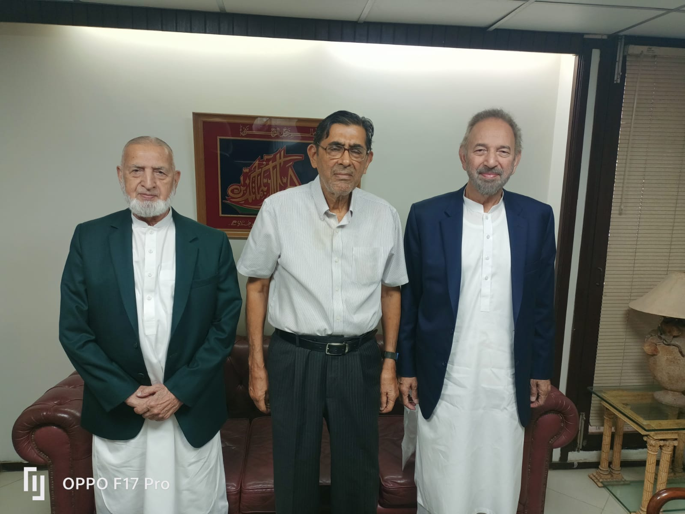

Lt Gen Ghulam Muhammad Malik (Retd), Chairman Al Mujtaba Education Trust and Lt Gen Muhammad Sabir (Retd) with Mr. Naseem Shafi, Chairman Saeeda Naseem Trust

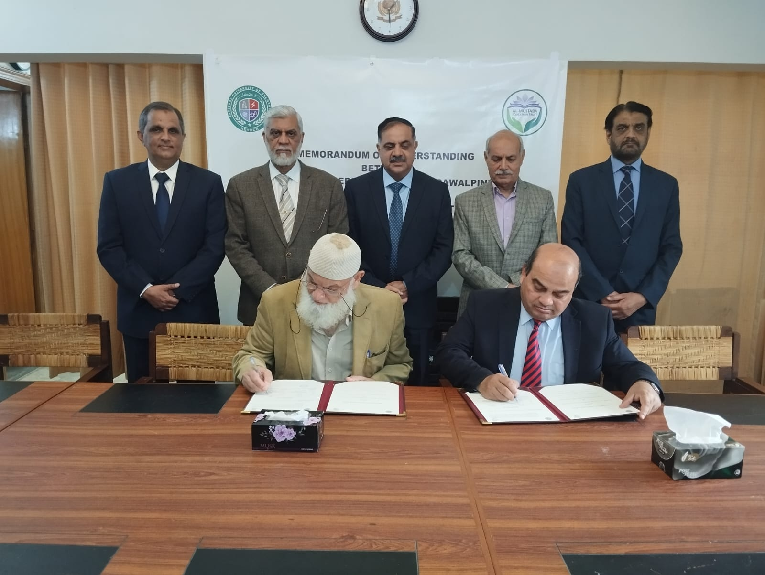

Signing of MOU with NUTECH

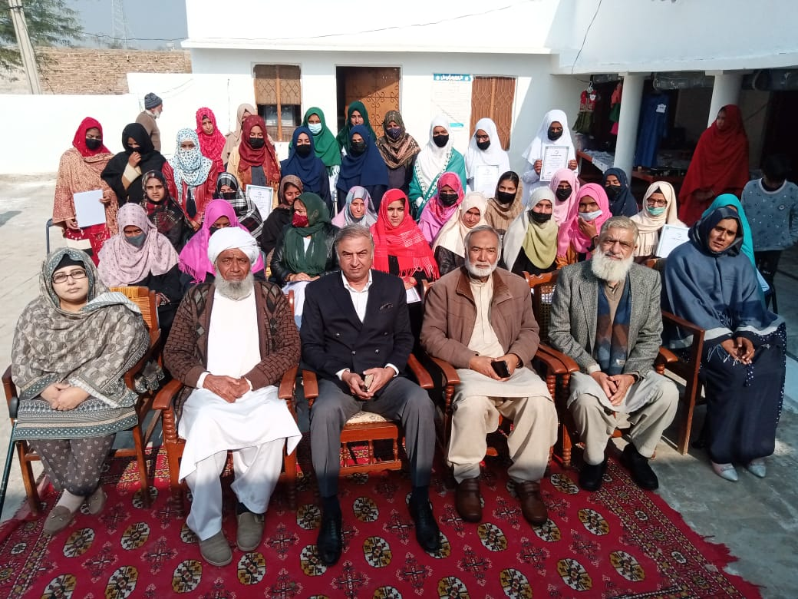

Group Photo of Qualifying Students with Maj Gen Malik Muhammad Masud (Retd), the Chief Guest at VC Chawali (Chakwal)

Al Mujtaba Vocational Training Centre

Rerha (Bagh) AJ & K

Photo Gallery

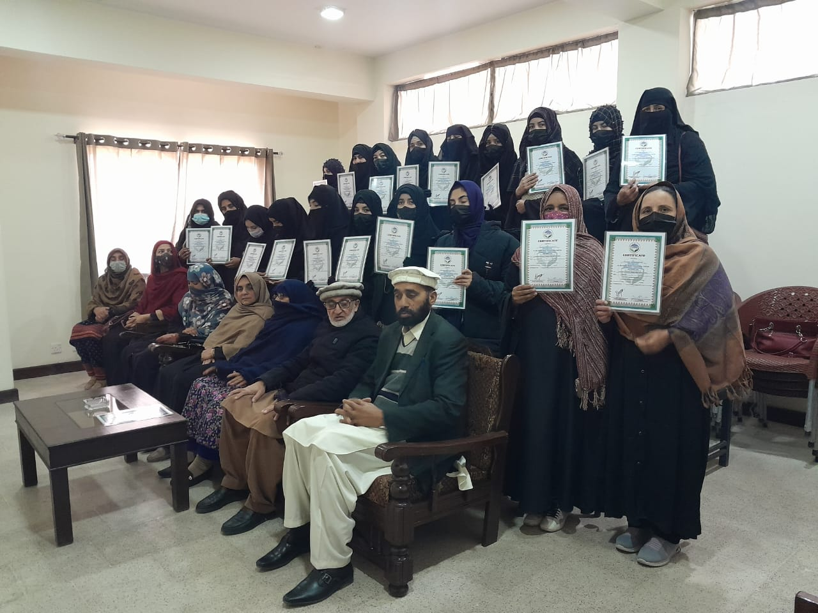

Group Photo of Qualifying Students of VC Rera (Bagh), AJ & K

Al Mujtaba Vocational Training Centre

Bucha (Mandra) Rawalpindi

Photo Gallery

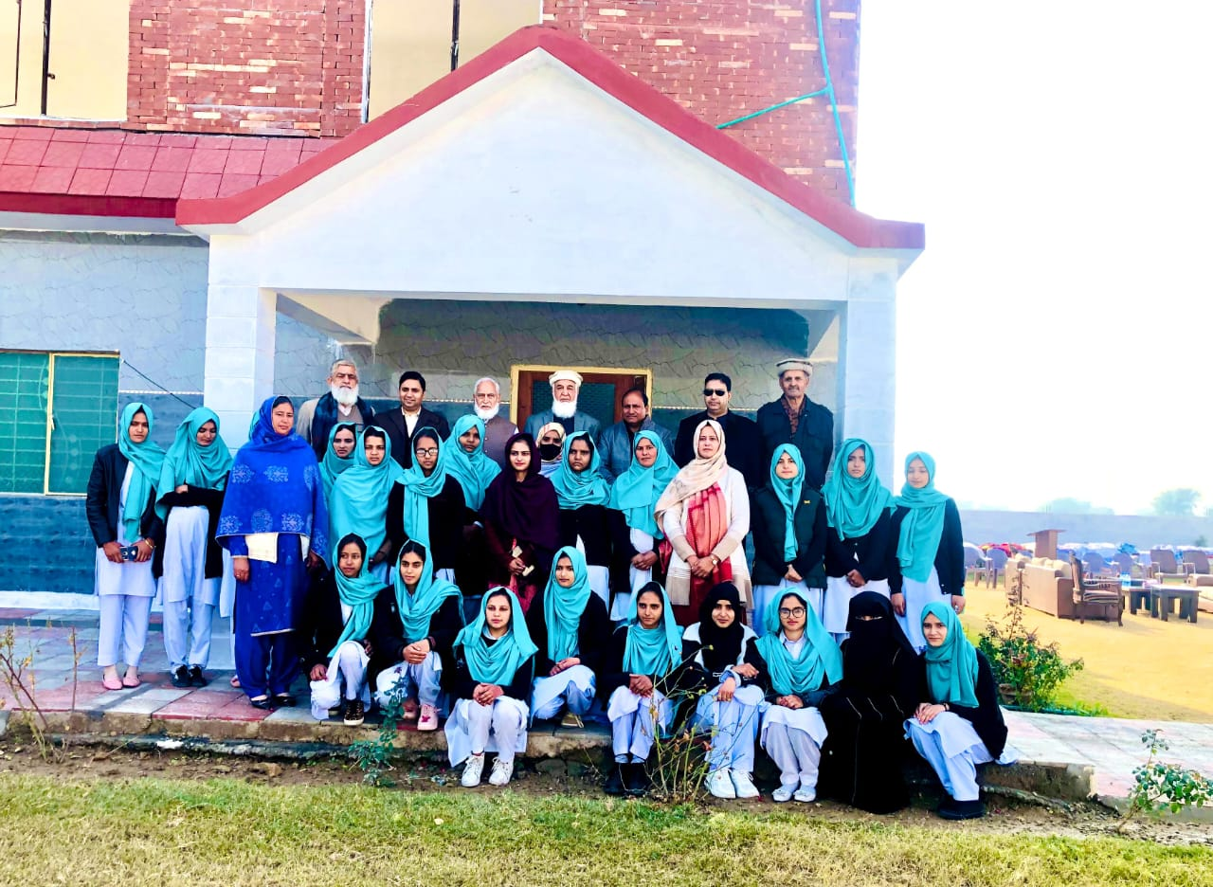

Group Photo of Successful Students with the Chief Guest at VC Bucha

Al Mujtaba Vocational Training Centre

Baffa (Mansehra)

Photo Gallery

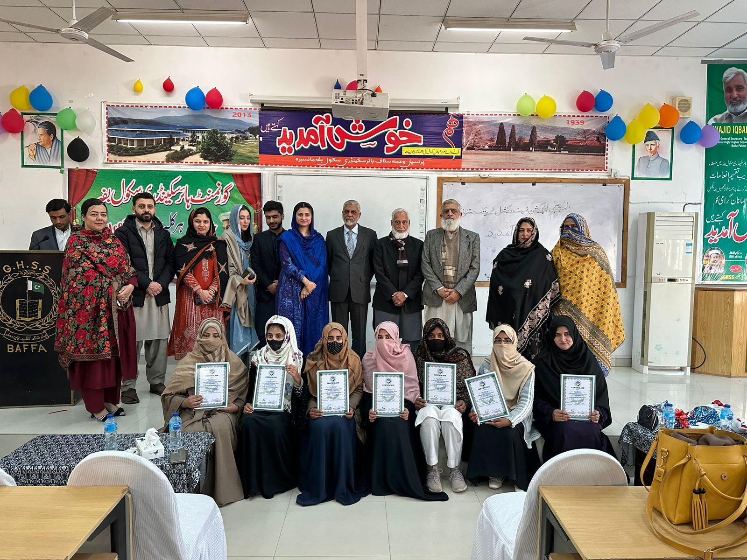

Group Photo of Successful Students with Chief Guest at VC Baffa (Mansehra

Al Mujtaba Vocational Training Centre

Jewra (Kahuta, Rawalpindi)

Photo Gallery

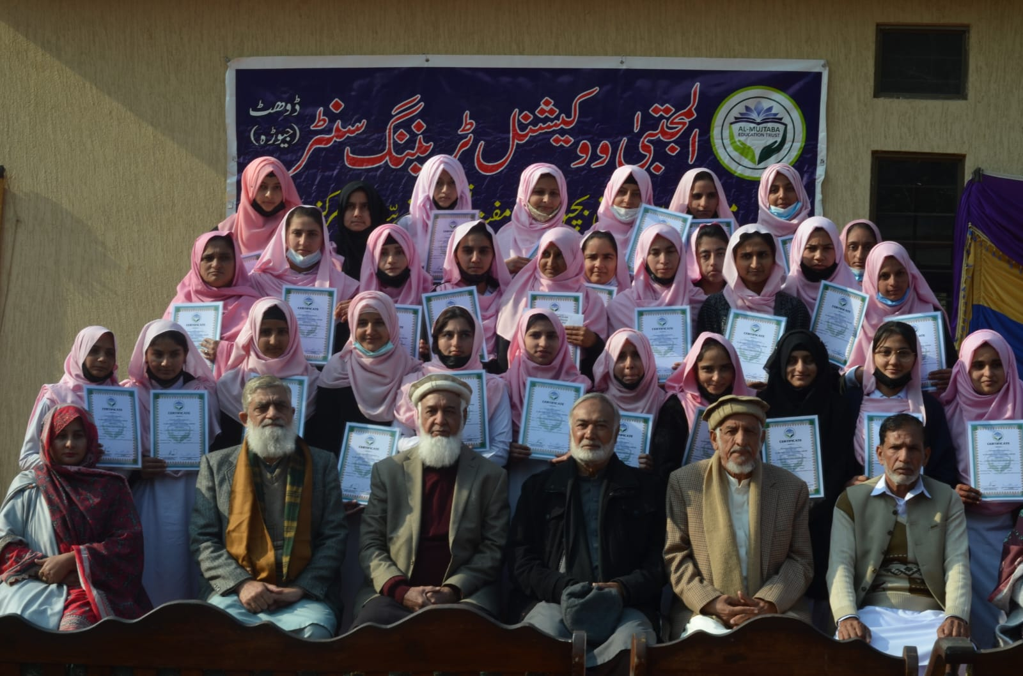

Group Photo of Qualifying Students with Air Marshal Khudadad, the Chief Guest at VC Jewra (Kahuta Rawalpindi)

Al Mujtaba Vocational Training Centre

VC Sillanwali, Sargodha

Photo Gallery

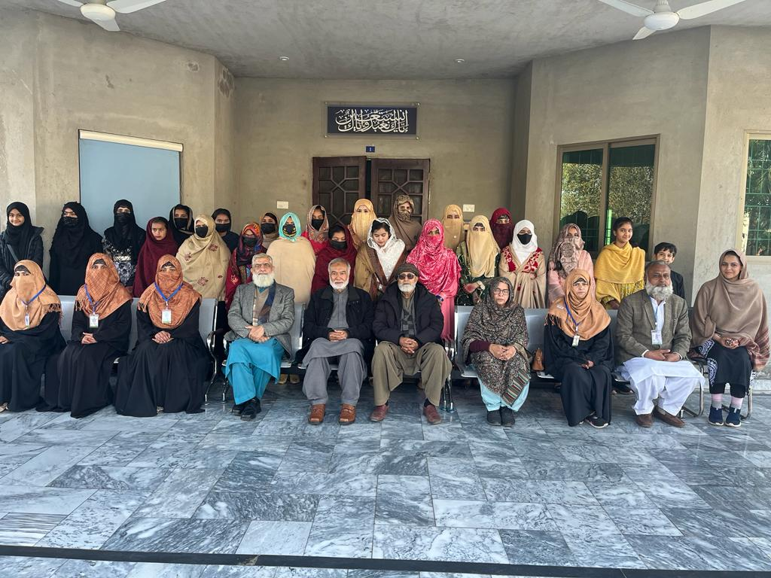

Group Photo of Successful Students with the Chief Guest at VC 118 NB, Sillanwali, District Sargodha

Annexure-B

Dist List Annual Progress Report - 2024

1. MD Mari Energies

2. MD FFC

3. MD Fauji Foundation

4. MD Fauji Cement

5. MD AWT

6. Mr. Adnan Sarwar Cheema

7. Mr. Naseem Shafi

8. Mr. Tariq Rafi

9. Mr Tariq Dawaiwala

10. Mr Tariq M Chaudhary, Karachi

11. Brig Rashid Qureshi (Retd)

12. Brig Muhammad Latif (Retd)

13 Brig Ashfaq Ahmed (Retd), Lahore

14. Dr AR Khalid (Retd)

15 Brig Khalid (Retd), Lahore

16. Mr. Ibrahim

17. Aamir Ashiq Dewan

18. Mr. Junaid Ismail Mansoori

19. Mr. Muhammad Hanif Gohar

20. Mr. Shahab Malik

21. Dr. M. Yahya Chawala

22. Mr. Azhar Nazir

23. Mr. Waseem Pasha Tajammal

24. Dr. Arif Ellahi

25. Mr. Ebrahim Qasim

26. MD FFBL

27. MD Mari Petroleum

28. Cdr Khalid Mehmood (Retd)

29. Col Haddique, Karachi

30. Brig Rashid Siddique (Retd)

31. Brig Arshad Raza (Retd)

32. Vice Chancellor Riphah International University

|  |  |  |  |  |
| --- | --- | --- | --- | --- |
|  | |  |  | |
|  |  | | |