Al Mujtaba Education Trust
Annual Progress Report for Year 2022
01 Jan 2022 – 31 Dec 2022
General.
1. The Year 2022 `proved to be eventful in-spite of unfortunate floods. The Trust continued its activities unabated throughout the year. A number of Board of Trustees meetings were held to review policies and effect improvements where necessary. Executive Committee Meetings were held on as required basis and scholarships were awarded to over 785 students for secondary, higher secondary, certification and DAE courses, vocational training and higher education. The area coverage has been enlarged to 53 Districts. Fund raising functions could not be held due to the havoc caused by the floods and natural mental bent of the philanthropists towards flood affectees.

2. A target of 731 students with budget estimate of Rs. 50 million (Rupees Fifty Million only) was set for year 2022. Considering that fund raising functions were not possible due to floods, special efforts were made by the fund raising team to arrange required funds. The Corporate Companies like Mari Petroleum Company Limited (MPCL) were approached to allocate sizeable funds from their CSR programmes for award of scholarships to our beneficiaries. Besides, private companies and individual philanthropists were also invited to support our programmes. These efforts paid off and we were able to support 785 beneficiaries with the available funds during year 2022.

Scope.
3. This report includes the following aspects: -
a. Award of Scholarships
b. Conduct of Vocational Training.
c. Achievements
d. Visits
e. Miscellaneous Aspects

Award of Scholarships.
4. Executive Committee meetings were held throughout the year at regular intervals. Difficulties were faced in reaching out to the students for award of scholarships due to untimely closure of education institutions and belated holding of annual examinations as well as announcement of academic results due to floods. Inspite of these constraints, scholarships have been awarded to 785 students against a target of 731 students set for year 2022. Details are as under: -
a. Saeeda Naseem and Muhammad Shafi Trusts Scholarships. 44 girl students belonging to rural areas have been awarded Saeeda Naseem Scholarships for classes 9,10 during year 2022. Besides, vocational training has been imparted to 249 rural area girls through Saeeda Naseem and Muhammad Shafi Trusts Scholarships and some additional funds.
b. General Scholarships- Classes 9 & 10. 150 students have been awarded AMET scholarships, target set for year 2022.
c. General Scholarships - Classes 11 & 12. 193 students have been awarded scholarships for classes 11 & 12.
d. Higher Education. 34 students have been awarded AMET scholarships during the year 2022 in the undermentioned faculties: -
(1) MBBS/DPT/DP/DVM : 07
(2) BS Nursing/BS (MLT) : 01
(3) BA/BSc/MSc : 02
(5) B.S/BBA : 16
(6) ADC/ADS : 01
(7) B.E : 01
(8) ADC/ADS : 01
(9) Pharmacist : 01
(10) Dr of Ophthalmology : 01
(11) Civil Engr : 01
(12) BA LLB : 01
(13) Mech Engr : 01

e. Diploma Courses. 38 students have been awarded scholarships for diploma courses spread over 3 years against a target of 25 set for year 2022.
f. Certification Courses. 120 students including 20 girl students have been awarded scholarships for certification courses.
g. Vocational Training. 249 female/ male students belonging to rural areas have been imparted vocational training in Dress Making, Embroidery, Basic Computer, Character Building and Amur-e-Khanadari.
Conduct of Vocational Training.
5. Two courses each of 6 months duration were conducted at Vocational Centres (VCs) Chak-118-NB, Sillanwali, Chawali (Chakwal), Rera (Bagh) Azad Jammu & Kashmir and Bucha (Mandra-Rawalpindi). One course could only be conducted at VC Baffa from Aug to Dec 2022 as this VC was commissioned in Aug 2022. Details are as under: -

COURSES

Ser | Name of VC | Courses
 |  | Dress Making Courses |  | No of Students Trained | Computer Courses |  | No of Students Trained
 |  | Course-1  Jan - Jun 2022 | Course-2  Jul - Dec 2022 |  | Course-1  Jan - Jun 2022 | Course-2  Jul - Dec 2022
a. | VC Chak 118-NB, Sillanwali | 17 | 22 | 39 | 20 | 42 | 62
b. | VC Chawali | 15 | 11 | 26 | 5 | 9 | 14
c. | VC Bucha (Mandra) | 8 | 29 | 37 | 0 | 0 | 0
d. | VC Rera (Bagh) Azad Jammu & Kashmir | 22 | 32 | 54 | 0 | 0 | 0
e. | Baffa | - | 17 | 17 | 0 | 0 | 0
Total |  | 62 | 111 | 173 | 25 | 51 | 76

Achievements.
6. Inspite of floods in certain parts of the country annual examinations were held successfully. Students sponsored by AMET have generally produced good results. Details are given below: -
a. Technological Skills
The Hunar Foundation (THF). 120 students including 20 girls attended different certification courses at various campuses of THF. They all have successfully completed their courses and stand qualified.
b. Other Technical Institutes.
Institute | Students | Grades Achieved
 |  | A+ | A | B | C | Failed | Remarks
Askari Institute of Technology (AIT) | 5 | 3 | 2 | - |  | -
Faiz-Ul-Islam Institute of  Technology (FIT) | 6 | - | - | - | - | 6
Prince Salman Institute of Technology (PSIT) | 6 | - | 2 | 1 | 2 | 1
Kahuta Institute of Technology (KIT) | 6 | 3 | 3 | - | - | 1
c. General Scholarships
Class | Students | Results
 |  | A+ | A | B | C | D | Failed | Left | Remarks
Secondary (Including Cadet Colleges) | 138 | 41 | 67 | 19 | 6 | - | 5 | -
Intermediate | 204 | 39 | 101 | 31 | 20 | - | 13 | -
Higher Education | 47 | 16 | 20 | 4 | 4 | - | - | 3

d. Vocational Training. 249 girl students attended vocational training courses at the respective vocational centres. Results are as under: -
Ser | Course Title | Students Trained | Grades Obtained
 |  |  | A+ | A | B | C | D | Failed
a. | Computer Courses | 76 | 43 | 25 | 5 | - | - | 3
b. | Dress Making Courses | 173 | 33 | 56 | 35 | 35 | 9 | 5
Total |  | 249 | 76 | 81 | 40 | 35 | 9 | 8

7. Some of Our High Achievers
a. Laiba Rizwan.
Laiba Rizwan secured our scholarship in class 9th, being a needy and talented student from a remote village of Gulli Bagh in District Mansehra (KP). She secured A Plus grade (957/1100) in matric from Siran Public School Baffa Mansehra. Spotting her potential, she was afforded an opportunity to study in Peace Group of Schools & Colleges Mansehra, about 20 KMs from her house. She proved her mettle and secured A Plus grade (1054/1100) in FSc. Her brilliance earned her our scholarship for 5 years Doctor of Physical Therapy (DPT) Course in Riphah International University Islamabad. She has secured GPA 3.57/4 in her last semester examination.
b. Isha Haider.
An orphan who belongs to a remote village of Kallar
Kahar. She was granted AMET scholarship in year 2020
for two years to complete her FSc. She secured 93% marks in Class 12 final board examination. She has been admitted in The Faisalabad University (TUF) on merit where she is pursuing 5 years programme of Doctor of Physiotherapy (DPT). She has secured CGPA 3.61 in her 2nd semester examination.
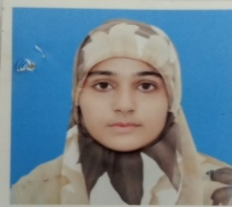
c. Sehrish Rauf.
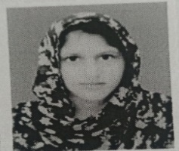
Sehrish Rauf is an orphan, daughter of a deceased soldier of Pakistan Army and hails from rural area of Interior Punjab. She completed her basic education from village school in flying colours. She was at a verge of abandoning her studies once and for at all due to financial difficulties. This is when AMET supported her while she was student of BSC Zoology in University of Sargodha. On graduation she was placed second in her class and also earned a silver medal with CGPA of 3.71. Alhamdo-lillah AMET took an exception and financially supported her as a special case for MPhil in genetics at Minhaj University Lahore. She has now completed her third semester with CGPA of 4.

d. Fatima Latif
Hails from a remote village of District Bahawalpur. She got admission in BS (CS) in University of Engineering Mughalpura Lahore (UET Lahore) on merit. Her entire education programme spread over 4 years has been sponsored by the Trust. She has successfully completed her course and is now looking for a job.
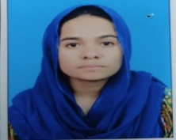
e. Umbul Banin
She belongs to a remote village of Gilgit Baltistan. She secured admission in Centre for Advanced Studies in Engineering (CASE) Islamabad in BSC in Electrical Engineering on merit. Her programme spread over 4 years has been entirely sponsored by the Trust. She has completed her studies and currently working in a well reputed Amazon based company. She intends doing masters from Germany.
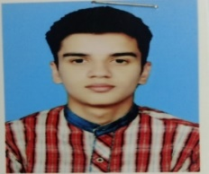
f. Faiz Rashid
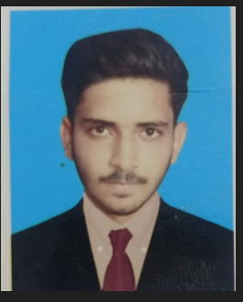
Cadet Faiz Rashid an orphan was sponsored by the Trust in Cadet College Sargodha. Having completed his intermediate education he appeared in ISSB and got selected for Pakistan Military Academy. He is the 1st AMET sponsored cadet to join the Academy and is in 2nd term.

g. Danish Fiaz
Student Danish Fiaz belongs to a remote village of District Sargodha. His father is a tailor. He scored 92% marks in matric board examination and got admission in FSc (Pre-Medical) in Superior College Sargodha on merit. He scored 95% marks in Annual Board Examination of FSc. He has joined Army Medical College on open merit as a regular cadet. He is the 1st Al Mujtaba Education Trust sponsored student to join the Army Medical College as a regular cadet.
Fund Raising Efforts.
8. The Chairman had a meeting with Mr. Adnan Sarwar Cheema and shared with him the performance of students being sponsored by him. He was pleased with the result produced by our students and donated Rs. 20.0 Million (Rupees Twenty Million only).
9. The Chairman called on Managing Director (MD) Mari Petroleum Company Limited. Education programmes of AMET were discussed at length and a proposal covering various education programmes involving financial support through CSR was presented to the MD. The Company fully accepted our proposal and donated Rs. 20 Million (Rupees Twenty Million only).
Visits
10. Lahore Visit. Chairman AMET accompanied by Vice Chairman and Member Special Projects visited Lahore from Saturday 10th December 2022 to Monday 12th December 2022. The visit was aimed at meeting Lahore based Trustees and to enroll new Friends of Trust who can assist AMET in finding potential donors for our forthcoming fund-raising function, before the holy month of Ramazan. Details are covered in the following paragraphs:-
a. 10th December 2022.
(1) Call on Mr Nauman Ashraf Son of Maj Gen M. Ashraf Chaudhary (Late). The Chairman along with Member Special Projects called on Mr Nauman Ashraf son of Maj Gen Muhammad Ashraf Chaudhary (Late) at his residence in DHA Phase-2 Lahore and offered condolences and prayers that may Allah SWT bless the departed soul of Maj Gen Ashraf in eternal peace and grant him highest place in ‘Jannat ul Firdous’.
(2) Call on Lt Col Asad Mehmood Khan (Retd). The Chairman along with Member Special Projects called on Lt Col Asad Mehmood Khan (Retd) at his residence in DHA Phase-2 Lahore and offered condolences for his son, who died around two months back due to cancer. May Allah SWT bless the departed soul in eternal peace and grant him highest place in ‘Jannat ul Firdous’.
b. 11th December 2022, Meeting of Trustees and Friends of Trust.
Vice Chairman started the meeting with recitation from Quran and introduced the new Friends of Trust. Thereafter, The Chairman AMET addressed the meeting. He welcomed the participants and gave a brief rundown of AMET activities and the progress made during the year 2022. Amongst friends of the Trust, Mr Orya Maqbool Jan, Dr Khalid Jamil and Dr Sohail Iqbal addressed the meeting and commenced efforts of AMET towards facilitating education of talented needy students and financial empowerment of rural area girls and women.
12. Karachi Visit. Chairman accompanied by Vice Chairman visited Karachi from 22 Dec 2022 to 25 Dec 2022. The visit was aimed at meeting Karachi based Trustees, as well as potential donors to initiate fund raising efforts. Details are given in the following paragraphs:-
b. 22 Dec 2022
(1) Meeting at Mari Petroleum Guest House.
As done before a meeting was arranged for our Trustees in Karachi in Mari Petroleum Guest House at 1830 hours. It was attended by the following:-
- Lt Gen (Retd) Ghulam Muhammad Malk (Chairman)
- Maj Gen(Retd) Malik Muhammad Masud (Vice Chairman)
- Mr Tariq M.Chaudhry, Trustee
- Mr Muhammad Tariq Dawaiwala, Trustee
- Lt Col(Retd) Muhammad Aslam, Trustee

(2) The Trustees were informed about the major activities of the Trust and asked to give their views regarding Fund Raising Function at Karachi in the month of Feb / Mar 2023. Generally the consensus was that we have not been able to contact many friends for the last few months and as such it would not be possible to hold the function before the month of Ramazan. Once we are able to attract some more donors we may hold the function sometimes in July / August 2023.

b. 23 Dec 2022, Meetings with Important Donors.
(1) Chairman alongwith his team met Mr Muhammad Naseem Shafi, Chairman Muhammad Shafi Trust at his office. He is a prominent donor of Al Mujtaba Education Trust and contributes a large amount every year. The team discussed with him the utilization of his donation. He was fully satisfied with our discussion and the progress achieved by the Trust.

(2) AMET team had a long meeting with Mr Tariq M Chaudhry at 1300 hours. He is one of our prominent Trustees and a major donor. He agreed to make more contacts and prepare for "Fund Raising Function" in July/August 2023.

(3) Chairman called on Mr Tariq Rafi, a prominent businessman and our regular donor and gave him the progress of the Trust. This was followed by lunch at his office in Ocean Mall Clifton.

- 24 Dec 2022. Chairman accompanied by his team visited Hunar Foundation Korangi Complex, Karachi at 1030 hrs. Had a very detailed discussion with Air Commodore (Retd) Muhammad Nasir Uddin, SI (M) and his close associates. He briefed the AMET team about progress of their Korangi Complex and the facilities which are increasing every year. He also shared with AMET team about THF efforts regarding collaboration with an NGO in Finland. He agreed to send us the details about their discussion and AMET may be able to benefit from this NGO.

Miscellaneous Aspects.
13. Cooperation with Like Minded Organizations. Trust is in the process of signing an MOU with Rawalpindi Medical College to secure admission of selected students in Allied Health Sciences.
Certificate Award Ceremonies.
14. These ceremonies were held at the respective vocational centres (VCs). The qualifying students were awarded course certificates and first three position holders at each of the VC were given cash prizes also.
15. Election of Vice Chairman. Maj Gen (Retd) Malik Muhammad Masood was elected as Vice Chairman of the Trust unanimously in Board of Trustees meeting held on 13 Oct 2022.
Photo Gallery.
16. Attached with the report.
Conclusion.
17. The year under review has ended on a good note. With the award of scholarships to 785 students in year 2022. The total number of beneficiaries supported by the Trust since 2016 stands at a respectable figure of 3148 students. Targets set for year 2022 have been surpassed due to generous support of our donors. It is felt that with the unflinching support of foreign donors as well as major donors like MPCL, Mr. Naseem Shafi and Mr. Adnan Sarwar Cheema, the Trust will be able to take care of increased number of beneficiaries and enlarge its area of coverage further, particularly in Sindh and Balochistan. The scholarships offered by Riphah University, The University of Faisalabad and Rawalpindi Medical College/ University would lead to opening up new avenues for beneficiary students interested in pursuing higher education. We gratefully acknowledge the support of our donors and look forward to their continued association.
18. May Allah always be our Guide and Protector.

Lt Gen (Retd)
Chairman
Ghulam Muhammad Malik
Rawalpindi
08 Mar 2023

Distribution
Attached

AL MUJTABA EDUCATION TRUST
CHAKLALA SCHEME III, RAWALPINDI

PHOTO GALLERY
Al Mujtaba Vocational Training Centre
Chawali (Chakwal)
Photo Gallery

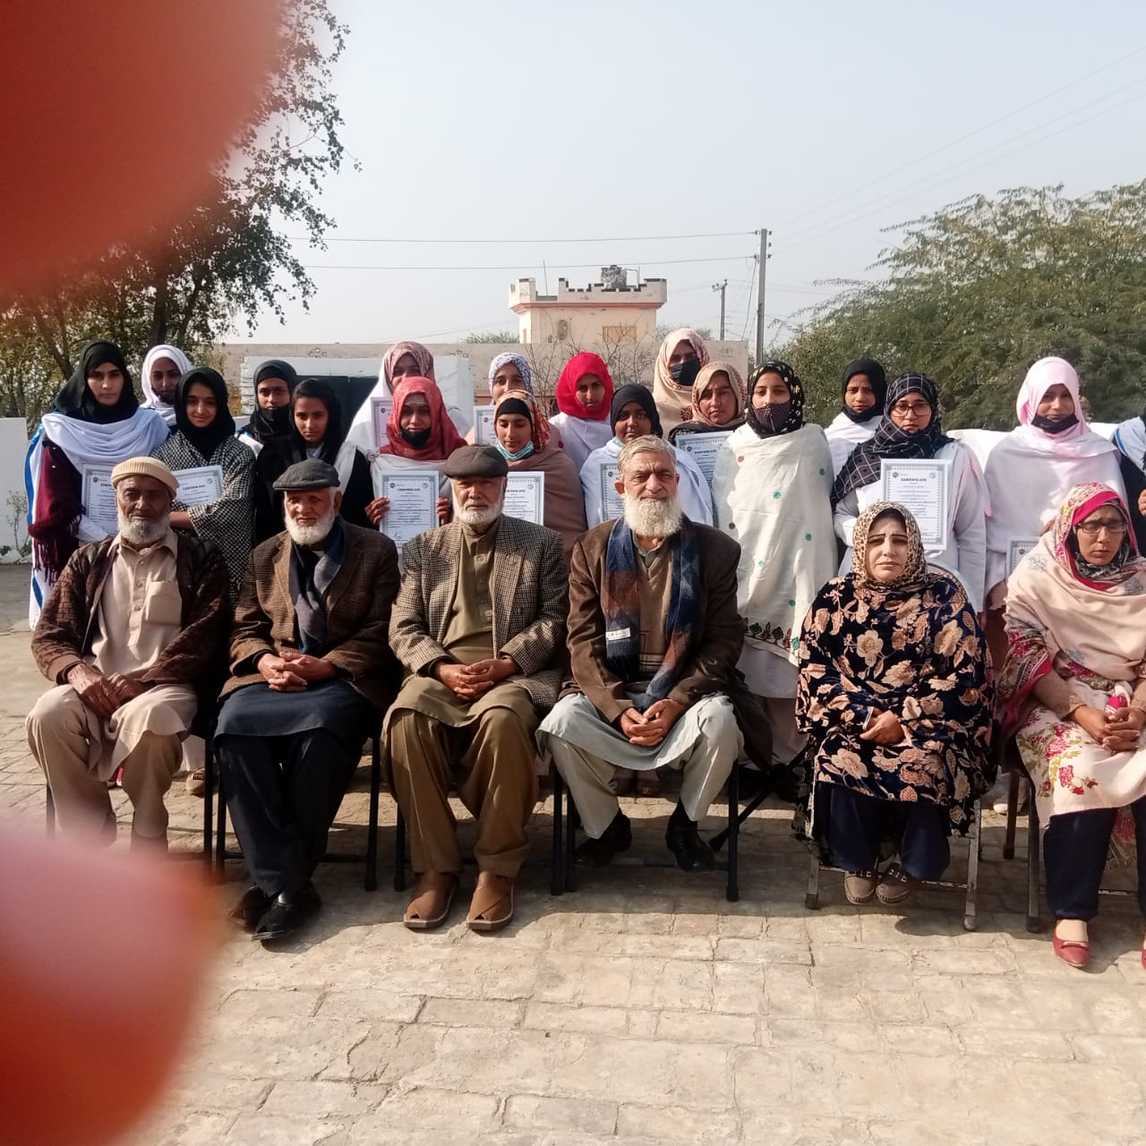
Group Photo of Students of VC Chawali with the Chief Guest

Al Mujtaba Vocational Training Centre
Rerha (Bagh) AJ & K
Photo Gallery
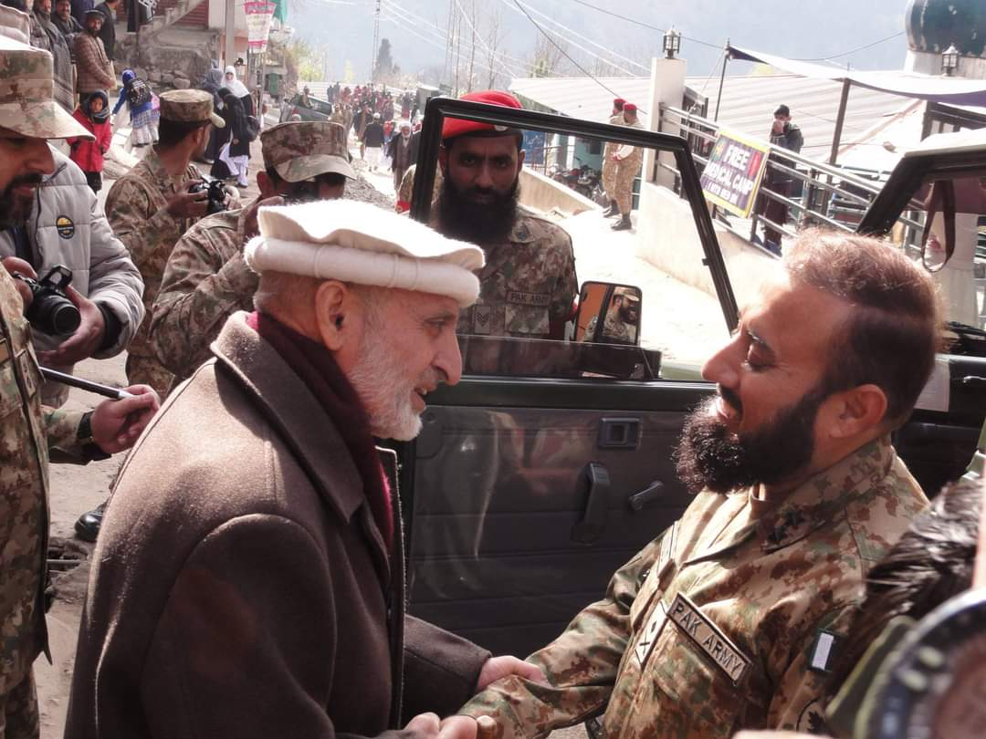
The Chief Guest Being Received by the Project Director

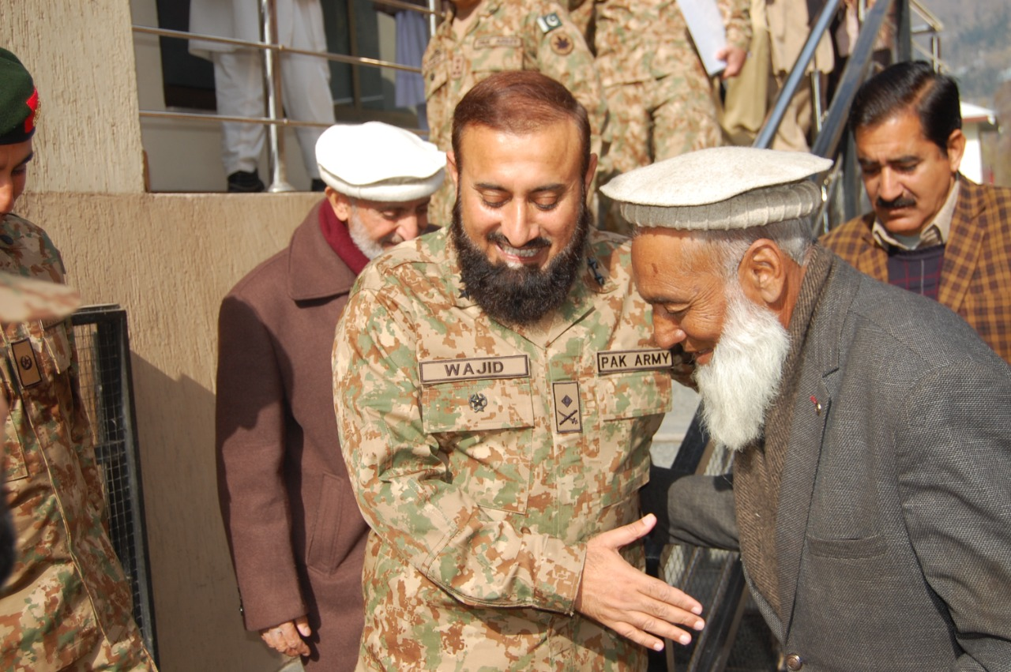
Chief Guest Being Introduced to the Notables

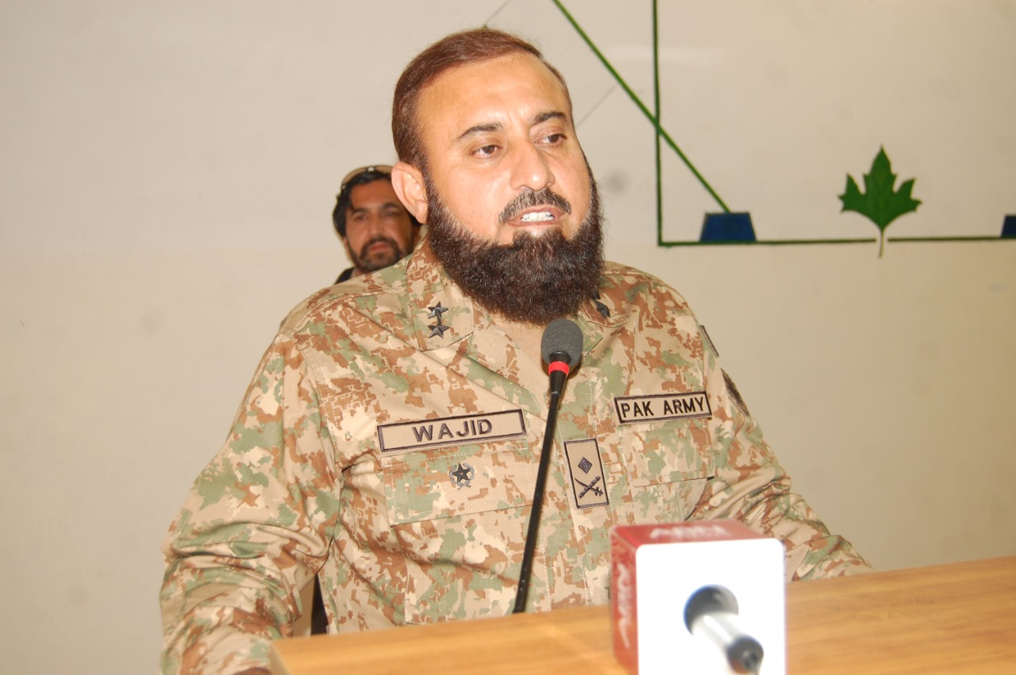
The Chief Guest Addressing the Audience

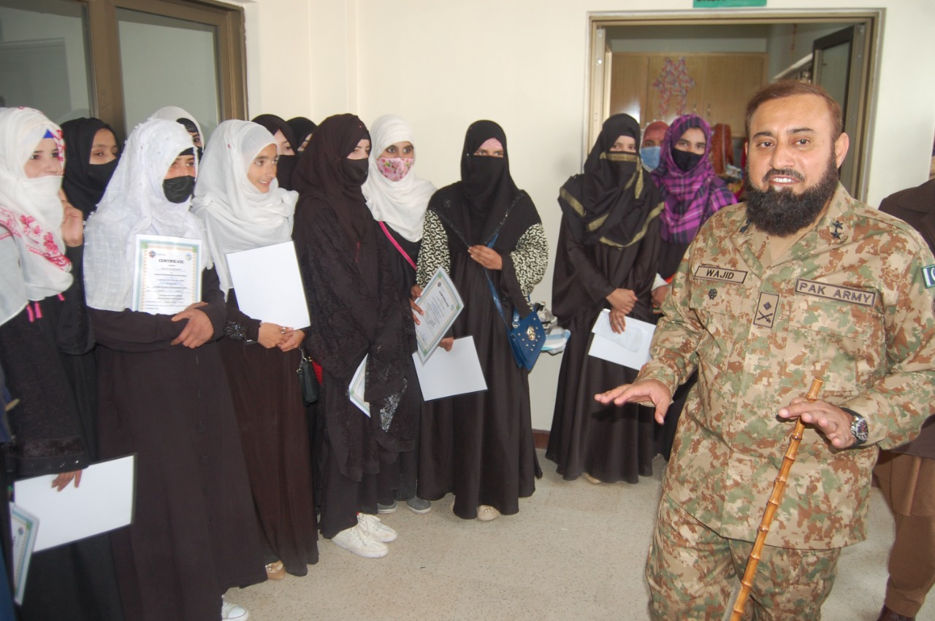
The Chief Guest Interacts with the Qualifying Girl Students of Dress Making Course

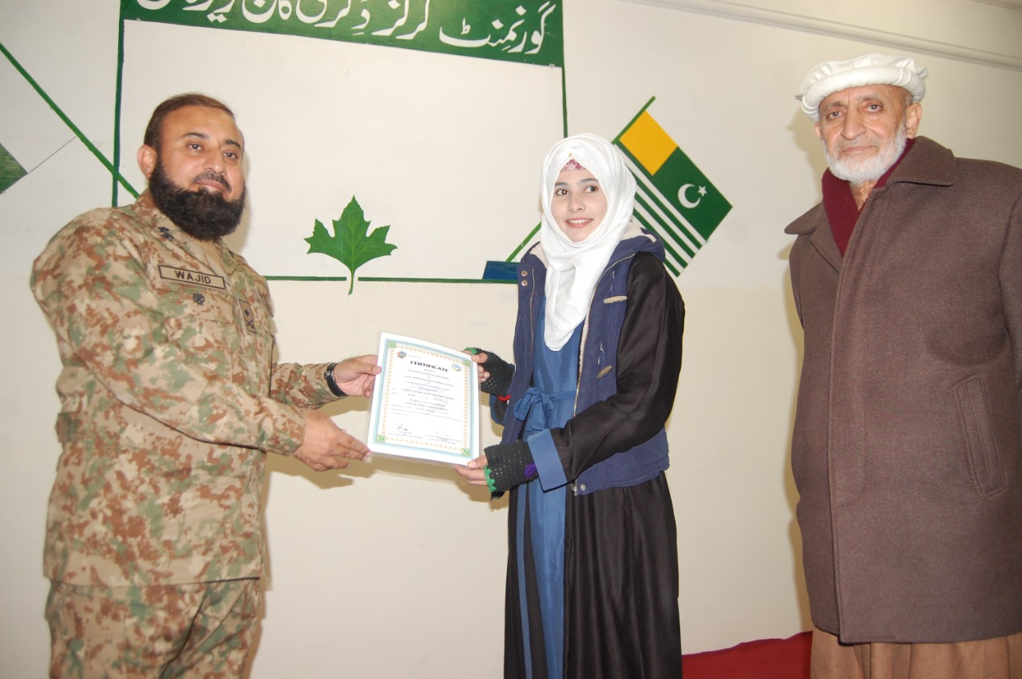
The Chief Guest Awarding Course Certificate to a Successful Girl Student

Al Mujtaba Vocational Training Centre
Bucha (Mandra) Rawalpindi
Photo Gallery

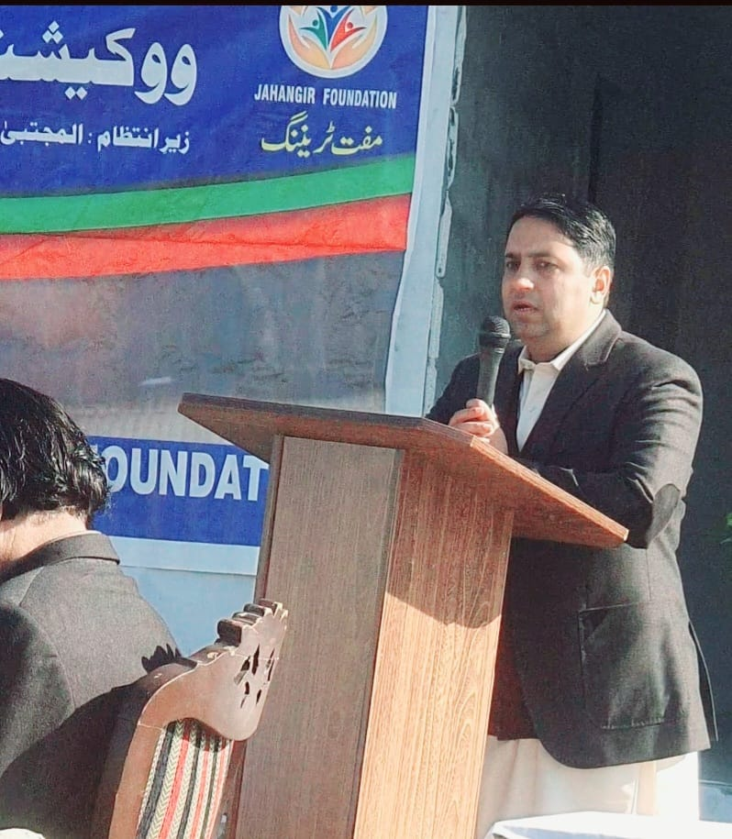
Project Director Presenting Welcome Address at VC Bucha

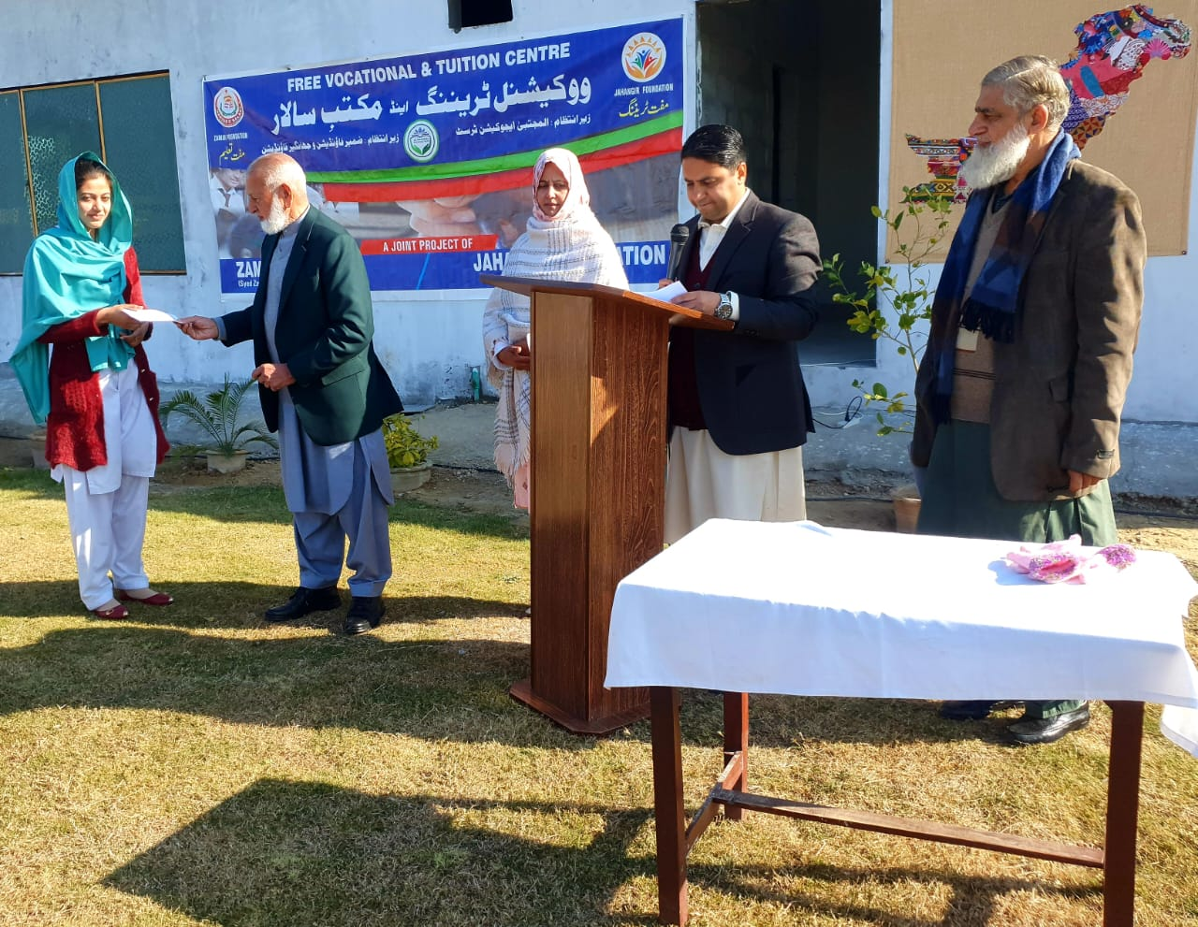
Position Holder Student Receiving Cash Prize from the Chief Guest at VC Bucha (Mandra)

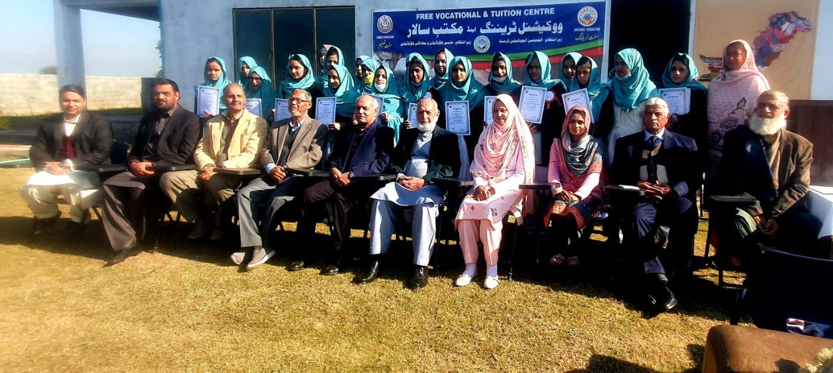
Course Group Photo with the Chief Guest, Teachers and Trust Management at VC Bucha (Mandra)

Al Mujtaba Vocational Training Centre
Baffa (Mansehra)
Photo Gallery

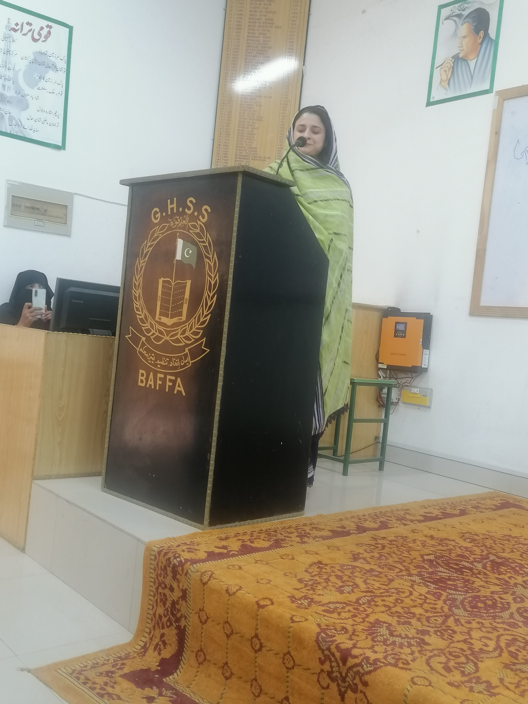
Project Director VC Baffa Delivers Her Welcome Address at VC Baffa
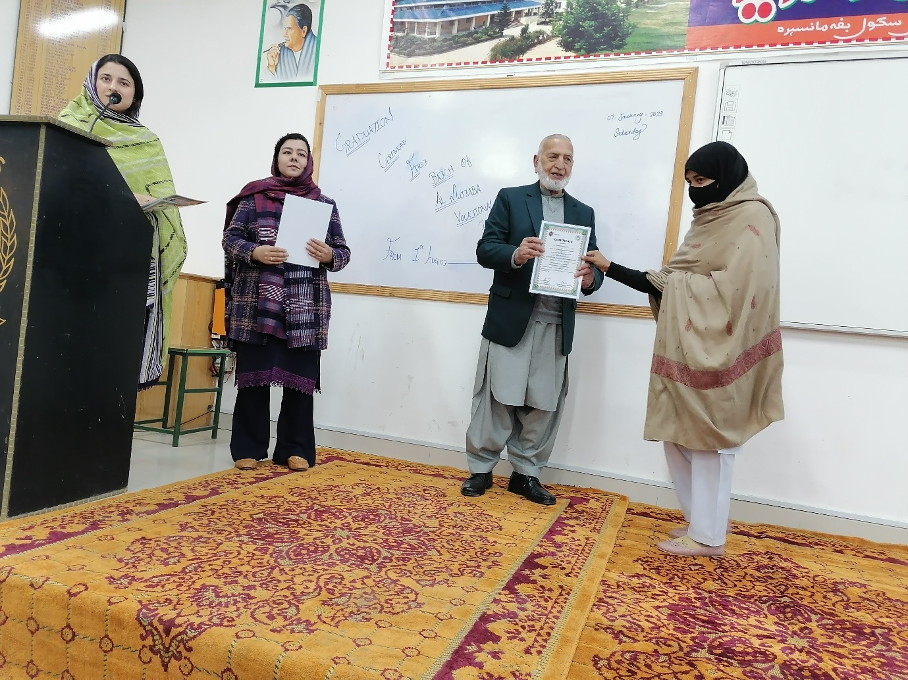
A Successful Girl Student Receives Course Certificate from the Chief Guest at VC Baffa

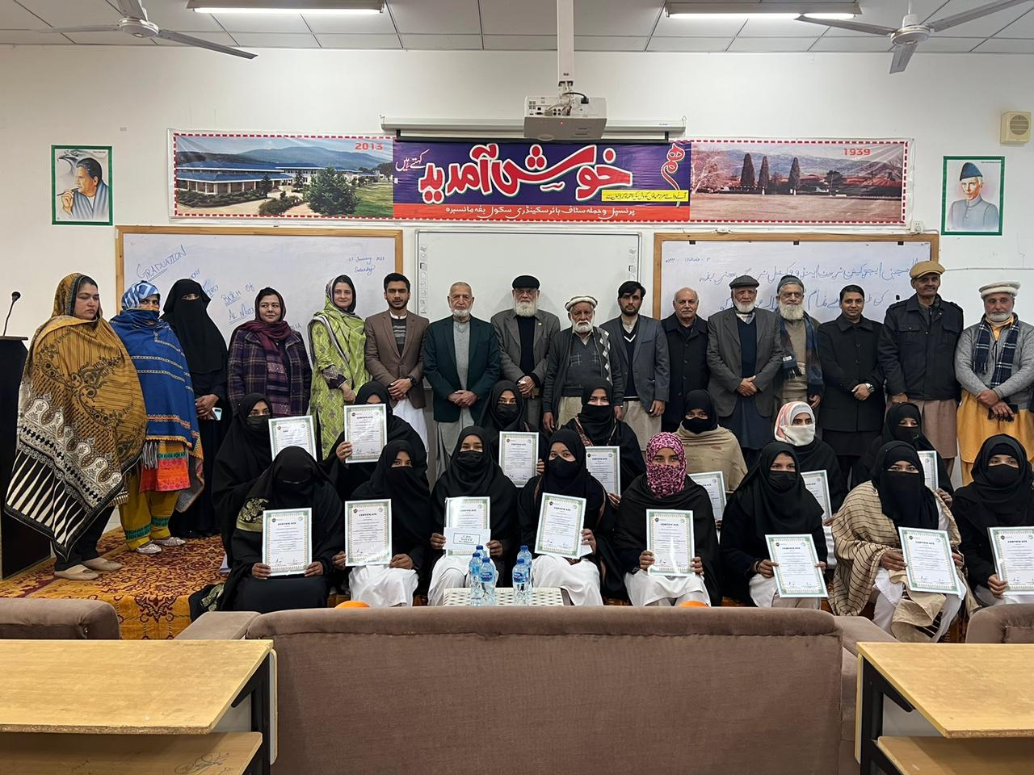
Course Group Photo with the Management at VC Baffa
