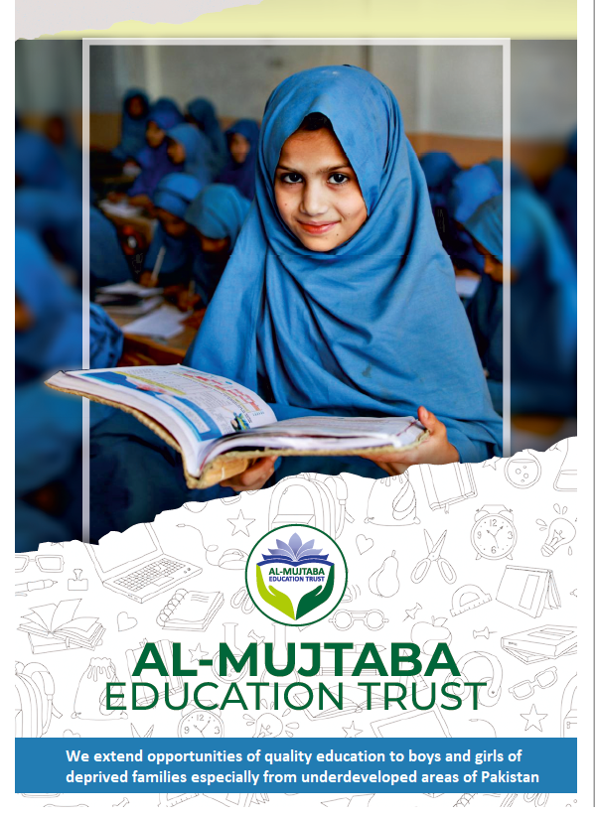

"Spend (in the Cause of Allah (SWT) from the provisions that We have given you before death "O my Lord, why did you not reprieve me awhile that I should have given in charity and become of the righteous." But Allah (SWT) does not at all reprieve a person when his term comes to an end, and Allah is well aware of what you all do.
(63:10)
___________________
Those who spend of their goods (in Charity) by night and by day in secret and in public shall have their reward with their Lord: on them shall be no fear nor shall they grieve.
(2:274)

Al Mujtaba Education Trust
Introduction
Education determines the intellectual prowess of a nation and ensures a systematic and assured course towards prosperity. Developed nations have a system of uniform quality education available to all segments of the society in the formative stage through public and private schools. Unfortunately majority of our talented youth is deprived of this opportunity for a host of reasons and thus a Raison D’etre for the creation of Al Mujtaba Education Trust.
Al Mujtaba Education Trust (AMET) was established in Jan 2016. After formulation of the Trust Deed and Bye Laws it was registered in February 2016 under Societies Registration Act, XXI of 1860 vide Registration No 47/2016. Thereafter, standard operating procedures (SOPs) regarding accounts, ‘zakat’ donations, selection of beneficiaries and monitoring procedures were prepared. Our Bye Laws stipulate the composition of the Executive Committee to run day-to-day affairs and job description of all members as well as employees. The Board of Trustees oversees the working of the Executive Committee and takes major policy decisions.
Vision
Our vision is to ‘break the poverty – illiteracy linkage,’. We intend to contribute towards the creation and sustenance of an environment where talented and needy students have access to scholarships and interventions that address resource gaps affecting the realization of their true potential.
We visualize a state where every talented and needy child gets fair opportunities to become responsible and productive member of the society.
Mission
Provide financial assistance to talented boys and girls from poor families to enable them to study and excel in existing or higher quality schools, colleges and institutions of technology. Where necessary, assist educational institutions in improving teaching skills of their teachers.
Objectives
- Support education of needy talented students by bearing expenses on fees, uniforms, and conveyance etc., and where necessary, have them admitted in higher quality institutions.
- Finance technical and vocational training for boys and girls having aptitude, thereby enabling them for suitable jobs.
- Support students having high grades to study in quality colleges to enable them to qualify for higher studies such as MBBS, MBA and Computer Science.
- Assist in capacity building in selected schools by organizing workshops and short courses in collaboration with NGO’s etc.
Scholarship Award Policy
Purpose. Ensure that students selected for award of scholarships are the most deserving in accordance with aims and objectives of the Trust.
Scope. The policy covers aspects related to selection of students for award of scholarships. It will be treated as guidelines for Trust selection processes by Trustees and the Executive Committee. While the policy covers all general considerations involved in processing student applications, case specific/additional issues needing special handling cannot be ruled out. Chairman of the Trust and Executive Committee will be authorized to handle and manage any deviations deemed essential and suitable to the situation/case in hand.
Policy Framework.
- Principles. Proper selection of students is a vital and sacred responsibility. Following principles form the cornerstones of the policy to ensure that Trust funds are utilized effectively for achieving objectives laid out in the ‘Memorandum’ and the ‘Articles of Association’: -
- Incorporation of fair, criteria based and transparent selection process.
- Gender-based equalization of opportunities.
- Maximization of outreach to extend benefits to all areas of the Country.
- Maximization of coverage of education streams.
- Sustainability.
- The process of selection will be kept simple and flexible with provision for due oversight. The policy will regulate following aspects: -
- Education levels for which scholarships will be awarded.
- Criteria for selection of beneficiaries.
- Selection Process.
- Roles and Responsibilities.
Categories/Levels of Education. Students of following education streams will be eligible for award of AMET scholarships: -
- Secondary (SSC) and Higher Secondary School Certificate (HSSC) levels.
- Vocational/Skill Training Courses
- Technology Courses. Skill Certificates, post Matric Diploma Associate Engineer (DAE) Courses.
- Graduate/Postgraduate Levels except Phd.
General Criteria
- Talented students belonging to economically challenged families will be eligible. Duality will not be allowed in that, students receiving financial support from any other source, otherwise eligible will not be considered. Following criteria will be applied; -
- Good Academic Record. Must have scored minimum ‘A’ grade marks in previous formal examinations with priority to: -
- Students at rural Govt. schools.
- Students at private schools where Govt. Schools are not available, inoperative or lacking specific subject teaching facility.
- Orphans will be especially facilitated.
- Recommended by administration of school where enrolled and/or Trustee.
- Students who have lower grades but still recommended by Trustee/Community representative and/or school administration on basis of their potential and/or marginalized status of family will be supported after independent evaluation carried out by the Scrutiny Committee deputed by the Board of Trustees.
- Un-enrolled children of poor families/orphans/madrassa students/street children (separated from families) will be considered as special cases and supported on case-to-case basis as decided by Board of Trustees. Recommendations for consideration for such cases may be made based on any of the following: -
  - Personal information of Sponsor/Project Director/Member Area Coordination Committee (ACC).
  - Recommendations of community representatives.
  - Any other reliable source of information.
Specific Criteria
- Secondary School Certificate (SSC)/Higher Secondary School Certificate (HSSC)
- Candidate must have secured 80% marks in class 8 annual examination.
- Candidate must have sought admission in a local registered/ recognized school/college respectively.
- Candidates must be recommended for award of scholarship by the head of the institution, member area coordination committee and the Project Director of the area.
- Continuation of support will be subject to academic performance. Achievement of at least A grade in class 9 and class 11 board examinations respectively will be mandatory.
Higher Education and Technology Courses – Additional Criteria
- Candidates must have secured admission in recognized Colleges/Universities/Institutes through their own efforts.
- Must have secured following minimum percentage marks for respective levels: -
- Higher Education. 80%
- DAE Courses. 60% in Matric or Entrance test of Institute.
- Skill Certificates. As per requirements of course. (Preferably 60% in Matric or Entrance test of Institute).
    - For DAE courses and Skill Certificates nominations (in accordance with Trust criteria) from partner institutes duly pre-evaluated by Trust will be given preference.
    - Existing beneficiaries coming through lower levels will be given extra weightage marks (to be decided by the ‘Executive Committee’ (EC) for continuation to graduate levels subject to meeting other criteria.
    - Continuation of support will be subject to academic performance. Achievement of following minimum grades will be mandatory: -
- Higher Education. Minimum 75% or equivalent GPA (2.75).
- DAE. Minimum 60%.
Vocational Training in Rural Areas. Youth of rural areas will be eligible irrespective of education qualifications. Preference will be given to girls who matriculate.
Selection Process
- Budgetary Allocation. The number of beneficiaries to be supported will depend on resource availability for the academic year. Subject to inflow of funds, draft plan for distribution of resources amongst various education levels will be evaluated by the Executive Committee and approved by the Chairman on following basis: -
- Availability of funds for continuation of scholarships for enrolled beneficiaries.
- Donor preferences for streams of education to be supported.
- Balanced distribution amongst genders, geographical areas, and education streams. The number of students for each level will be determined on an annual basis.
- Budget estimates and targets set for different levels of education will be approved by the EC on a yearly basis.
Identification of Potential Beneficiaries
    - Needy and talented students meeting Trust criteria of academic record can apply directly to Trust. Applications will be required to be sent to Trust offices on prescribed forms downloadable from Trust website ‘almujtaba.pk’ or acquired from Trust office.
    - Trustees nominated as ‘Project Director (PD)’ will recommend potential candidates for AMET support and facilitate their selection process.
    - Tests/interviews etc., will be conducted by AMET if/when considered necessary.
Consideration of Beneficiaries for Selection
    - Recommended cases will be scrutinized by ‘Scrutiny Committee’ (SC) nominated by Chairman Trust for shortlisting prior to discussion in EC meeting for final approval.
    - Donors may nominate specific cases for award of scholarships out of their donations. Such nominations will be included as a special category, however, approval in EC meeting will be mandatory. In case EC considers a nomination at variance with Trust policies, alternate names will be requested or proposed for concurrence by donor.
    - Selection will be finalized and approved by the EC. Chairman will be final arbiter.
    - PDs will act as sponsors for respective candidates.
    - Frequency of Selection. Selection of beneficiaries will be carried out in accordance with admission schedules of academic institutions. Exceptions will be considered on case to case and on required basis.
Selection of Candidates. Four step process will be followed: -
    - Step 1. Allocation of budget for AMET support.
    - Step 2. Identification of candidates and recommendations by PDs for inclusion in shortlists for AMET support: -
- ‘Candidate Registration Form’ will be filled in and endorsed for each proposed candidate for AMET support by respective PDs as well as members area coordination committees.
- Where felt necessary ‘Confirmatory Tests’ by Member/Committee designated by EC will be carried out.
- Where considered necessary PD/ Senior Member Coord (SMC) will carry out and present comparative evaluation of candidates to ensure fair selection amongst competing cases in case of resource constraint.
- Step 3. Short Listing and preparation of provisional list will be carried out by Security Committee (SC).
    - Step 4 - Final Selection
- Each candidate included in short-listed as potential beneficiary will be presented in Executive Committee Meeting for approval. Information provided in ‘Beneficiary Registration Form’ will be the basis of consideration.
- Chairman may approve inclusion of exceptional cases other than those shortlisted by ‘Scrutiny Committee’.
- Timely Completion of Selection Process. It will be ensured that the selection process is completed in time to enable selected candidates to pay their education expenses to the respective institutions on specified dates.
Support Package
  - Financial support levels will vary in accordance with the needs of beneficiaries.
  - While all expenses related to education including fees, books, transport/hostel charges, uniform etc., will be eligible, actual grants will be on required basis to be decided by the EC.
  - Sustainability for the entire duration of course will be ensured. It will thus be arranged that funds needed for continuation of education progress are kept available as "restricted funds" to be released in accordance with payment schedules of educational institutions in subsequent years till completion of the course/degree/studies.
  - Part payments, one-time grants and returnable time-based loans may be considered on case-to-case basis.
Monitoring and Evaluation. Post selection beneficiaries will be monitored by respective PDs who will engage with students, parents, and respective academic institutions. Following aspects will be included in the monitoring activities: -
  - Monitoring and maintaining academic results and records of funds allocated as the beneficiaries’ progress through academic years. Case files for each student will be maintained.
  - Counselling of beneficiaries who fail to achieve minimum essential grades. A graduated approach from counselling to warning to suspension and if necessary, termination of scholarship, will be adopted allowing maximum possible opportunity to the beneficiary to improve.
  - Facilitation to beneficiaries for resolution of any issues having potential to impact studies.
  - Recommendations for continuation of support or discontinuation in case of persistent dissatisfactory progress and/or matters related to conduct.

Termination/Withdrawal of Scholarship. In case of continued and persistent unsatisfactory academic performance or conduct scholarships will be terminated. Scholarships will also be withdrawn from beneficiaries who manage to get financial support from any other source.

Policy Review. The policy will be reviewed on an annual basis.

Education Streams and Scholarships Awarded Since Inception

- Areas Covered: 8 Districts including Rawalpindi, Mansehra, Chakwal, Sargodha, Attock, Gujranwala, FATA, Karachi

- Areas Covered: 18 Districts including: -
- Punjab. Rawalpindi, Sargodha, Khushab, Mianwali, Chakwal, Faisalabad, Lahore, Sahiwal, Gujranwala, Attock
- Sindh. Karachi, Nawabshah
- KPK. Mansehra, Kohat, Haripur, Charsada, Peshawar
- Balochistan. Kohlu

- Areas Covered. 21 districts including: -
- Punjab. Rawalpindi, Sargodha, Khushab, Mianwali, Chakwal, Faisalabad, Lahore, Gujranwala, Sahiwal, Attock, Khanewal, DG Khan,
- Sindh. Karachi, Nawab Shah
- KPK. Mansehra, Peshawar, Charsadda, Kohat, Karak, Haripur
- Balochistan. Kohlu
2019

- Areas Covered. 36 districts including: -
- Punjab. Rawalpindi, Sargodha, Khushab, Mianwali, Chakwal, Faisalabad, Lahore, Gujranwala, Sahiwal, Attock, Khanewal, DG Khan, Okara, Jhang. Nankana Sahib.
- Sindh. Karachi, Nawab Shah, Sanghar, Tando Jam
- KPK. Mansehra, Peshawar, Charsadda, Kohat, Karak, Haripur, Bannu, DI Khan
- Balochistan. Kohlu, Barkhan
- Azad Jammu & Kashmir. Muzaffarabad, Bagh, Kotli, Hatian Bala, Rawalakot, Palandri
- Gilgit Baltistan. Gilgit

2020

- Areas Covered. 46 districts including: -
- Punjab: Attock, Chakwal, D G Khan, Faisalabad, Gujranwala, Kasur, Khushab, Jhang, Lahore, Mianwali, Muzafargarh, Nankana Sahib, Okara, Pakpattan, Rawalpindi, Sahiwal, Sargodha, Khanewal, Multan.
- Sindh: Karachi, Nausheroferoz, Hyderabad, Nawabshah, Sanghar
- KPK: Charsadda, Kohat, Mansehra, Mardan, Shangla, South Waziristan, North Waziristan, Kohistan, Abbottabad, Haripur, Peshawar, Banu, DI Khan.
- Balochistan: Kohlu, Barkhan, Quetta.
- Azad Jammu & Kashmir: Bagh, Rawalakot, Neelum, Palandri.
- Gilgit Baltistan: Gilgit
- Capital Territory Islamabad
2021

- Areas Covered. 53 districts including: -
- Punjab: Attock, Chakwal, Chiniot, Faisalabad, Gujranwala, Gujrat, Jehlum, Jhang, Kasur, Khanewal, Khushab, Lahore, Mandi Bahauddin, Mianwali, Multan, Muzzafargardh, Okara, Pakpatan Shareef, Rajanpur, Rawalpindi, Sahiwal, Sargodha, Sialkot, Vehari.
- Sindh: Karachi, Benazirabad, Tando Allah Yar, Sanghar, Tando Adam
- Khyber Pakhtun Khwa: Charsadda, Dir, Kohat, Laki Marwat, Malakand, Mansehra, Mardan, Mohmand, Peshawar, Swabi, Wana, Banu
- Balochistan: Kohlu, Barkhan, Loralai, Quetta.
- Azad Jammu & Kashmir: Bagh, Palandri, Kotli, Rawalakot
- Gilgit Baltistan: Gilgit, Diamir, Ghizer
- Capital Territory Islamabad: Capital Territory Islamabad

2022

(Award of scholarships for year 2020 was affected due to COVID-19)

Gender Ratio

Equal opportunities are provided to both, girls and boys as evident from the following figure.

Our Beneficiaries – Some Samples

Laiba Rizwan

Laiba Rizwan belongs to a remote village of Gulli Bagh in District Mansehra (KP). She secured our scholarship in class 9th and went on to achieve A Plus grade (957/1100) in matric from Siran Public School Baffa Mansehra. In view of her hard work and potential, she was afforded an opportunity to study in Peace Group of Schools & Colleges Mansehra, about 20 KMs from her house. She proved her mettle and secured A Plus grade (1054/1100) in FSc. Her brilliance earned her our scholarship for 5 years Doctor of Physical Therapy (DPT) Course in Riphah International University Islamabad. She has secured GPA 3.57/4 in her last semester examination.
Isha Haider

An orphan who belongs to a remote village of Kallar Kahar. She was granted AMET scholarship in year 2020 for two years to complete her FSc. She secured 93% marks in Class 12 final board examination. She has been admitted in The Faisalabad University (TUF) on merit where she is pursuing 5 years program of Doctor of Physiotherapy (DPT). She has secured CGPA 3.61 in her 2nd semester examination.
Sehrish Rauf
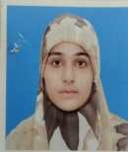

Sehrish Rauf is an orphan and hails from a rural area of Interior Punjab. She intended to pursue BSC Zoology at University of Sargodha but due to financial difficulties she was on the verge of abandoning her studies. We consider it a matter of satisfaction that we helped her avoid that path and supported her to complete her degree. She has lived upto expectations and graduated with CGPA of 3.71 and won a silver medal. Considering her keen interest in education we continued her support for MPhil in Genetics at Minhaj University Lahore. She has now completed her third semester with a CGPA of 4, the highest possible grade.
Fatima Latif
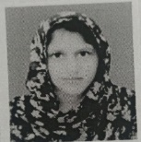

Fatima Latif Hails from a remote village of District Bahawalpur. She got admission in BS (CS) in University of Engineering Mughalpura Lahore (UET Lahore) on merit. Her entire education program spread over 4 years has been sponsored by the Trust. She has successfully completed her course with a CGPA near 3.5.

Umbul Banin
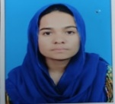
Umbul Banin belongs to a remote village of Gilgit Baltistan. She secured admission in Centre for Advanced Studies in Engineering (CASE) Islamabad in BSC in Electrical Engineering on merit. Her program spread over 4 years has been entirely sponsored by the Trust. She has completed her studies and is currently working in a well reputed Amazon based company. She intends doing masters from Germany.

Faiz Rashid Malik
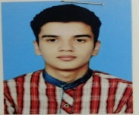
Cadet Faiz Rashid an orphan was sponsored by the Trust in Cadet College Sargodha. Having completed his intermediate education he got selected for Pakistan Military Academy to become a commissioned army officer. He is the 1st AMET sponsored cadet to join the Academy and is in 2nd term.

Collaboration with Other Organizations
Technology Institutes
The Hunar Foundation (THF)
The Hunar Foundation (THF) imparts technical training to the needy, talented youth all over Pakistan. A Memorandum of Understanding (MOU) has been signed between THF and Al Mujtaba Education Trust (AMET) whereby part of the expenses amounting to Rs 5000/- per student per month are borne by AMET. 461 students sponsored by AMET have completed their training at THF campuses at Karachi, Tando Allah Yar and Kharian in the past 7 years. High achievers are selected to appear in City and Guild Examination, UK based NGO. Awarded City and Guild certificates improving their chances to get jobs in foreign countries. Almost 60 to 70% of the 461 students trained by THF have been employed in different industries while the rest are either self-employed or pursuing higher education.
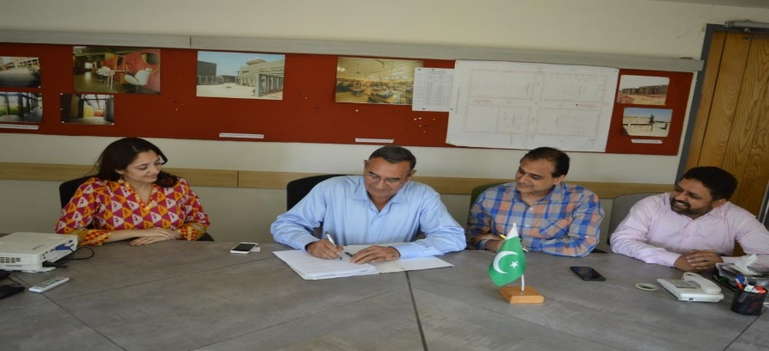

MOU signing occasion ‘The Hunar Foundation’
Anjuman Faizul Islam
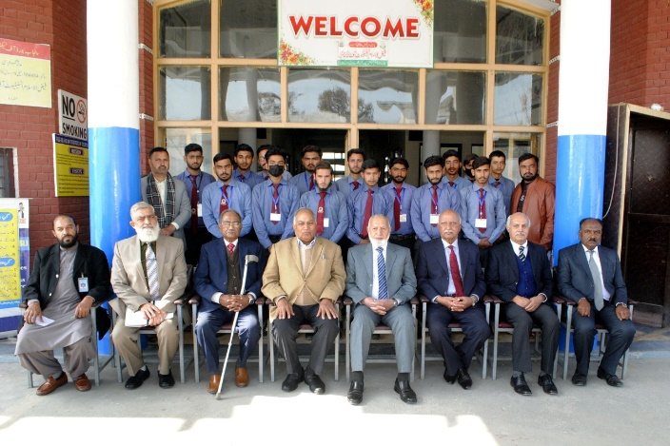
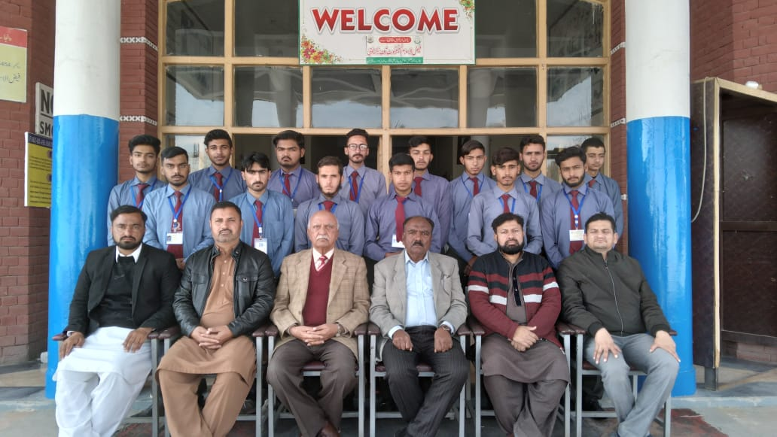
Anjuman Faizul Islam runs multiple programs including, a Technical Institute, an orphanage and a secondary school for girls at their Mandra Campus. Currently 35 students studying at Faizul Islam Institute of Technology, Mandra Campus, are being sponsored by AMET.
Chairman AMET, Management and Sponsored Students at Anjuman Faizul Islam at Mandra Campus
Sultana Foundation

Sultana Foundation constitutes a technical institute, vocational training institute and several schools/colleges at their different campuses. Presently 38 students are being sponsored by AMET at Sultana Foundation Technical Institute and College of Commerce.
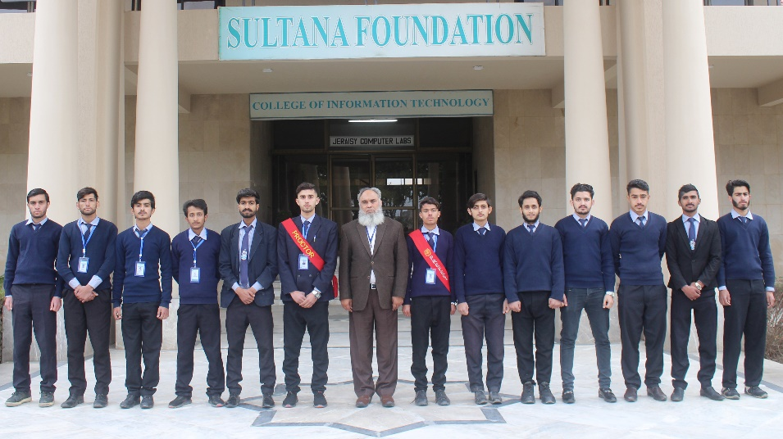

Principal Technology Institute Lt Col Mehfooz (R) with AMET sponsored students

Askari Institute of Technology (AIT)
This institute is located at Rawat, District Rawalpindi, on G.T Road. It imparts technical training to the youth in addition to DAE streams in multiple disciplines. AMET is sponsoring 29 students at AIT currently.
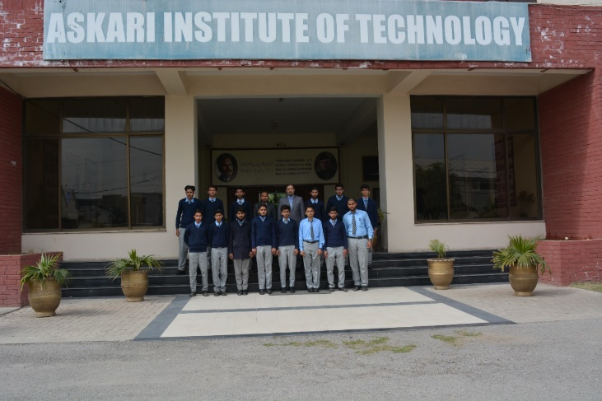

AMET Sponsored Students Studying at Askari Institute of Technology

KRL Institute of Technology.
This institute is located at Nougran (Kahuta), District Rawalpindi. AMET is sponsoring 23 including 5 x girl students.

Higher Education Institutes
The University of Faisalabad
9 students sponsored by AMET have been granted admission in the following educational programs at TUF: -
  - Doctor of Physiotherapy : 6
  - Doctor of Pharmacy : 3

Riphah International University Islamabad
AMET has an signed MOU with Riphah University for award of 10 scholarships in the faculties of Management Sciences, Engineering & Applied Sciences, Computing, Rehabilitation & Allied Health Sciences and Social Sciences & Humanities. Currently 8 boys and girl students are attending under mentioned courses: -
- Doctor of Physiotherapy : 5
- BS (MLT) : 2
- M. Phil : 1
Institutes with Boarding Houses
- Cadet College Karnal Sher Khan Shaheed - The college has been named after Captain Karnal Sher Khan Shaheed (Nishan-e-Haider) and is located near village Nouwan Killi, the native home of our national hero. 3 students are being supported at this institute.
- Cadet College Sargodha – 10
- Cadet College Kohlu - 2
- Cadet College Palandri - 4
- Military College Murree - 3
- Military College Jhelum - 1
- Aligarh Public School & College Lahore - 2
- Cadet College Killa Saifullah - 1

MOUs
AMET has signed MOUs with the following organizations: -
- The Hunar Foundation
- Cadet College Sargodha
- Cadet College Karnal Sher Khan Shaheed Swabi
- Military College Jehlum
- Tehzib Ul Akhlaq Trust
- Economic Affairs Division (EAD), Govt of Pakistan
- Riphah International University Islamabad

Specific Scholarships Schemes
Saeeda Naseem and Mr. Muhammad Naseem Shafi Trusts Scholarships
Saeeda Naseem Scholarships were started jointly by Saeeda Naseem Trust and Al Mujtaba Education Trust in year 2018. Mr. Naseem Shafi, Chairman Saeeda Naseem Trust, donates Rs. 2.0 million annually specifically for education of girl students belonging to rural areas while 4.0 Million are being devoted to the vocational training of literate female segment of rural area population. Year wise students benefitted from this donation are shown below: -
  - 2018/19. 43
  - 2019/20. 95
  - 2020/21. 52
  - 2021/22. 43
  - 2022/23. 44
Fauji Fertilizer Company (FFC)
FFC has donated Rs. 10.0 million over the past four years. 116 Students have been awarded scholarships utilizing FFC donation received through their CSR program.
Colonel Ghulam Sarwar Cheema (Late) Scholarships
Mr Adnan Sarwar Cheema (Son of Colonel Ghulam Sarwar Cheema) has donated a large amount for scholarships in memory and for Eisal-e-Sawab for his late father during the past 4 years. 570 students have benefitted from these scholarships so far.
Brig Maqsood Ul Hassan (Late) Scholarships
Brig Asif Maqsood and his family have instituted a scholarship named after their late father and donated Rs. 1.0 million for the education of talented needy students. This donation has been utilized for General Scholarships awarded to students of classes 9, 10, 11 and 12.
Brig Muhammad Sadiq Chaudhary (Late) Scholarships
Family of Brig Muhammad Sadiq Chaudhary (Late) donated Rs. 2.5 Million in the past three years. This donation has been utilized for supporting talented and needy students in 3 years Diploma courses. 27 needy talented students are attending DAE courses at the following institutions through these scholarships: -
  - Faiz-ul-Islam Institute of Technology, Mandra
  - Askari Institute of Technology, Rawat
  - Prince Salman Institute of Technology, Islamabad
  - Kahuta Institute of Technology

Mari Petroleum Company (MPCL) Scholarships
Mari Petroleum Company donated Rs. 7 Million, 9.2 Million and 10.08 Million from their CSR during past 4 years. The funds have been utilized for awarding scholarships to 166 students who are perusing different levels of education.
Vocational Training
Concept. A large segment of the rural female population continues to be “unskilled” and is thus under-utilized with subdued contribution to the society at large and their families in particular. Responding to this need, it was decided to set up Vocational Centers in the rural areas for girls. Five Vocational Centers (VCs) have been set up in the rural areas at village Chawali, District Chakwal, Chak 118-NB, Tehsil Sillanwali Distt Sargodha, Bucha (Near Mandra) District Rawalpindi, Rera District Bagh (Azad Jammu and Kashmir and Buffa (Mansehra).
Courses Conducted. Ten courses of 06 months duration each have been conducted at the respective VCs during years 2018 to 2022.

Curriculum Covered. Training is being imparted in the following aspects:
  - Measurement and Cutting.
  - Stitching.
  - Hand Embroidery.
  - General awareness, motivational and religious training.
  - Computer training.

Achievements
Technological Skills
The Hunar Foundation (THF)
Course Title | No. of Students | Results
Certification Course - 2017 | 29 | All students achieved A and A⁺ Grades
Certification Courses – 2018 | 94
Certification Courses – 2019 | 102
Certification Courses – 2020 | 56
Certification Courses – 2021 | 60
Certification Courses – 2022 | 120
Other Institutes
Institute | Students | Grades Achieved
 |  | A+ | A | B | Failed
Askari Institute of Technology (AIT) | 12 | 4 | 7 | 1 | -
Faizul Islam Institute of Technology (FIT) | 12 | - | 2 | - | 10@
Prince Salman Institute of Technology (PSIT) | 13 | - | 7 | 4 | 2@
Kahuta Institute of Technology (KIT) | 10 | 5 | 4 | - | 1@
General Scholarships
2022
Class | Students | Results
 |  | A+ | A | B | C | Failed | Left
Secondary (Including Cadet Colleges) | 138 | 41 | 67 | 19 | 6 | 5 | -
Intermediate | 204 | 39 | 101 | 31 | 20 | 13 | -
Higher Education | 47 | 16 | 20 | 04 | 04 | 0 | 03
2021
Class | Students | Results
 |  | A+ | A | B | C | Failed
Secondary (Including Cadet Colleges) | 90 | 43 | 43 | 04 | _ | _
Intermediate | 142 | 47 | 81 | 09 | _ | 05 @
Higher Education | 34 | 18 | 12 | 03 | _ | 01 @
2020
Class | Students | Results
 |  | A+ | A | B | C | Failed
Secondary (Including Cadet Colleges) | 130 | 52 | 78 | _ | _ | _
Intermediate | 136 | 55 | 81 | _ | _ | _

2019
Class | Students | Results
 |  | A+ | A | B | C | Failed
Middle | 5 | 4 | 1 | _ | _ | _
Secondary | 110 | 36 | 56 | 10 | 3 | 5@
Intermediate | 127 | 19 | 49 | 29 | 14 | 16@
2018
Class | Students | Results
 |  | A+ | A | B | C | Failed
6, 7 & 8 | 29 | 7 | 15 | 5 | 2 | _
Secondary | 69 | 17 | 26 | 13 | 8 | 5@
Intermediate | 79 | 21 | 36 | 10 | 5 | 7@
2017
Class | Students | Results
 |  | A+ | A | B | C | Failed
6 & 7 | 6 | 4 | _ | _ | 2 | _
8 | 10 | 3 |  | 4 | 2 | 1@
9 | 13 | 5 | 4 | 2 | 2 | _
10 | 18 | 11 | 6 | 1 | _ | _
Technical | 16 | 11 | 2 | 1 | _ | 2@

Vocational Training
Center | 2018 | 2019 | 2020 | 2021 | 2022
Sillanwali | 21 | 42 | 21 | 36 | 101
Chawali | 25 | 48 | 25 | 49 | 40
Bucha (Mandra) | _ | _ | 17 | 44 | 37
Rera (Bagh) AJ & K | _ | _ | _ | 68 | 54
Danda Shah Bilawal |  | 37 | 21 | 25 | -
Baffa (Manshera) | - | - | - | - | 17

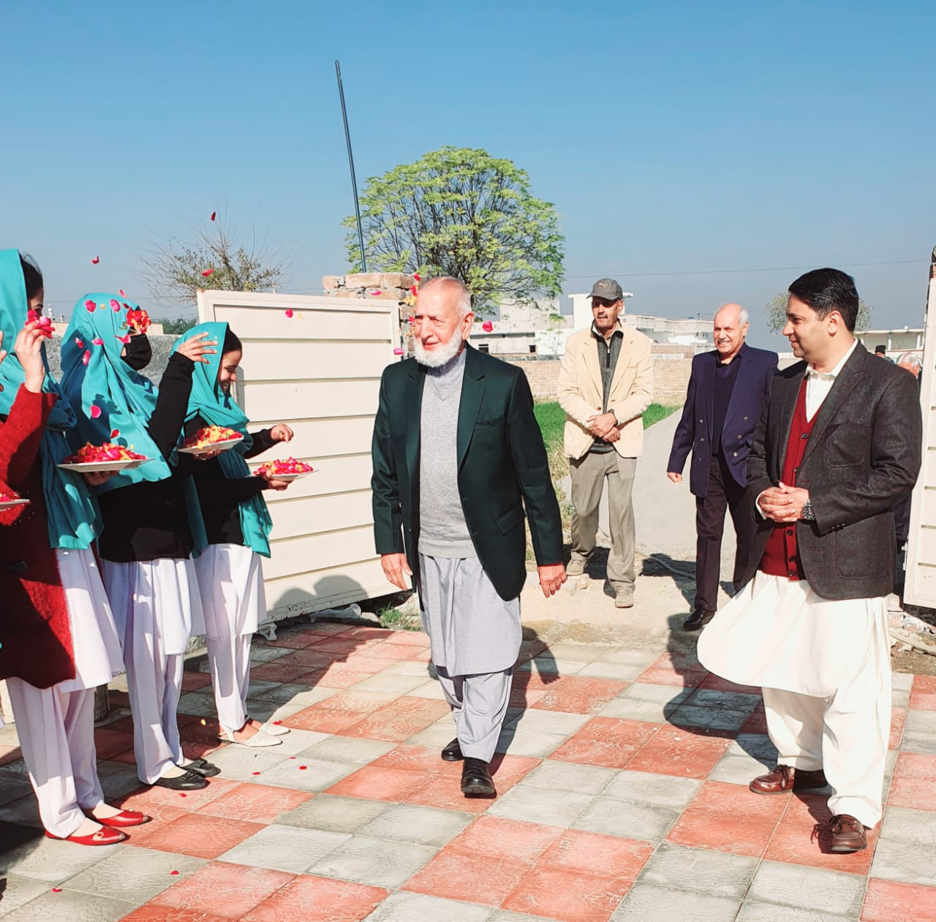
Chief Guest Being Welcomed by the Project Director and Students at VC Bucha (Mandra)

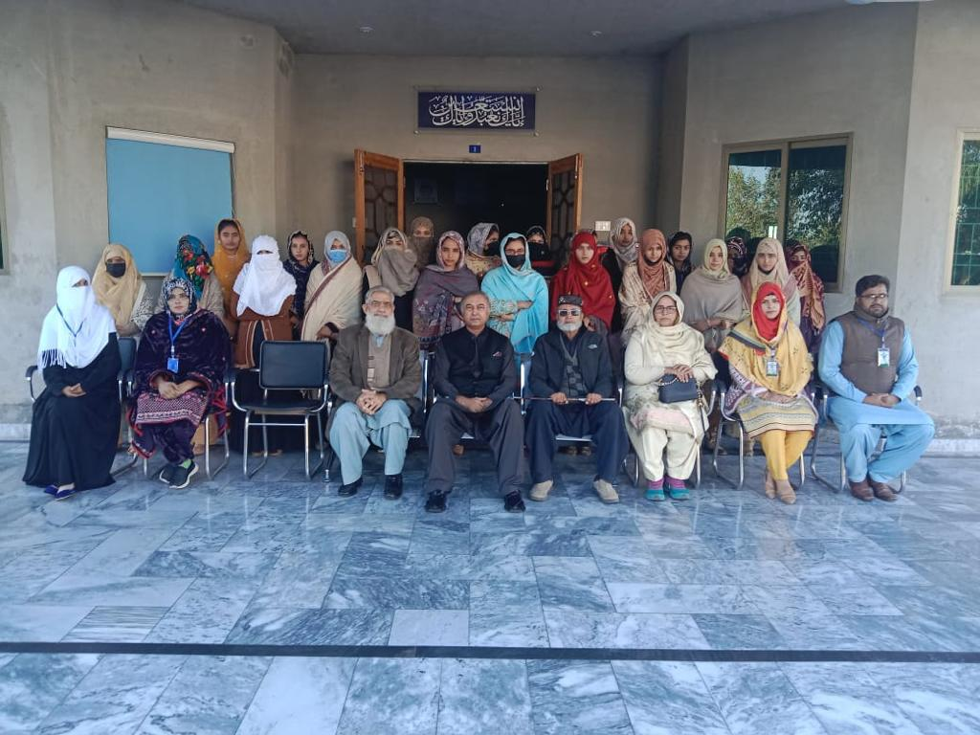
Group Photo of Course Participants with the Chief Guest at VC Chak-118, Sillanwali
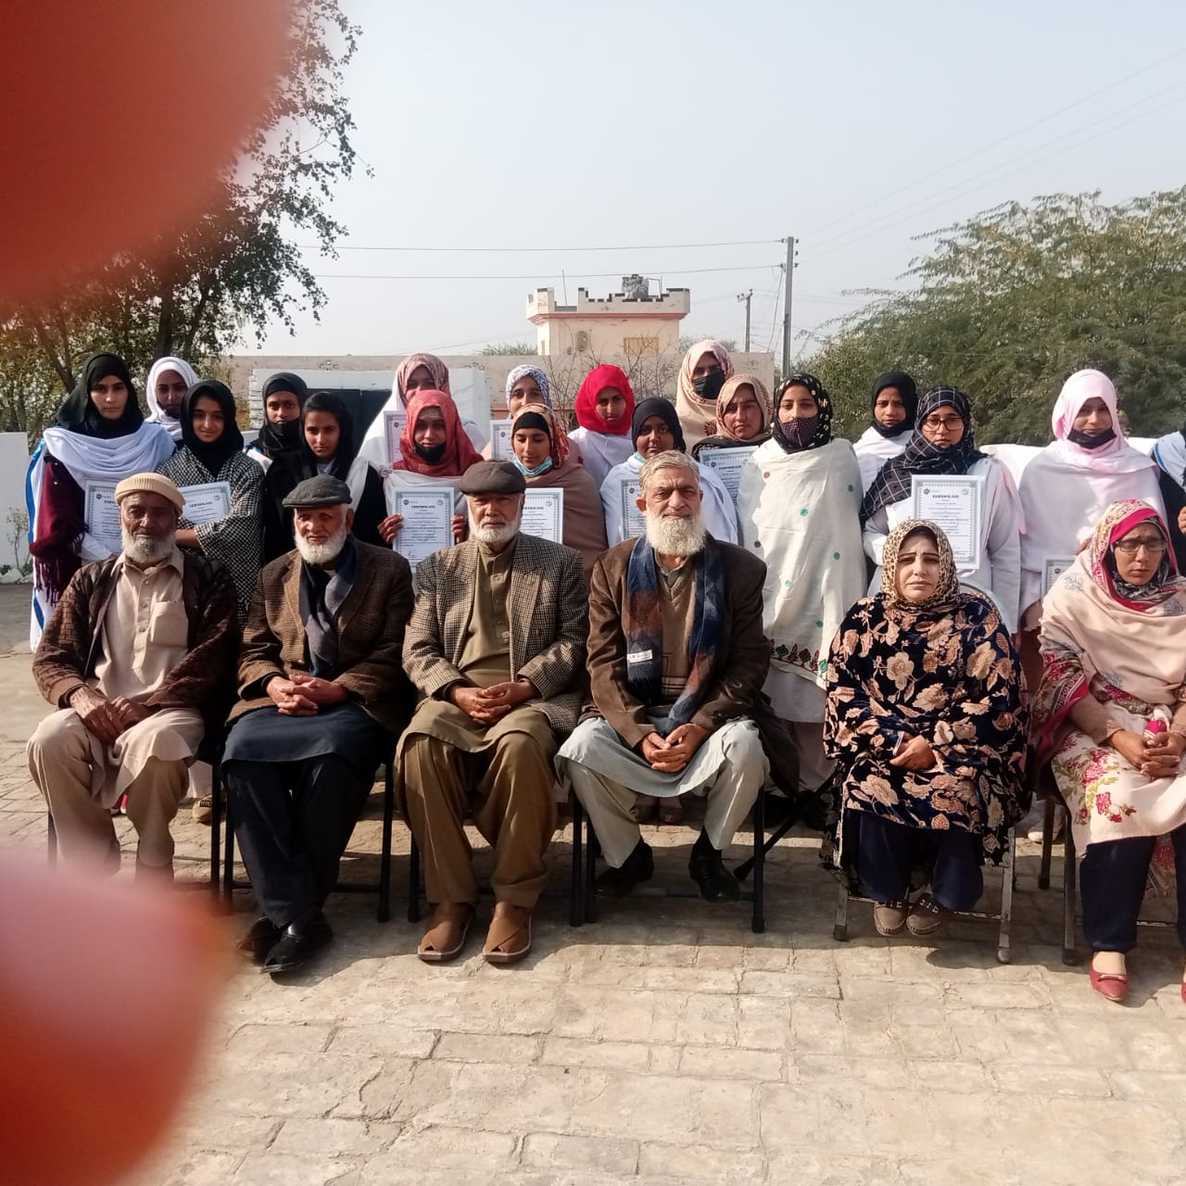
Group Photo of Students of VC Chawali with the Chief Guest
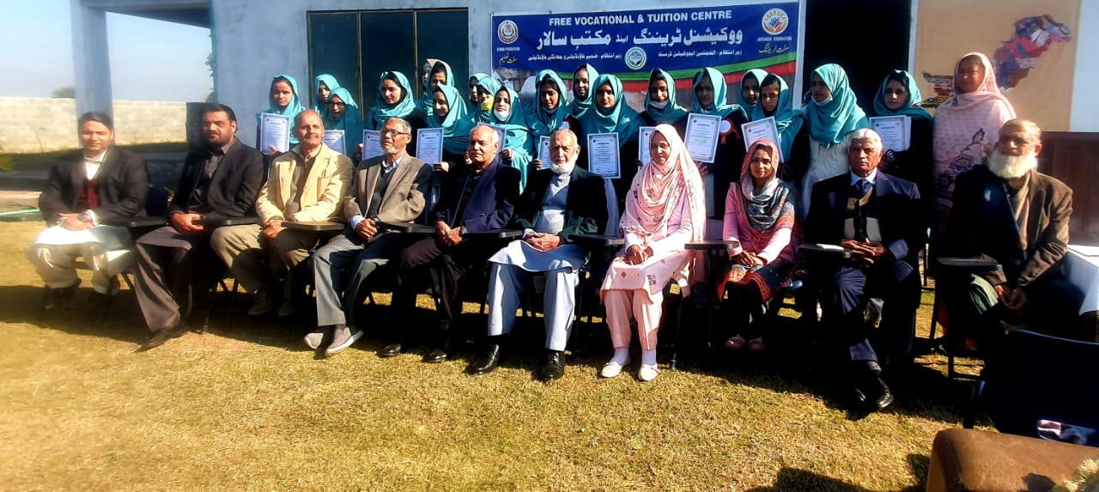
Course Group Photo with Chief Guest, Teachers and Trust Management at VC Bucha (Mandra)

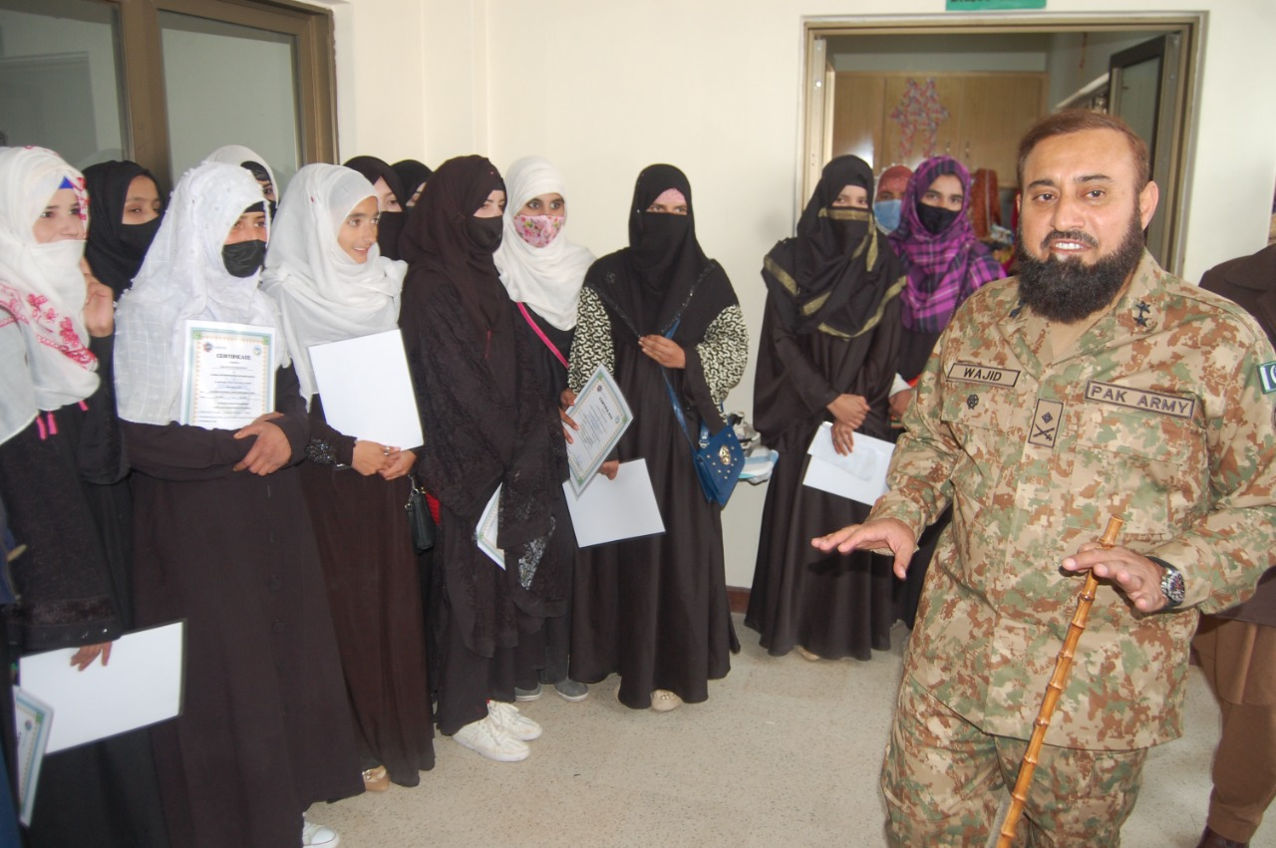
The Chief Guest Interacts with the Qualifying Girl Students of Dress Making Course
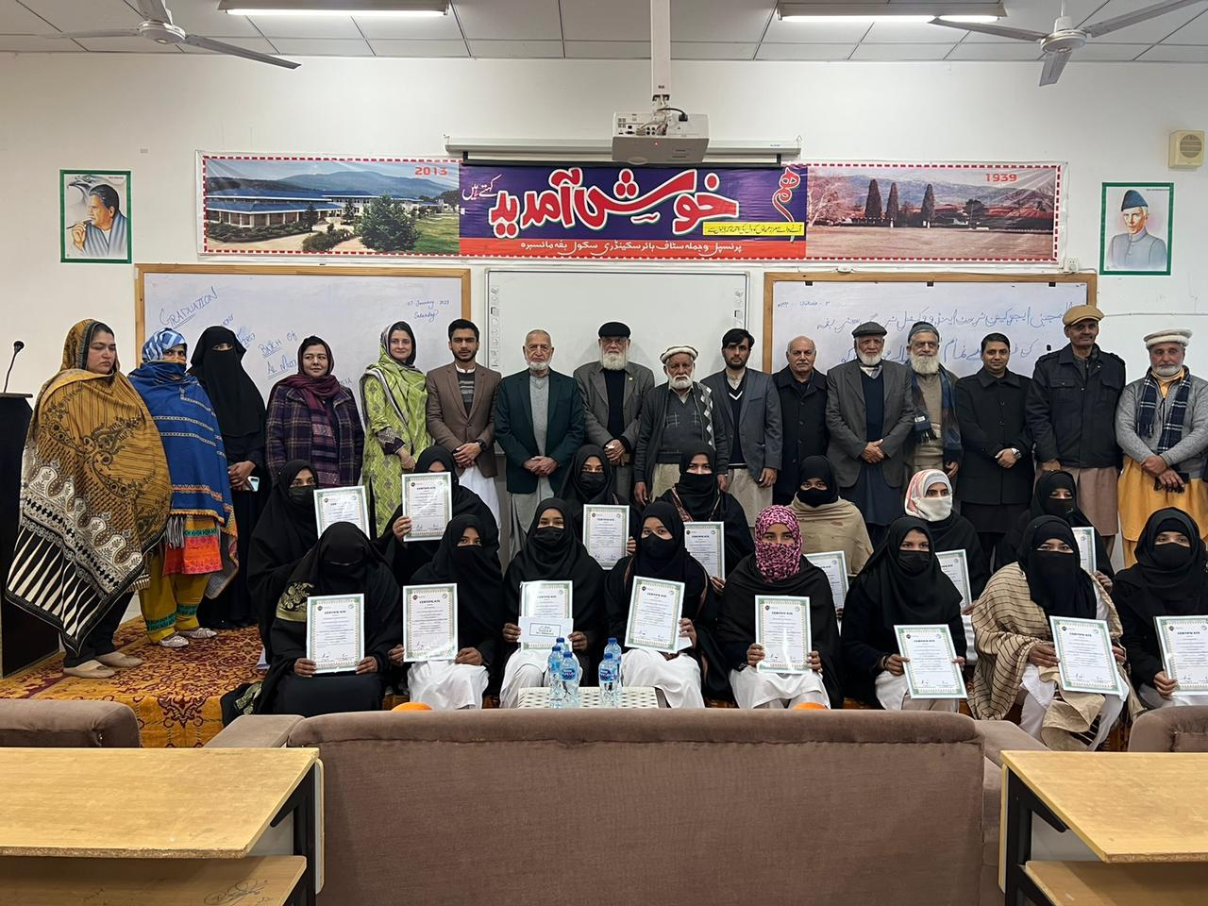
Course Group Photo with the Management at VC Baffa
Management Aspects
Certification of Al Mujtaba Education Trust by Pakistan Centre for Philanthropy (PCP)

PCP conducted 2nd evaluation of AMET on 03 Oct 2020 for the period covering years 2019, 2020 and 2021. Staff checks were carried out by PCP team evaluating the following aspects at length: -

  - Internal Governance
  - Program Delivery
  - Financial Management

PCP team expressed its satisfaction over the education programs being conducted by AMET, awarded 83 percent marks during year 2020 to the Trust. PCP team presented its evaluation report to the Certification Panel who have certified the Trust for 3 years (years 2021 to 2023). Certificate to this effect has since been awarded by PCP.
Financial Management
Award of Tax Exemption On Donations by FBR
AMET applied for Tax Exemption on donations to FBR. FBR conducted a staff check followed by the presentation to the Income Tax Commissioner on AMET education programs. Having satisfied themselves with the activities of AMET, FBR awarded tax exemption on donations till 22 Nov 2023.
Annual Audit of Accounts
Trust accounts are regularly audited by approved external auditors as per requirements of regulatory bodies. Chartered Account firms namely, M/s Amir Alam Khan and Company and Shahzad Qazi and Company are the two approved QCR rated firms that have been engaged since 2016.
Registration of AMET with Economic Affairs Division (EAD),Govt of Pakistan
Responding to the requirement of our foreign donors a case was taken up with the EAD for registration of the Trust with them. Required details were submitted to the EAD which they got verified through Intelligence Bureau and Ministry of Foreign Affairs. Resultantly AMET stands registered with EAD and MOU to this effect has been signed. Trust can now receive foreign donations in its bank accounts in Pakistan through “online Transfer” from abroad.
Trust Accounts
Trust maintains the following accounts. The separate Zakat Account is maintained to ensure Shariah compliance: -
- Zakat Account
- Donation Account

Future Plans

Al Mujtaba Education Trust believes in continual improvements. We keep our processes under review and maintain a forward-looking approach. Some aspects that form of our future plans are enumerated below: -
- Enlarge footprint in all the provinces.
  - Increase number of beneficiaries progressively.
  - Enlarge geographic presence particularly in Sindh and Balochistan.
  - Explore more educational Avenues.
- Encourage girls to opt for ‘Employment Skills Training’.
- Continue focus on Technical Training Programs.
- Expand support for higher education.
- Develop ‘Alumni Culture’ – payback by beneficiaries.
- Develop donor pool - philanthropists/corporates.
- Continually improve internal management.
- Expand E learning in rural areas.
- Maintain a high standard of compliance with all regulatory requirements.

Board of Trustees
Chairman: Lt Gen Ghulam Muhammad Malik (Retd)
Rawalpindi/Islamabad
- AVM Khudadad Khan (Retd)
- Maj Gen Muhammad Ovais Mustafa (Retd)
- Maj Gen Viqar Ahmad Khan (Retd)
- Maj Gen Muhammad Masud Malik (Retd)
- Brig Fateh Khan Malik (Retd)
- Brig Zafar Masood Ansari (Retd)
- Brig Hafeez Ahmed (Retd)
- Brig Mukhtar Ahmed (Retd)
- Brig Ahmed Nawaz Zafar (Retd)
- Brig Asad Hakeem (Retd)
- Brig Muhammad Akram Malik (Retd)
- Brig Tariq Saeed (Retd)
- Brig Wasim Ahmad Malik (Retd)
- Col Zafar Ali Sufi (Retd)
- Col Sultan Mehmood (Retd)
- Lt Col Tariq Ahsan Ali Khan (Retd)
- Lt. Col Ghulam Abbas (Retd)
- Lt Col Muhammad Hayat Khan (Retd)
- Lt Col (Retd) Hamid Mehmood Butt
- Lt Col (Retd) Shaikh Shamim Akhtar
- Mr Abdul Qadeer Mansoor
- Mr Mohsin Jahangir
- Mrs. Rakhshinda Jabeen Durrani
- Syeda Zamara Basit
- Miss Shazia Aslam Rizvi C/O Col Muhammad Aslam Rizvi (Retd)
- Miss Anam Abdul Malik
Lahore
- Brig Arshad Raza (Retd)
- Brig Ashfaq Ahmed (Retd)
- Brig Iftikhar Ahmed (Retd)
- Brig Iftikhar Hasan Siddiqui (Retd)
- Lt Col Asad Mehmood Khan (Retd)
- Dr A R Khalid
Karachi
- Brig Rashid Siddiqui (Retd)
- Brig Muhammad Lateef (Retd)
- Col Ayaz Malik (Retd)
- Col Muhammad Hadique (Retd)
- Mr. Shabban Elahi
- Mr. Muhammad Hanif Gohar
- Mr. Tariq Dawai Wala
- Mr. Tariq M Chudhary
UK
- Mr Tariq Ali Khan
- Mr Azam Khan
- Mr Mudassir Jehangir

Conclusion

By the Grace of Allah Al Mujtaba Education Trust has been able to sponsor 3148 students (Boys/Girls) all over Pakistan with the help and support of its valuable donors since its inception. With the onset of 8th academic year (year 2023) earnest efforts are being made to increase the number of beneficiaries and enlarge the area coverage with particular focus on Sindh and Balochistan provinces. Depending upon the availability of funds, efforts will be made to support larger number of students for higher education besides capacity building of teachers in remote areas. Al Mujtaba Education Trust looks up to its well-wishers to come forward wholeheartedly to support the weak segments of our society through quality education.

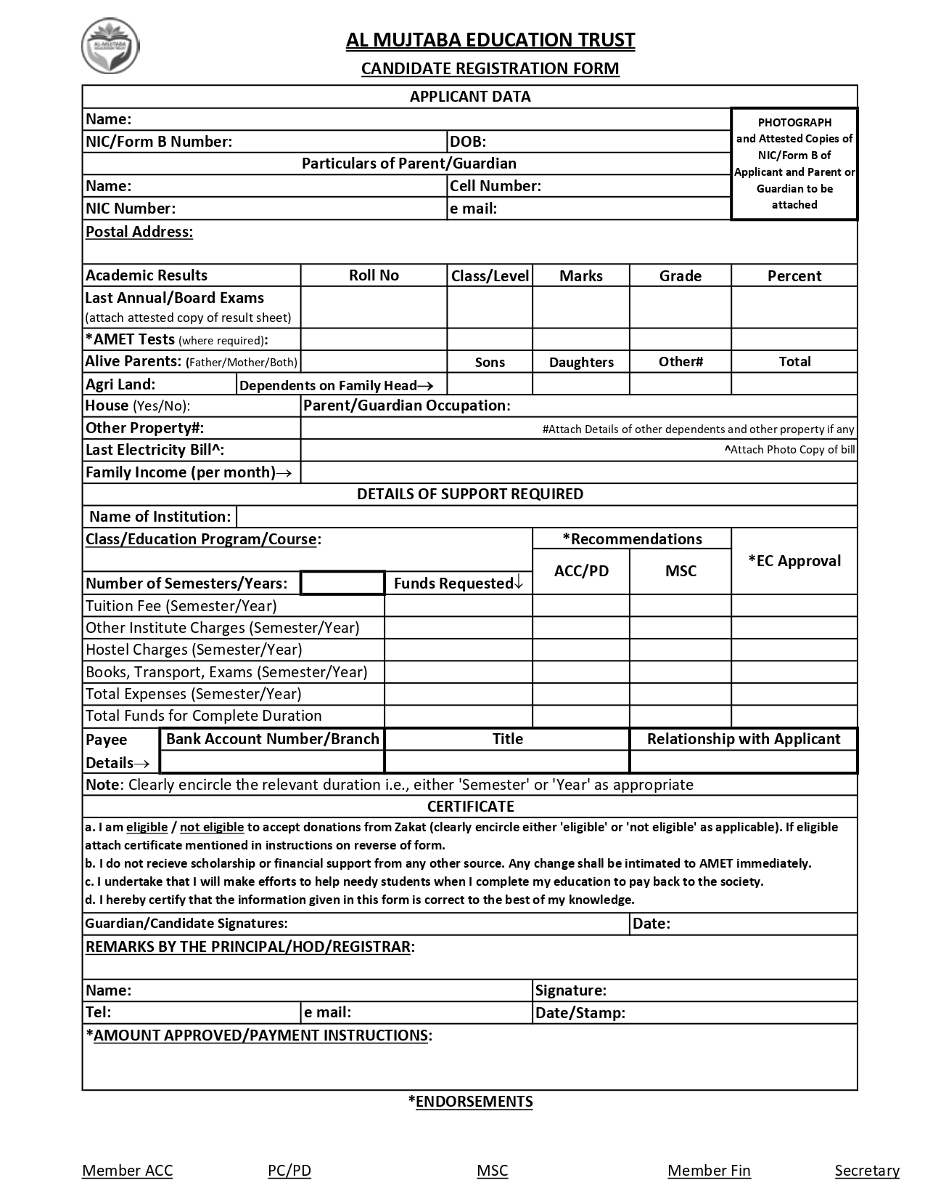

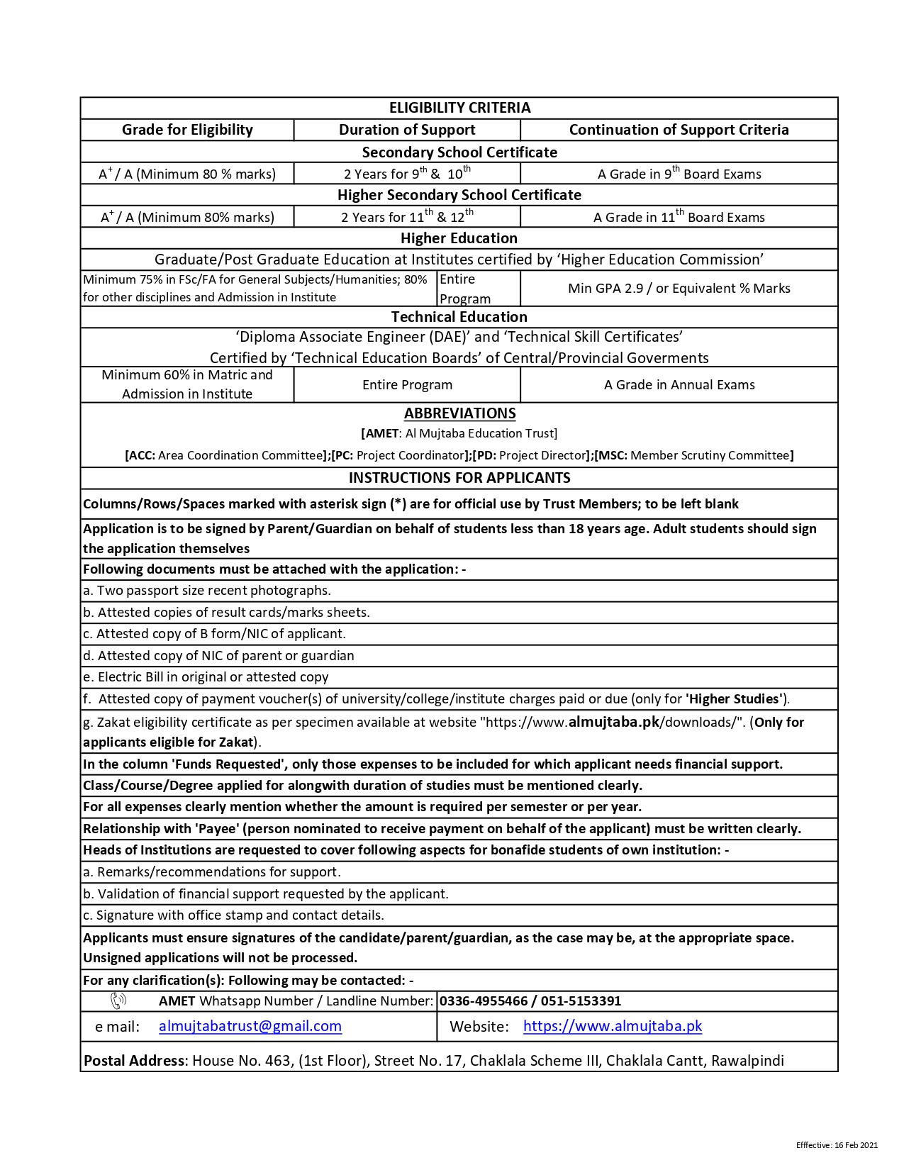

The messenger of Allah (SWT) said that Allah (SWT) The Glorious and Exalted Says: Spend (on charity), O son of Adam, and I shall spend on you. [Hadith Qudsi 11]
____________________
Abu Kabshah al Anmari reported that the Prophet (SAWS) said: "I swear upon three (things) and ask you to memorize my words: Sadaqah (charity) given from a property never decrease it; a man who suffers injustice and is patient with it, Allah will grant him strength; a man who starts begging, Allah will cause him to be poor." [Related by Tirmidhi]

