- “Spend (in the Cause of Allah (SWT) from the provisions that We have given you before death should come to any of you and then he should say, “O my Lord, why did You not reprieve me awhile that I should have given in charity and become of the righteous.” But Allah (SWT) does not at all reprieve a person when his term comes to an end, and Allah is well aware of what you all do. (63:10)

- Those who spend of their goods (in charity) by night and by day in secret and in public shall have their reward with their Lord: on them shall be no fear nor shall they grieve (2:274)

Al Mujtaba Education Trust
Name adopted after one of the
Attributed names of
Holy Prophet Muhammad
(Peace be upon Him)

Introduction

Education determines the intellectual prowess of a nation and ensures a systematic and assured course towards prosperity. Developed nations have a system of uniform quality education available to all segments of the society in the formative stage through public and private schools. Unfortunately majority of our talented youth is deprived of this opportunity for a host of reasons and thus a Raison D ’ etre for the creation of Al Mujtaba Education Trust.
Al Mujtaba Education Trust (AMET) was established in Jan 2016 and after formulation of the Trust Deed and Bye Laws was registered in the ensuing month under Societies Registration Act, XXI of 1860 vide Registration No 47/2016. Thereafter, standard operating procedures (SOPs) regarding accounts, ‘zakat’ donations, selection of beneficiaries and monitoring procedures were prepared. Our Bye Laws stipulate the composition of the Executive Committee to run day to day affairs and job description of all members as well as employees. The Board of Trustees oversees the working of the Executive Committee and takes major policy decisions.
Al Mujtaba Education Trust has been established to contribute towards educating and grooming the poor and bright children with focus on but not restricted to rural and backward areas. At the same time, it is intended to provide guidance, training and direction to teachers where required for improving the standard of education and impacting larger number of students. It is a non-political, non-commercial, non-government organization, providing equal opportunities to boys and girls.
The Vision

Our vision is to break the ‘poverty – illiteracy’ linkage, so that no Pakistani child or young person should have to give up her/his educational pursuits for want of resources. We intend helping talented students to realize their true potential through scholarships and interventions to help address such resource gaps that affect quality of education being imparted to them. We visualize a state where every Pakistani child gets fair opportunities to become responsible and productive member of the society.

Mission

Provide financial assistance to talented boys and girls from poor families to enable them to study and excel in existing or higher quality schools and colleges. Arrange for technical education for those who do not show aptitude for higher education. Where necessary, assist educational institutions in improving teaching skills of their teachers.
Objectives

- Support education of poor students by bearing expenses on fees, uniform and conveyance etc and where necessary, have them admitted in higher quality institutions.
- Finance technical and vocational training for boys and girls having aptitude, thereby enabling them for suitable jobs.
- Support students having high grades in matric to study in quality intermediate colleges to enable them to qualify for higher studies.
- Assist in capacity building in selected schools by organizing workshops and short courses in collaboration with NGOs etc.

Selection Criteria

Priority for Support

- Students of rural schools to be given preference.
- Students of private schools where Govt Schools are not available, inoperative or lacking specific subject teaching facility.
- Orphans to be given favourable consideration.
Selection Process

Designated Project Coordinators assisted by the Area Coordination Committees (ACCs) comprising of area notables and teaching staff of education institutions, facilitate the selection process. The selection process entails four stages that are explained in the following discourse.
Identification of Potential

We have adopted a multi-pronged strategy to select the most deserving students with requisite talent and potential for the optimum utilization of our donors’ contributions. For this purpose, our preference is to acquire input based on personal knowledge of the heads of the institutions and apolitical notables of the area. However, beneficiaries are also attracted through advertisements in newspapers, brochures and our web site. We have also established rapport with some renowned technical institutes and NGOs like The Hunar Foundation, Sultana Foundation, Askari Institute of Technology and Anjuman Faiz Ul Islam to extend our support to the deserving students, who are finding it difficult to meet their expenses. Where necessary, we hold our own tests to select beneficiaries.
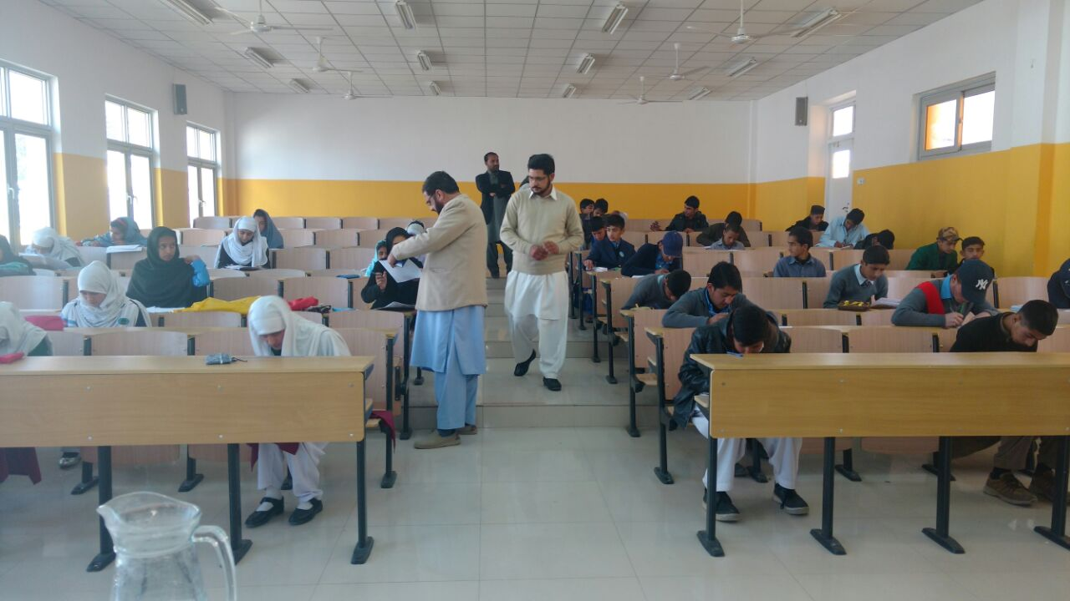
Class 8th Entry Test Being Held at Baffa (District – Mansehra)
Selecting Beneficiaries
On receipt, the requests for support are scrutinized by the Project Coordinators, who determine the type and duration of the support. The support could be in terms of tuition fees, examination fees, conveyance or hostel charges as well as incentive stipends to students, who perform well in Government Schools where education is free. The support is finally approved by the Executive Committee.

Monitoring and Counseling

This is the hallmark of our support system. The beneficiaries’ performance is closely monitored through area based coordination committees or designated project coordinators for which regular meetings are held and progress reports acquired from the heads of the institutions. Corrective measures are taken where necessary and affected students are counselled by the respective heads of institutions as well as project coordinators / members of area coordination committees.
Review and Feedback Meetings

We are fully aware that there is always room for improvement and we therefore hold periodical meetings of the project coordinators with the Chairman. In Sha Allah it will continue to be a regular feature for the enhancement of our systems and procedures. Examination results are obtained from the respective institutions on regular basis. The results are evaluated and the students found not performing well are cautioned accordingly. The parents/ guardians of such students are also advised to improve the performance of their wards. The students constantly not performing well are deprived of the scholarship by the Trust.
Achievements for Academic Year – 2016/2017
- Class 8. Cadet Muhammad Adeel who was admitted in Cadet College Sargodha has stood 1st in his class in his annual examination obtaining A plus grade. He has been promoted to class 9 and is doing very well in his class.
- Class 9. A total of 15 students were awarded AMET scholarships. They all have passed their board examination and have been promoted to class 10. Detailed results are as under :-
- A plus Grade : 11
- A Grade : 4
- Class 10. 7 students were awarded AMET scholarships. They all have passed their board
examinations. Miss Arwa Nadeem scored 94% marks and stood first in her school. Breakdown of result is as follows:-
- A Plus Grade : 4
- A Grade : 3
- Class 11. 14 students were awarded AMET scholarships. Master Daniyal Siddique, studying in Cambridge International Science College, Talagang secured 94% marks and has stood 1st in Rawalpindi Board of Intermediate Education. Overall, results are as under:-
- A plus Grade : 6
- A Grade : 5
- B Grade : 3
- Class 12. One student was awarded AMET scholarship who has passed the board
examination securing A plus grade.
- Technical Education.
- The Hunar Foundation (THF). 29 students attended technical training at THF. 5 students out of these have qualified the City and Guild Business Center examinations. 3 students got distinction while 2 got merit. 24 students who attended a year long course at THF Karachi Campus have all passed their annual examination. 12 out of these 24 students have secured more than 80% marks and qualified for City and Guild examination.
- 11 students who were awarded AMET scholarships are persuing technical education at different institutions at Rawalpindi encompassing various disciplines. They all have completed 1st year of their education and passed their annual examination. Details are as follows:-
- A plus Grade : 7
- A Grade : 4

Award of Scholarships for the Academic Year 2017/2018

Beneficiary State

Middle | 43
Secondary | 71
Intermediate | 89
Vocational/ Technical | 42
Graduation | 01
Total | 246

Area Coverage & Funds

Area Coverage
We were able to cover 08 districts in 2016 and 18 districts in 2017. These include :
Punjab – Districts. Rawalpindi, Sargodha, Khushab, Mianwali, Chakwal, Faisalabad, Lahore,
Sahiwal, Gujranwala, Mianwali
Sindh – Districts. Karachi, Nawabshah
Khyber Pakhtun Khwa – Districts. Mansehra, Kohat, Haripur, Charsada, Peshawar
Balochistan – District. Kohlu

Allocation of Funds
- Academic Year 2016/ 2017. Rs. 2,449,752.00
- Academic Year 2017/ 2018.
Upto February 2018 Rs. 10,725,044.00

Profiles of Some Very Deserving Students

Muhammad Danial Siddique
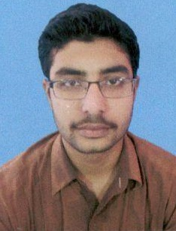
Muhammad Danial Siddique is a highly talented son of an ex serviceman from village Pirah Fatehal, District Chakwal with an ambition to become a doctor. He scored 91% marks in his matriculation exams. AMET is bearing his expenses of travel, books and uniform etc amounting to Rs. 31,400/-per year Encouraged by the support, he has stood 1st in Rawalpindi Board Pre Medical Part 1 exams by scoring 474/505 marks. He was honoured by the Executive Committee on his visit to the Trust on 12 Dec 2017.
Muhammad Adeel

He belongs to Village Kandan, Tehsil Shahpur, District Sargodha. A unique model for potential donors. He is being sponsored by Mr Abdul Samad Gandhakwala from Karachi. He has been shifted from his rural school and admitted in Class 8 in Cadet College Sargodha, which gives concession of Rs. 5000/- per month to the students sponsored by our Trust. He is included amongst the high achievers of the institution. He has stood first in the class in the annual examination. Mr Samad donates Rs. 1,20,000 at the beginning of each year as education expenses which are remitted to Cadet College Sargodha annually. Mr Samad is kept informed about the academic performance of the sponsored student.
Ahmed Yar
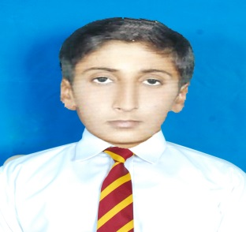
He belongs to a remote village of District Sargodha and is an orphan. He stood first in the entrance test conducted at Cadet College Sargodha. He has been admitted in the College on merit. He obtained 12th position out of 26 students in Mid Term Tests. He has stood 1st in the class in his final examination securing 98% marks. He is being sponsored by Mr. Aziz-ul-Hasan, a US based Pakistani. Rs. 1,20,000.00 are being paid by the sponsor annually as education expenses of Ahmed Yar. The sponsor is being kept informed about the academic performance of the student.

Faizan Ali
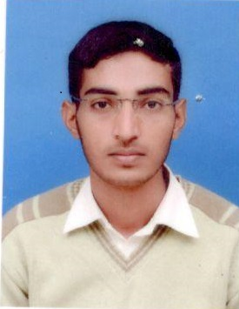
Faizan Ali hails from Talagang. His father is a retired Lance Naik, who despite meagre resources is determined to give the best possible education to his four children. Faizan studied in rural schools where educational facilities are inadequate but that handicap did not deter him in pursuit of his education. He was able to qualify the entry tests for NUST and was selected to undergo Bachelor of Engineering Degree course in Mechatronics at the College of EME. Faizan has studied hard and diligently. Considering his desire to learn and limited resources at the disposal of his family, Al Mujtaba Education Trust selected him for support on the recommendations of his Alma Mater. Rs 120000/- per annum are being paid to allay part of his educational expenses.
Sana Bibi

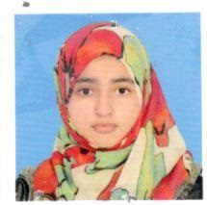

Sana Bibi hails from Dhoke Kala Khan, District Rawalpindi. Her father is paralyzed, bed ridden and jobless. Her mother works in different houses to earn her livelihood and manage a family of 06 members. Sana secured 89% marks in Matric. Seeing her potential and the precarious financial situation of the family AMET has got her admitted in Sir Syed Science College Rawalpindi in 1st year. The Trust has paid the entire education expenses of Sana amounting to Rs. 44,570.00 for academic year 2017/ 2018.
Rahila Abdul Rehman
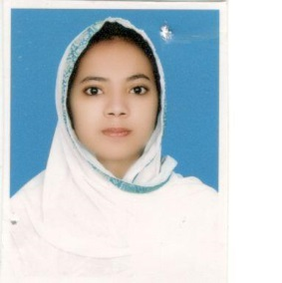
She hails from a family of eleven members residing at Jhang City. Her father is handicapped and jobless. Her elder brother is working at a shop as a salesman on monthly salary of Rs. 10,000.00. Her younger brother is employed at a brick kiln as a labourer at a meagre salary of Rs. 3000.00 per month. She scored 94% marks in her Matric examination. Seeing her potential, AMET got her admitted in Chenab College Jhang and is contributing Rs. 72,100.00 per year as her education expenses.
Humaira Anjum
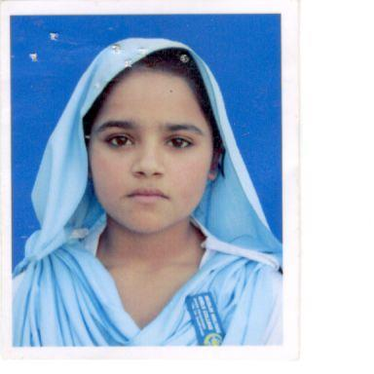
Humaira is from a humble family. Her education upto Matric is from Govt Girls Higher Secondary School Bewal, Tehsil Gujar Khan. Her father is a labourer and mother contributes towards family expenses by working in peoples’ houses. With their meager earning, they support a family of eight persons. Humaira passed her Matric exam securing 79% marks. Thereafter, she was not in a position to continue her studies. AMET came forward to support her for further education. She is now studying in a private local college and doing well in studies. In a recently conducted term exam she has scored 72% mks and stood first in the class.
Sobia Ziareb
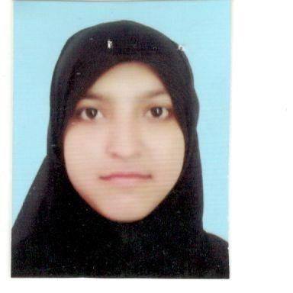
Sobia Ziareb is from a low income family from Bewal, Tehsil Gujar Khan. Her father is a labourer supporting a family of five members. She passed her Matric exam from Govt Girls Higher Secondary School Bewal, Tehsil Gujar Khan in A plus grade. AMET supported her in getting admission in a good private college away from her home where she is doing very well. She has passed her first year exam scoring 81% marks. She has the potential to pass her Fsc exam in very good grade and get admission in some good college/university.
Future Plans

- Steadily enhance the number as well as level of education beyond intermediate level.
- Increase area coverage from the present 18 districts.
- Introduce E learning in rural areas to optimize the use of limited resources and target larger number of students.
- Organize workshops for improving the quality of teachers in selected schools.
- Develop and operate an interactive website to extend our area coverage and facilitate interaction with the beneficiaries.
- Establish atleast two vocational centres for girls/ladies empowerment.
- Certification by Income Tax Department and PCP having had two yearly audits required for the purpose.
- Extend support to talented students doing graduation and post graduation studies as well, who are finding it difficult to meet their educational expenses and complete their studies due to unforeseen circumstances.
Cooperation with Other Organizations

The Hunar Foundation. The Hunar Foundation (THF) is imparting technical training to the talented/needy youth all over Pakistan. A Memorandum of Understanding (MOU) has been signed between The Hunar Foundation and Al Mujtaba Education Trust. 24 students sponsored by us have completed their training at THF Campus Karachi. 12 students out of these 24 have qualified to appear in City and Guild Examination to be held in year 2018. Our Trust supported each of these 24 students by paying Rs. 5000.00 per student per month. Additionally 5 students were sponsored who appeared in City and Guild examination and qualified scoring more than 80 percent marks in year 2017. Currently 30 students are being supported at the Hunar Foundation Karachi Campus whose training commenced on 1st Jan 2018 for a period of 6 months.
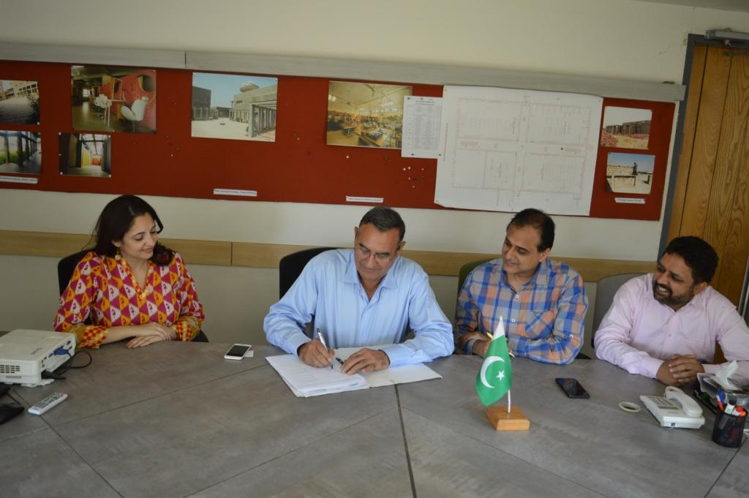
MOU Being Signed with Hunar Foundation in Karachi
Anjuman Faiz Ul Islam. Anjuman Faiz Ul Islam is managing a Technical Institute, an orphanage, a vocational centre and an intermediate college for girls at their Mandra Campus. Currently 15 students studying at their Mandra Campus are being sponsored by us. They all are doing well and have passed their examination in “A plus grade”.
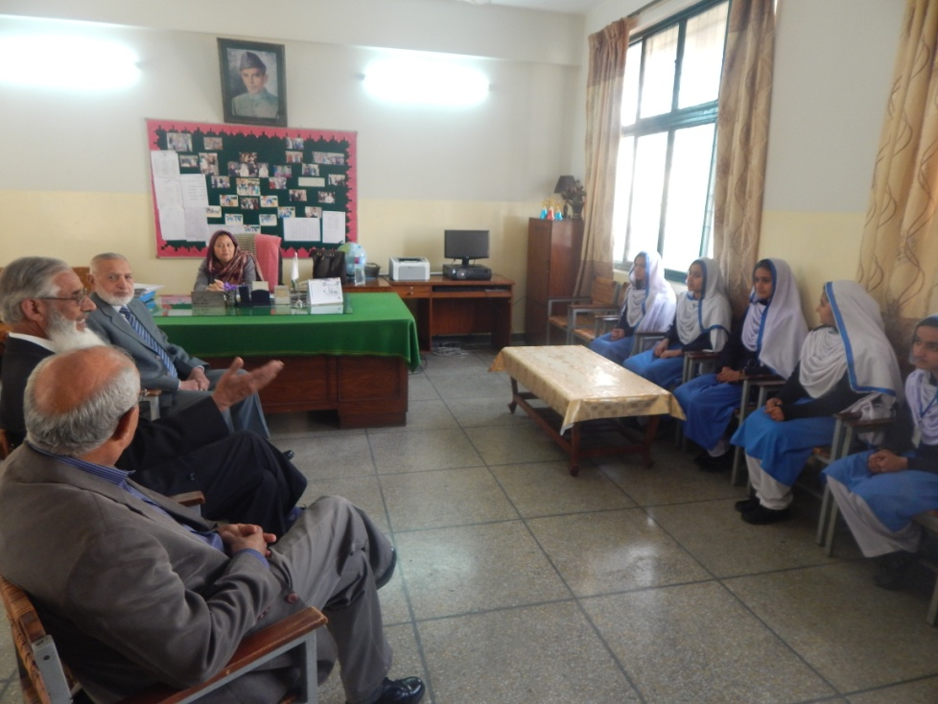
AMET Team Meets Principal Girls Secondary School at Mandra Campus
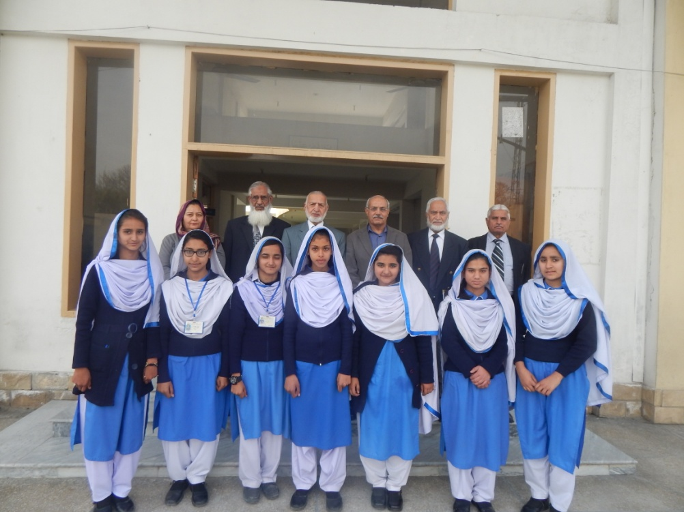
Chairman With Students Sponsored By AMET at Secondary School at Mandra Campus
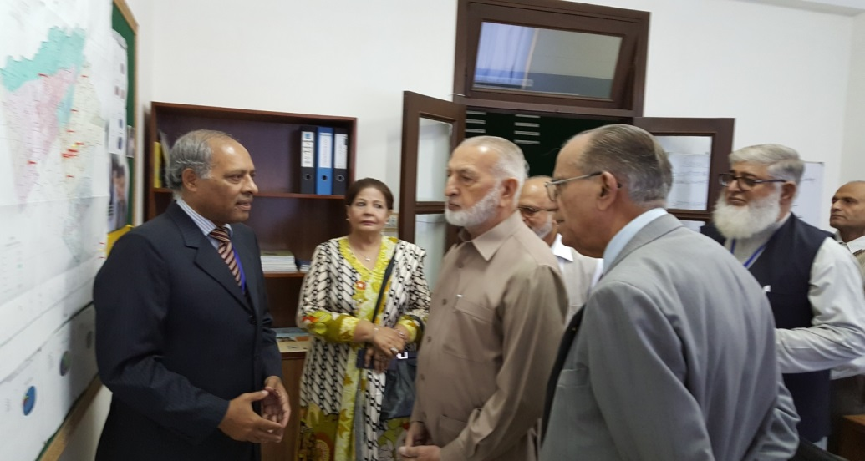
Sultana Foundation. Sultana Foundation is running a technical institute, vocational training institute and a number of schools / colleges at their different Campuses. Presently 06 students sponsored by AMET are under training in Prince Suleman Technical Institute.

Chairman’s Visit to Sultana Foundation, Islamabad
Cadet College Sargodha. This college is located on Bhalwal-Sargodha road. The management has agreed to allocate 05 vacancies annually to AMET. The College has agreed to charge subsidized education expenses of Rs. 1,20,000/- per student per annum. Currently six students sponsored by AMET are studying at this college.
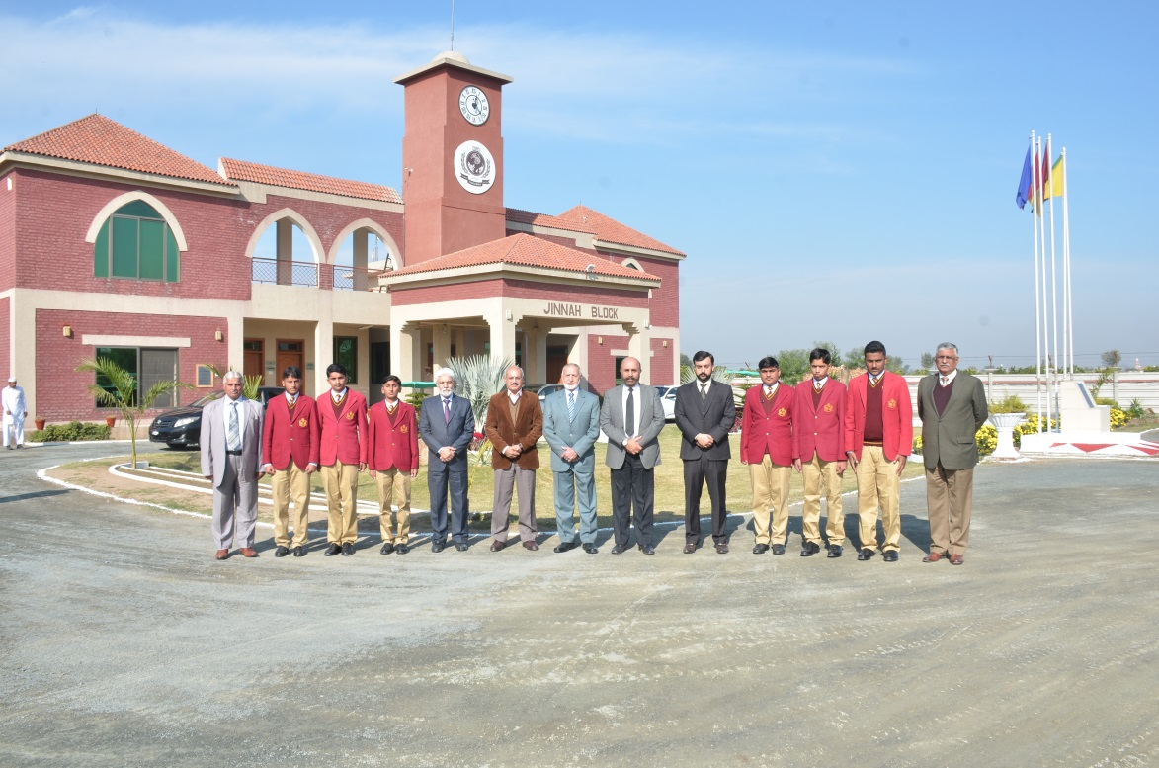
Chairman and his Team with Faculty of Cadet College Sargodha
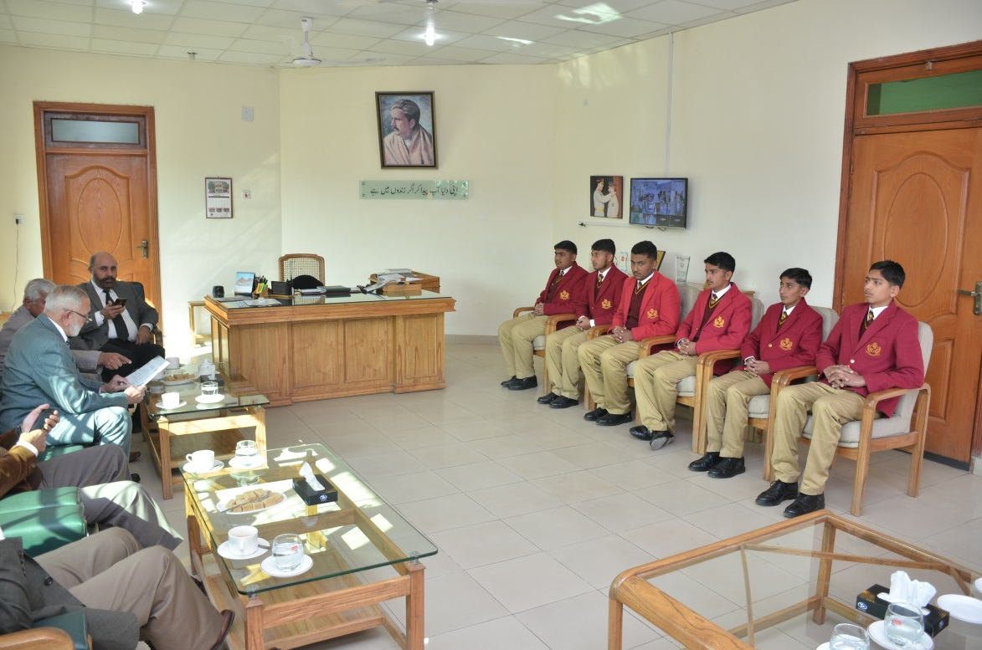
Chairman and his Team Interact with Students Sponsored by AMET at Cadet College Sargodha
Cadet College Karnal Sher Khan Shaheed. This college has been named after Capt Karnal Sher Khan Shaheed (Nishan-e-Haider), who embraced Shahadat during Kargil operations. This college is located almost 10 km from Swabi along Swabi-Mardan Road near village Nawan Killi, the native home of Capt Sher Khan. AMET is sponsoring three talented students at this college whose parents are not able to meet their total expenses.
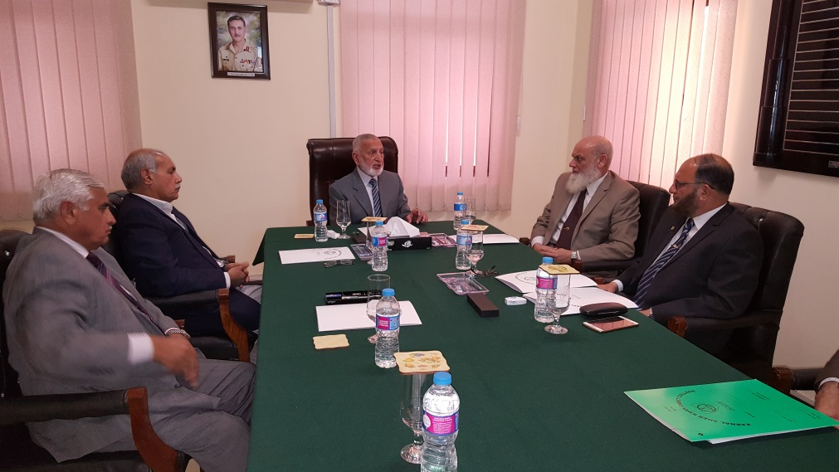
Visit to Karnal Sher Khan Shaheed Cadet College, Swabi (KPK)
Kaghan Memorial Trust (KMT). KMT is running a charitable school at village Kawai in Kaghan Valley since the aftermath of devastating earthquake of October 2005. This school is dedicated to the disadvantaged children of Kaghan Valley. AMET is supporting the education of 06 such students at the school in conjunction with KMT. Regular feed back is being received from KMT by AMET on the academic progress of these students which is praise worthy.
Askari Institute of Technology (AIT). This institute is located at Rawat, District Rawalpindi, on G.T Road. It is imparting technical training to the youth and conducting diploma courses of different disciplines. Besides AIT is also running a school/ College and a women empowerment centre. AMET is sponsoring 08 students at AIT for the past 2 years. Regular feedback indicates good performance by our students.
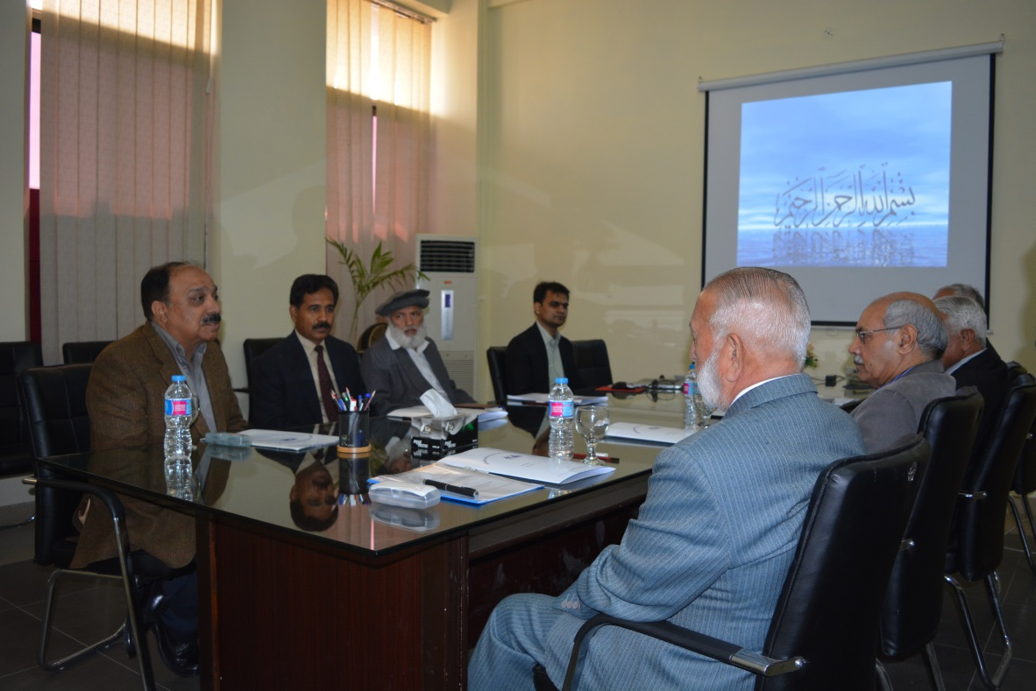
AMET Team Being Briefed by Brig Tahir Malik, Director AIT Rawat
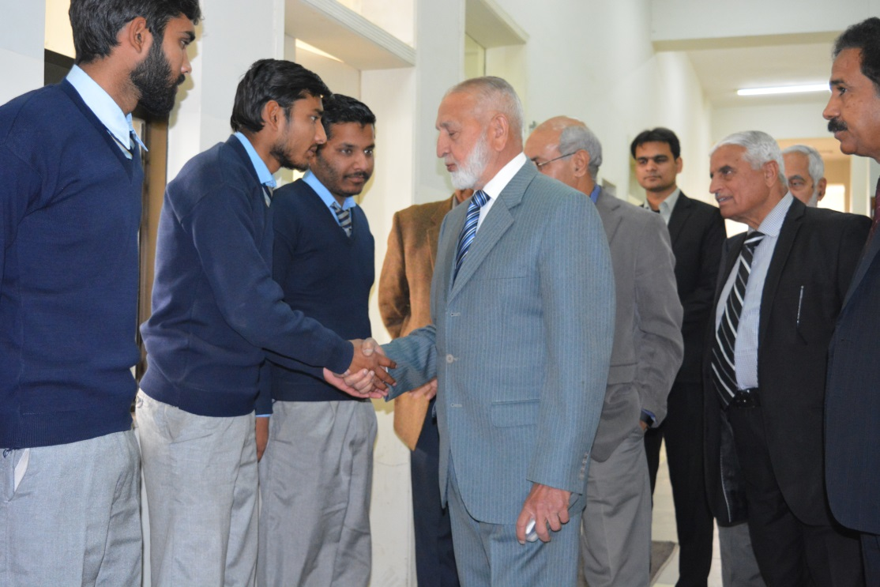
Chairman meets AMET Sponsored Students at AIT at Rawat

Special Scholarship Schemes
- Mazhar Scholarship
Rear Admiral (Retired) Amjad Mazhar Hussain, who after retirement from Royal Navy (UK) is settled in London,donated Rs. 2.00 million as one time donation for the Eisal-e-Sawab of his late father, Syed Mazhar Hussain Shah. The donor desired the utilization of this donation most judiciously.

Efforts were made to select the beneficiaries from all over the country covering general as well as technical education. Financial support from this donation has been titled as Mazhar Scholarships. 63 boys/girls have been selected and awarded Mazhar Scholarships for a period of two years. The donor is fully satisfied with the procedure followed. The Trust is very grateful to Admiral Amjad for his generous donation.
- Saeeda Naseem Shafi Scholarship
Mr. Muhammad Naseem Shafi, Managing Trustee Saeeda Naseem Shafi Trust, has donated Rs. 2.5 million annually for the education of girl students only from rural areas. This scheme has been titled as Saeeda Naseem Shafi Scholarships. In 2018, approximately Rs. 1.7 million will be allocated to the students who are already being sponsored by AMET for the academic year 2017/2018. The remaining amount will be utilized for fresh cases during academic year 2018/19 and vocational training centre set up for girls at Chak 118 NB, Tehsil Sillanwali, District Sargodha. We are very grateful to Mr. Naseem Shafi for his generous donation.

Meeting AMET Objectives
- Vocational Training. The Trust has been able to initiate action to realise one of its most important objectives related to vocational training. First Vocational Centre (VC) of AMET has been set up at Chak 118 NB Sillanwali, district Sargodha. It has started functioning with effect from 01 Jan 2018. First batch of 22 female students is being imparted vocational training for a period of 06 months. These students will be trained in Cutting, Stitching, Knitting and Handicraft. Efforts are in hand to set up more Vocational Centres in the villages..
- Teachers Training Workshop. A teacher Training Workshop was conducted under Al Mujtaba Education Trust on 13 Jan 2018 in Excelsior School Sysytem, G 13/1 Islamabad. The workshop was organized with the assistance of Association For Academic Quality (AFAQ). Following number of Teachers participated in the workshop:-
  - Excelsior School System Senior Campus - 14 teachers
  - Excelsior School System Junior Campus - 13 teachers
  - Excelsior School System Bewal Campus - 11 teachers
Total - 38
The workshop had two sessions of two hours each, wherein following subject were covered:-
- Lesson Planning
- Class Management
Overall the workshop proved to be very useful for the teachers and they were much wiser on the subjects covered in the workshop.
Financial Management
Bank
One account each for ‘Donations’ and ‘Zakat’ is being operated at Meezan Bank Ltd (Islamic Banking System) Chaklala Scheme III Rawalpindi Cantt. Donations and ‘Zakat’ received are deposited in relevant accounts.

Audit
A reputed audit firm, Amir Alam Khan & Co. has been appointed to audit our accounts. It has already carried out two audits and Audit Reports are being shared with all Trustees.
Board of Trustees

Chairman: Lt Gen (R) Ghulam Muhammad Malik

Trustees

Rawalpindi / Islamabd
- Mrs. Rakhshinda Jabeen Durrani
- Mr. Abdul Qadeer Mansoor
- Maj Gen (R) Muhammad Ovais Mustafa
- Brig (R) Fateh Khan Malik
- Brig (R) Zafar Masood Ansari
- Brig (R) Mukhtar Ahmed
- Brig (R) Ahmed Nawaz Zafar
- Brig (R) Asad Hakeem
- Brig (R) Muhammad Akram Malik
- Brig (R) Tariq Saeed
- Col (R) Zafar Ali Sufi
- Lt Col (R) Tariq Ahsan Ali Khan
Karachi
- Mr. Muhammad Ahmed
- Mr. Aman Elahi
- Mr. Javed Rehman
- Brig (R) Muhamamd Lateef Butt (Area Coordinator)
- Brig (R) Rashid Siddique
- Col (R) Ayaz Malik

Lahore
- Mrs. Tehmina Aslam
- Shiekh Abdul Majeed
- Brig (R) Arshad Raza
- Brig (R) Iftikhar Siddiqi
- Col (R) Asad Mehmood
United Kingdom
- Mr. Tariq Ali Khan
The Chairman as well as all the Trustees are rendering their services to
the Trust on voluntary basis.
Conclusion

Al Mujtaba Education Trust has been able to sponsor 387 students (Boys/Girls) all over Pakistan with the help and support of its valuable donors since its inception. With the on set of 3rd Academic Year earnest efforts are being made to raise the number of beneficiaries to 500. Depending upon the availability of funds, efforts will be made to support students for higher education besides capacity building of teachers in remote areas. Al Mujtaba Education Trust looks up to its well wishers to come forward whole heartedly to support the weak segments of our society through quality education.
You May Send Your Donations to

Donations

Al Mujtaba Education Trust
Meezan Bank Ltd, Chaklala
Scheme III Rawalpindi
Account No. 08070102087783
Swift.m=Mezanpakka
Ifna.PK 66 MEZN
0008070102087783
Br Code – 0807

Zakat

Al Mujtaba Education Trust
Meezan Bank Ltd, Chaklala
Scheme III Rawalpindi
Account No. 08070102491794
Swift.m=Mezanpakka
Ifna.PK 66 MEZN
0008070102491794
Br Code - 0807
- The Messenger of Allah (SWT) said that Allah (SWT) The Glorious and Exalted Says: Spend (on charity), O son of Adam, and I shall spend on you. [Hadith Qudsi 11]

- Abu Kabshah al Anmari reported that the Prophet (SAWS) said: “I swear upon three (things)and ask you to memorize my words: Sadaqah (charity) given from a property never decrease it; a man who suffers injustice and is patient with it, Allah will grant him strength; a man who starts begging, Allah will cause him to be poor.” [Related by Tirmidhi]

House No. 463 (1st Floor), Street No. 17, Chaklala Scheme III, Rawalpindi Cantt
Telephone: 051-5153391
E-mail: almujtabatrust@gmail.com

